LFEnergyFunctionalArchitectureModel
25 Jan 2024 12:41:59
 | Purpose
 | The LF Energy members EPRI, RTE, Alliander, and Aachen University have joined together in LF Energy Archimate Working Group to create an architecture model for LF Energy. LF Energy is an open-source foundation focused on the power systems sector, hosted within The Linux Foundation. LF Energy provides a neutral, collaborative community to build the shared digital investments that will transform the world’s relationship to energy. The goal of the LF Energy Architecture Model is to become the place to go for sharing references architectures and project architectures within the LF Energy community. It aims to clarify the ecosystem of LF Energy: wherefore can the LF Energy projects be used, how they interact together, and examples of how they can be adopted in reference architectures. This will provide a clear and deep understanding of how the LF Energy projects contribute to business functions and help the project adoption, foster synergies between projects, and limit the overlap between projects. For more information, please watch the special episode of TFiR: State of Energy where Swapnil Bhartiya sits down with Prince Singh, Solution Architect at Alliander and Benoît Jeanson, Enterprise Architect at RTE, and talk about LF Energy Architecture Model and how it makes it easier for anybody in the world to identify LF Energy Projects that are of interest to them and how they can be integrated into their organization.
 | LFEnergyFunctionalArchitectureModel | 2 | / 214
 | Views
 | Actors and Roles
 | No viewpoint
 | 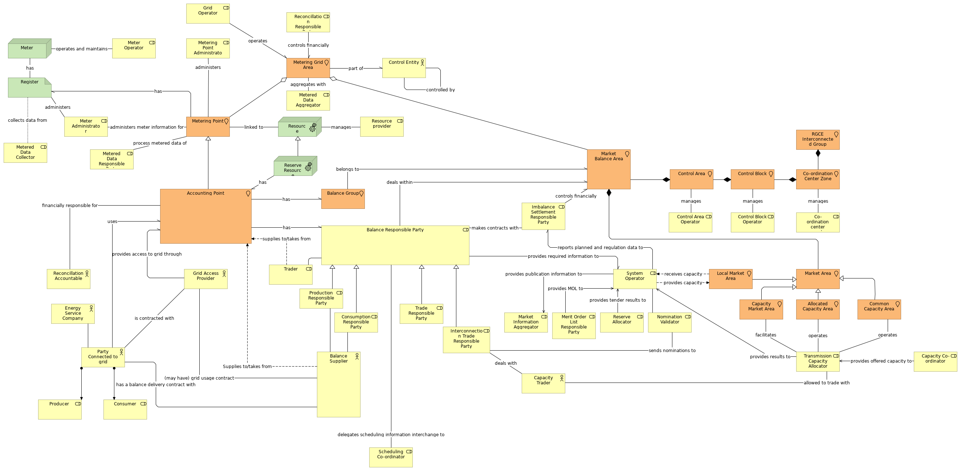
 | Documentation
 | Organisation Viewpoint is a standard viewpoint in ArchiMate and "...focusses on the (internal) organistion of a company, network of companies, or of another organisational entity." Here, we use the organisation viewpoint to model different business actors and role in the energy market. The original document used for this viewpoint is ENTSOE The Harmonized Electricity Market Role Model Version 2017-01
 | Elements
 | Element | Type
 | Accounting Point | Location
 | Allocated Capacity Area | Location
 | Balance Group | Location
 | Balance Responsible Party | Business Role
 | Balance Supplier | Business Actor
 | Capacity Co-ordinator | Business Role
 | Capacity Market Area | Location
 | Capacity Trader | Business Actor
 | Co-ordination center operator | Business Role
 | Co-ordination Center Zone | Location
 | Common Capacity Area | Location
 | Consumer | Business Role
 | Consumption Responsible Party | Business Role
 | Control Area | Location
 | Control Area Operator | Business Role
 | LFEnergyFunctionalArchitectureModel |  | 3 | / 214
 | Element | Type
 | Control Block | Location
 | Control Block Operator | Business Role
 | Control Entity | Business Actor
 | Energy Service Company | Business Actor
 | Grid Access Provider | Business Actor
 | Grid Operator | Business Role
 | Imbalance Settlement Responsible Party | Business Role
 | Interconnection Trade Responsible Party | Business Role
 | Local Market Area | Location
 | Market Area | Location
 | Market Balance Area | Location
 | Market Information Aggregator | Business Role
 | Merit Order List Responsible Party | Business Role
 | Meter | Node
 | Meter Administrator | Business Role
 | Meter Operator | Business Role
 | Metered Data Aggregator | Business Role
 | Metered Data Collector | Business Role
 | Metered Data Responsible Party | Business Role
 | Metering Grid Area | Location
 | Metering Point | Location
 | Metering Point Administrator | Business Role
 | Nomination Validator | Business Role
 | Party Connected to grid | Business Actor
 | Producer | Business Role
 | Production Responsible Party | Business Role
 | Reconcillation Accountable | Business Actor
 | Reconcillation Responsible Party | Business Role
 | Register | Artifact
 | Reserve Allocator | Business Role
 | Reserve Resource | Equipment
 | Resource | Equipment
 | Resource provider | Business Role
 | RGCE Interconnected Group | Location
 | Scheduling Co-ordinator | Business Role
 | System Operator | Business Role
 | Trade Responsible Party | Business Role
 | Trader | Business Role
 | Transmission Capacity Allocator | Business Role
 | LFEnergyFunctionalArchitectureModel |  | 4 | / 214
 | CoMPAS Realization
 | No viewpoint
 | 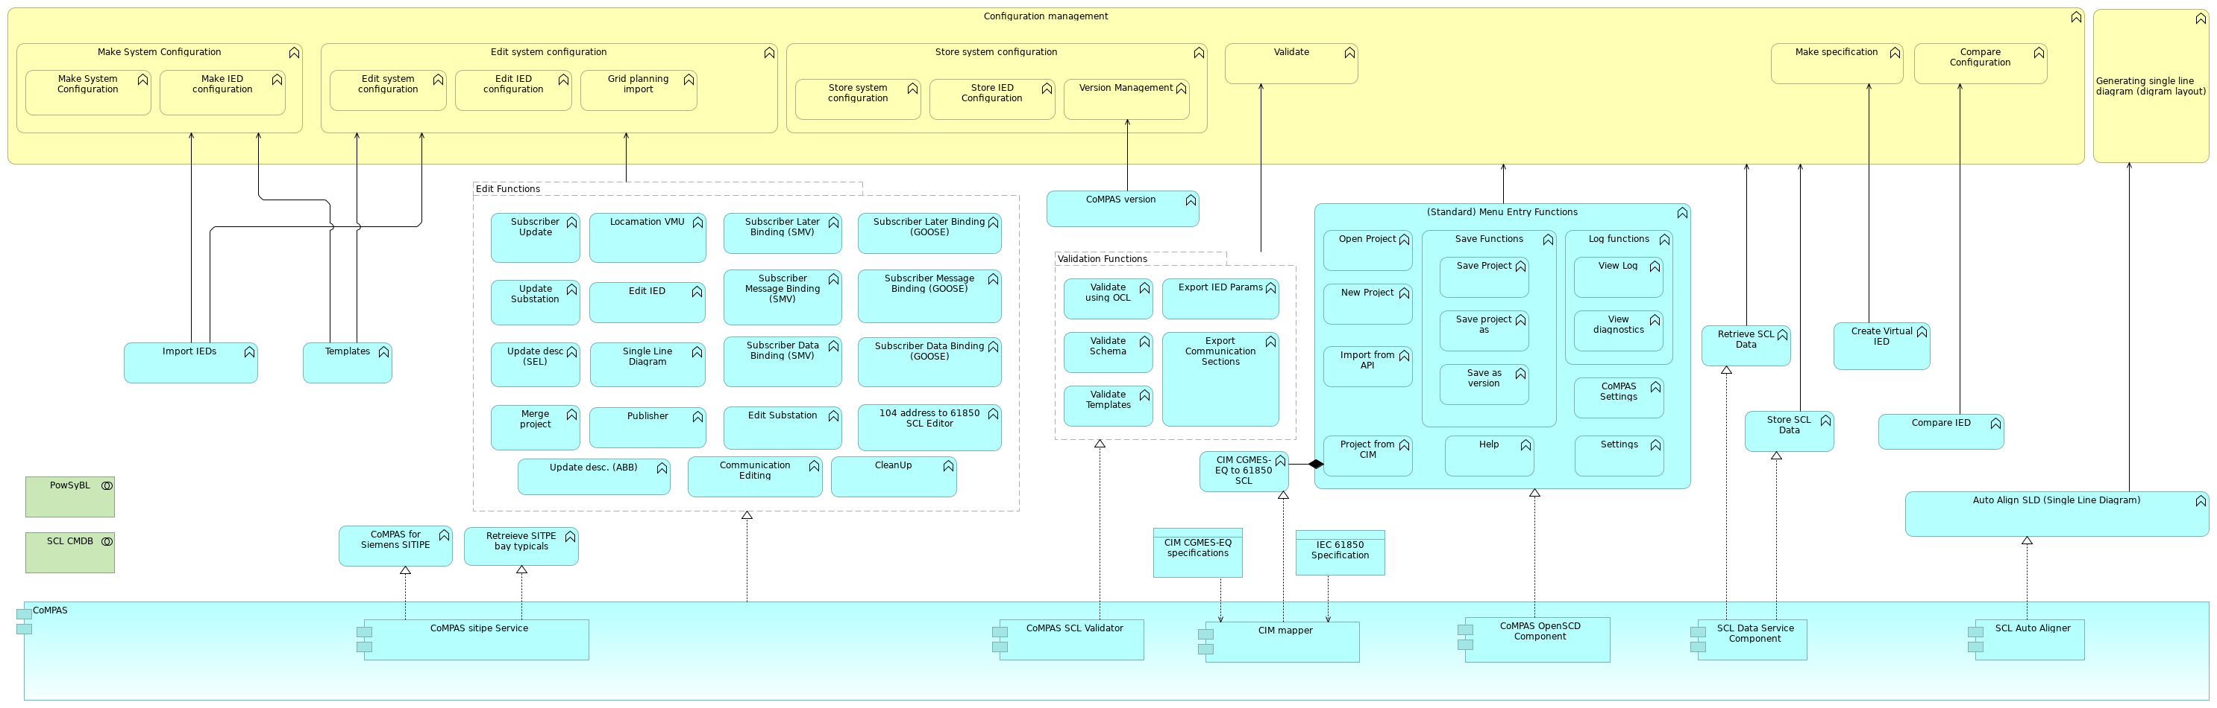
 | Documentation
 | This is the project achitecture view of the CoMPAS project. CoMPAS is going to provide common open source software blocks for the automizing the process for configuring Substation Automation Systems and has the ability to integrate third-party tools. For more information on CoMPAS, check out the project's page: https://lfenergy.org/projects/compas/
 | Elements
 | Element | Type
 | (Standard) Menu Entry Functions | Application Function
 | 104 address to 61850 SCL Editor | Application Function
 | Auto Align SLD (Single Line Diagram) | Application Function
 | CIM CGMES-EQ specifications | Data Object
 | CIM CGMES-EQ to 61850 SCL | Application Function
 | CIM mapper | Application Component
 | CleanUp | Application Function
 | Communication Editing | Application Function
 | Compare Configuration | Business Function
 | Compare IED | Application Function
 | CoMPAS | Application Component
 | CoMPAS for Siemens SITIPE | Application Function
 | CoMPAS OpenSCD Component | Application Component
 | CoMPAS SCL Validator | Application Component
 | CoMPAS Settings | Application Function
 | CoMPAS sitipe Service | Application Component
 | CoMPAS version | Application Function
 | Configuration management | Business Function
 | Create Virtual IED | Application Function
 | Edit Functions | Grouping
 | Edit IED | Application Function
 | Edit IED configuration | Business Function
 | Edit Substation | Application Function
 | LFEnergyFunctionalArchitectureModel |  | 5 | / 214
 | Element | Type
 | Edit system configuration | Business Function
 | Edit system configuration | Business Function
 | Export Communication Sections | Application Function
 | Export IED Params | Application Function
 | Generating single line diagram (digram layout) | Business Function
 | Grid planning import | Business Function
 | Help | Application Function
 | IEC 61850 Specification | Data Object
 | Import from API | Application Function
 | Import IEDs | Application Function
 | Locamation VMU | Application Function
 | Log functions | Application Function
 | Make IED configuration | Business Function
 | Make specification | Business Function
 | Make System Configuration | Business Function
 | Make System Configuration | Business Function
 | Merge project | Application Function
 | New Project | Application Function
 | Open Project | Application Function
 | PowSyBL | Technology Collaboration
 | Project from CIM | Application Function
 | Publisher | Application Function
 | Retreieve SITPE bay typicals | Application Function
 | Retrieve SCL Data | Application Function
 | Save as version | Application Function
 | Save Functions | Application Function
 | Save Project | Application Function
 | Save project as | Application Function
 | SCL Auto Aligner | Application Component
 | SCL CMDB | Technology Collaboration
 | SCL Data Service Component | Application Component
 | Settings | Application Function
 | Single Line Diagram | Application Function
 | Store IED Configuration | Business Function
 | Store SCL Data | Application Function
 | Store system configuration | Business Function
 | Store system configuration | Business Function
 | Subscriber Data Binding (GOOSE) | Application Function
 | Subscriber Data Binding (SMV) | Application Function
 | Subscriber Later Binding (GOOSE) | Application Function
 | Subscriber Later Binding (SMV) | Application Function
 | Subscriber Message Binding (GOOSE) | Application Function
 | Subscriber Message Binding (SMV) | Application Function
 | Subscriber Update | Application Function
 | LFEnergyFunctionalArchitectureModel |  | 6 | / 214
 | Element | Type
 | Templates | Application Function
 | Update desc (SEL) | Application Function
 | Update desc. (ABB) | Application Function
 | Update Substation | Application Function
 | Validate | Business Function
 | Validate Schema | Application Function
 | Validate Templates | Application Function
 | Validate using OCL | Application Function
 | Validation Functions | Grouping
 | Version Management | Business Function
 | View diagnostics | Application Function
 | View Log | Application Function
 | LFEnergyFunctionalArchitectureModel |  | 7 | / 214
 | Contingency Analysis
 | No viewpoint
 | 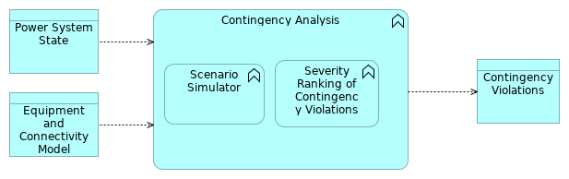
 | Elements
 | Element | Type
 | Contingency Analysis | Application Function
 | Contingency Violations | Data Object
 | Equipment and Connectivity Model | Data Object
 | Power System State | Data Object
 | Scenario Simulator | Application Function
 | Severity Ranking of Contingency Violations | Application Function
 | LFEnergyFunctionalArchitectureModel |  | 8 | / 214
 | DSA aggregation
 | No viewpoint
 | 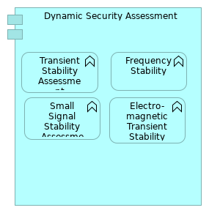
 | Elements
 | Element | Type
 | Dynamic Security Assessment | Application Component
 | Electro-magnetic Transient Stability Assessment | Application Function
 | Frequency Stability | Application Function
 | Small Signal Stability Assessment | Application Function
 | Transient Stability Assessment | Application Function
 | LFEnergyFunctionalArchitectureModel |  |  | 9 | / 214
 | Dynamic Security Assessment
 | No viewpoint
 | 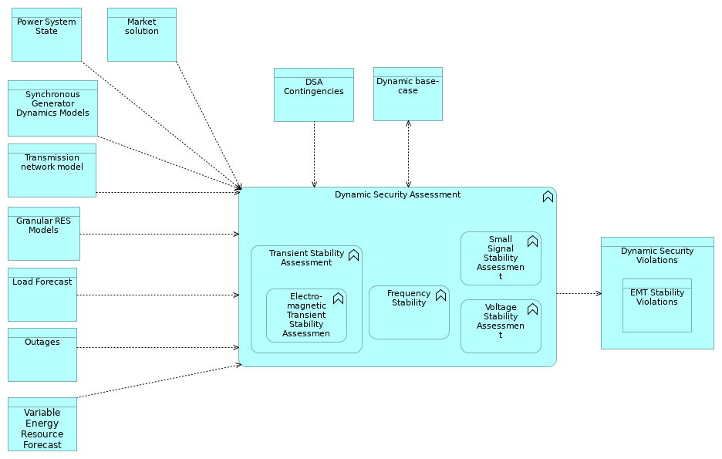
 | Elements
 | Element | Type
 | DSA Contingencies | Data Object
 | Dynamic base-case | Data Object
 | Dynamic Security Assessment | Application Function
 | Dynamic Security Violations | Data Object
 | Electro-magnetic Transient Stability Assessment | Application Function
 | EMT Stability Violations | Data Object
 | Frequency Stability | Application Function
 | Granular RES Models | Data Object
 | Load Forecast | Data Object
 | Market solution | Data Object
 | Outages | Data Object
 | Power System State | Data Object
 | Small Signal Stability Assessment | Application Function
 | Synchronous Generator Dynamics Models | Data Object
 | Transient Stability Assessment | Application Function
 | Transmission network model | Data Object
 | Variable Energy Resource Forecast | Data Object
 | Voltage Stability Assessment | Application Function
 | LFEnergyFunctionalArchitectureModel |  | 10 | / 214
 | LFEnergyFunctionalArchitectureModel | 11 | / 214
 | Event Management Detailed
 | No viewpoint
 | 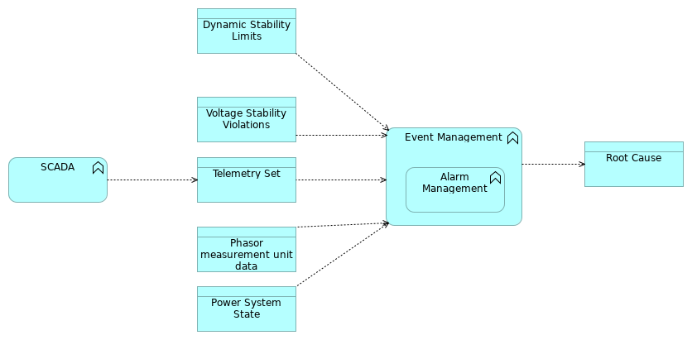
 | Elements
 | Element | Type
 | Alarm Management | Application Function
 | Dynamic Stability Limits | Data Object
 | Event Management | Application Function
 | Phasor measurement unit data | Data Object
 | Power System State | Data Object
 | Root Cause | Data Object
 | SCADA | Application Function
 | Telemetry Set | Data Object
 | Voltage Stability Violations | Data Object
 | LFEnergyFunctionalArchitectureModel |  | 12 | / 214
 | Facility Ratings
 | No viewpoint
 | 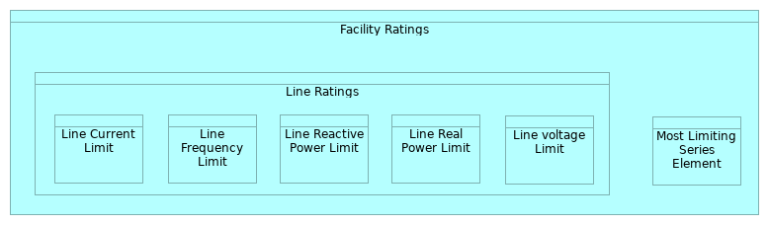
 | Elements
 | Element | Type
 | Facility Ratings | Data Object
 | Line Current Limit | Data Object
 | Line Frequency Limit | Data Object
 | Line Ratings | Data Object
 | Line Reactive Power Limit | Data Object
 | Line Real Power Limit | Data Object
 | Line voltage Limit | Data Object
 | Most Limiting Series Element | Data Object
 | LFEnergyFunctionalArchitectureModel |  | 13 | / 214
 | FledgePower Realization
 | No viewpoint
 | 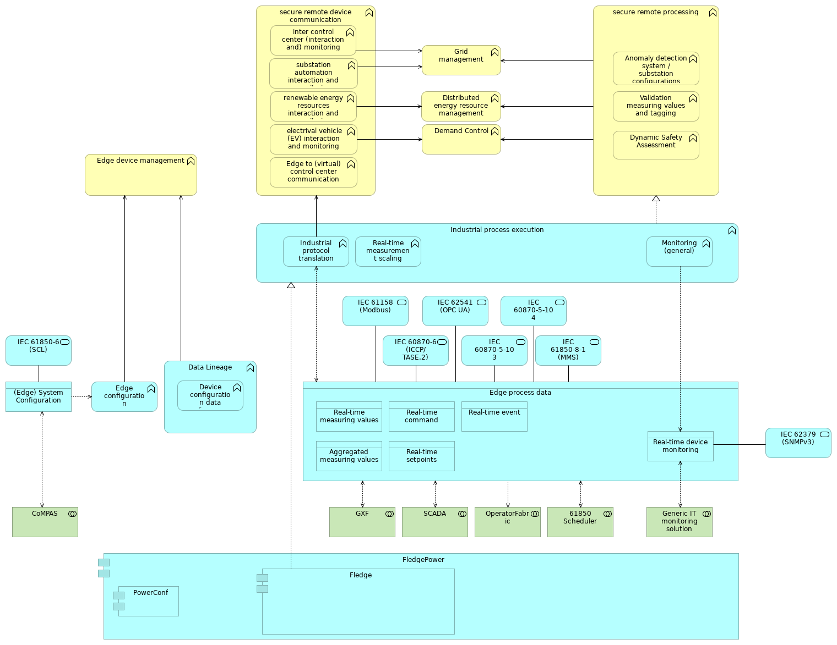
 | Documentation
 | This is the project achitecture view of the FledgePower project. FledgePOWER is a multi-protocol translation gateway for power systems based on the industrial IoT LF Edge project Fledge. For more information on FledgePower, check out the project's page: https://lfenergy.org/projects/fledgepower/
 | Elements
 | Element | Type
 | (Edge) System Configuration | Data Object
 | 61850 Scheduler | Technology Collaboration
 | Aggregated measuring values | Data Object
 | Anomaly detection system / substation configurations | Business Function
 | CoMPAS | Technology Collaboration
 | Data Lineage | Application Function
 | Demand Control | Business Function
 | Device configuration data lineage | Application Function
 | LFEnergyFunctionalArchitectureModel |  | 14 | / 214
 | Element | Type
 | Distributed energy resource management | Business Function
 | Dynamic Safety Assessment | Business Function
 | Edge configuration management | Application Function
 | Edge device management | Business Function
 | Edge process data | Data Object
 | Edge to (virtual) control center communication | Business Function
 | electrival vehicle (EV) interaction and monitoring | Business Function
 | Fledge | Application Component
 | FledgePower | Application Component
 | Generic IT monitoring solution | Technology Collaboration
 | Grid management | Business Function
 | GXF | Technology Collaboration
 | IEC 60870-5-103 | Application Service
 | IEC 60870-5-104 | Application Service
 | IEC 60870-6 (ICCP/TASE.2) | Application Service
 | IEC 61158 (Modbus) | Application Service
 | IEC 61850-6 (SCL) | Application Service
 | IEC 61850-8-1 (MMS) | Application Service
 | IEC 62379 (SNMPv3) | Application Service
 | IEC 62541 (OPC UA) | Application Service
 | Industrial process execution | Application Function
 | Industrial protocol translation | Application Function
 | inter control center (interaction and) monitoring | Business Function
 | Monitoring (general) | Application Function
 | OperatorFabric | Technology Collaboration
 | PowerConf | Application Component
 | Real-time command | Data Object
 | Real-time device monitoring | Data Object
 | Real-time event | Data Object
 | Real-time measurement scaling | Application Function
 | Real-time measuring values | Data Object
 | Real-time setpoints | Data Object
 | renewable energy resources interaction and monitoring | Business Function
 | SCADA | Technology Collaboration
 | secure remote device communication | Business Function
 | secure remote processing | Business Function
 | substation automation interaction and monitoring | Business Function
 | Validation measuring values and tagging | Business Function
 | LFEnergyFunctionalArchitectureModel |  | 15 | / 214
 | Grid Model Aggregation
 | No viewpoint
 | 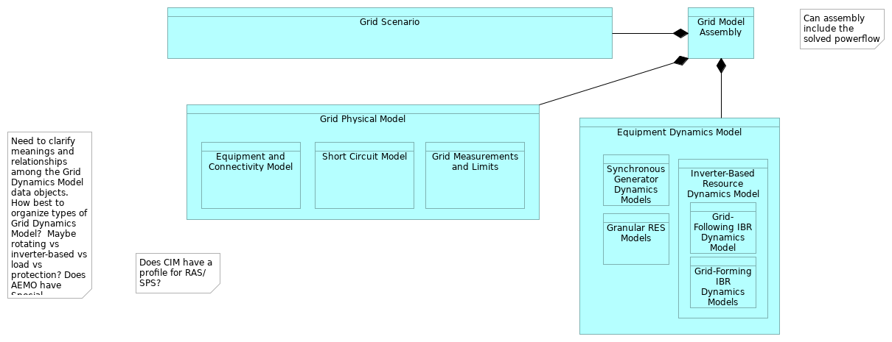
 | Elements
 | Element | Type
 | Equipment and Connectivity Model | Data Object
 | Equipment Dynamics Model | Data Object
 | Granular RES Models | Data Object
 | Grid Measurements and Limits | Data Object
 | Grid Model Assembly | Data Object
 | Grid Physical Model | Data Object
 | Grid Scenario | Data Object
 | Grid-Following IBR Dynamics Model | Data Object
 | Grid-Forming IBR Dynamics Models | Data Object
 | Inverter-Based Resource Dynamics Model | Data Object
 | Short Circuit Model | Data Object
 | Synchronous Generator Dynamics Models | Data Object
 | LFEnergyFunctionalArchitectureModel |  | 16 | / 214
 | GXF Realization
 | No viewpoint
 | 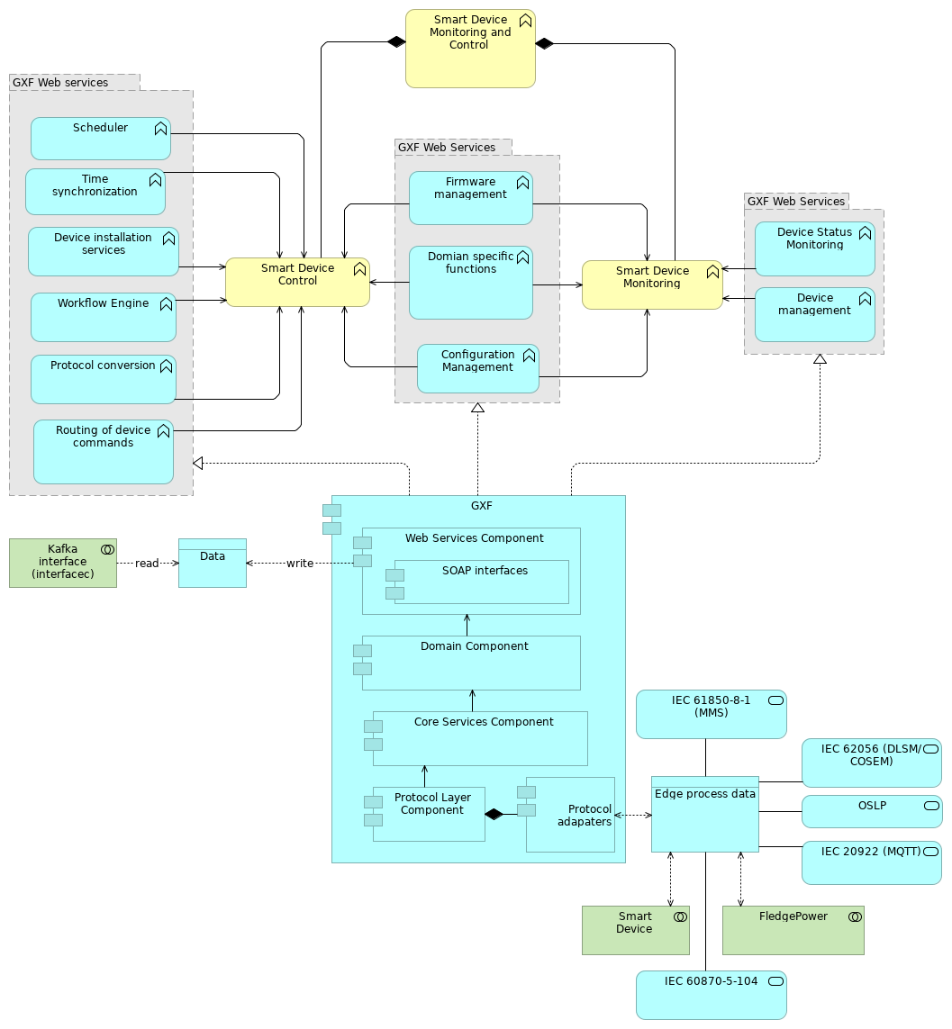
 | Documentation
 | This is the project achitecture view of Grid eXchange Fabric (GXF) project. GXF is a software platform that enables hardware monitoring and control in the public space. GXF provides several functions out of the box and provides scalability & high availability, high security, a generic design, and no vendor lock-in. GXF is currently deployed in several public use cases, including microgrids, smart metering, public lighting, and distribution automation. For more information on GXF, check out the project's page: https://lfenergy.org/projects/gxf/
 | LFEnergyFunctionalArchitectureModel | 17 | / 214
 | Elements
 | Element | Type
 | Configuration Management | Application Function
 | Core Services Component | Application Component
 | Data | Data Object
 | Device installation services | Application Function
 | Device management | Application Function
 | Device Status Monitoring | Application Function
 | Domain Component | Application Component
 | Domian specific functions | Application Function
 | Edge process data | Data Object
 | Firmware management | Application Function
 | FledgePower | Technology Collaboration
 | GXF | Application Component
 | GXF Web Services | Grouping
 | GXF Web Services | Grouping
 | GXF Web services | Grouping
 | IEC 20922 (MQTT) | Application Service
 | IEC 60870-5-104 | Application Service
 | IEC 61850-8-1 (MMS) | Application Service
 | IEC 62056 (DLSM/COSEM) | Application Service
 | Kafka interface (interfacec) | Technology Collaboration
 | OSLP | Application Service
 | Protocol adapaters | Application Component
 | Protocol conversion | Application Function
 | Protocol Layer Component | Application Component
 | Routing of device commands | Application Function
 | Scheduler | Application Function
 | Smart Device | Technology Collaboration
 | Smart Device Control | Business Function
 | Smart Device Monitoring | Business Function
 | Smart Device Monitoring and Control | Business Function
 | SOAP interfaces | Application Component
 | Time synchronization | Application Function
 | Web Services Component | Application Component
 | Workflow Engine | Application Function
 | LFEnergyFunctionalArchitectureModel |  | 18 | / 214
 | High level DFD w Data Exchange Standards
 | No viewpoint
 | 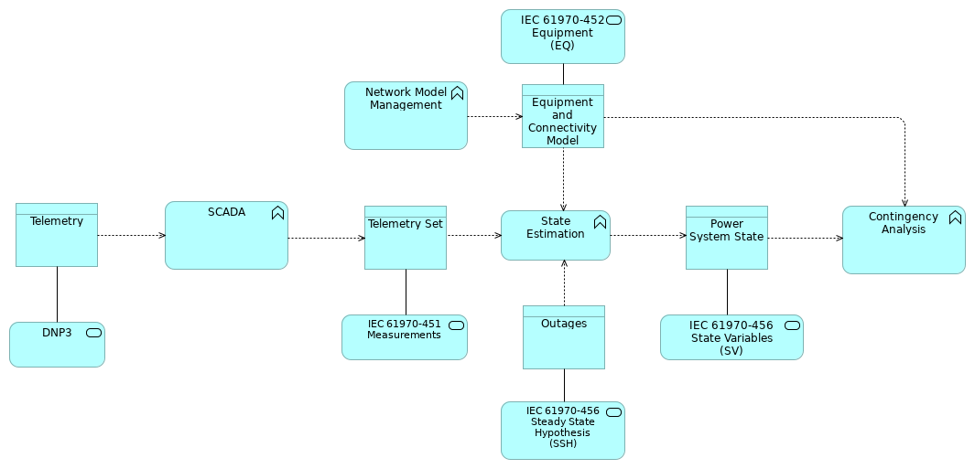
 | Elements
 | Element | Type
 | Contingency Analysis | Application Function
 | DNP3 | Application Service
 | Equipment and Connectivity Model | Data Object
 | IEC 61970-451 Measurements | Application Service
 | IEC 61970-452 Equipment (EQ) | Application Service
 | IEC 61970-456 State Variables (SV) | Application Service
 | IEC 61970-456 Steady State Hypothesis (SSH) | Application Service
 | Network Model Management | Application Function
 | Outages | Data Object
 | Power System State | Data Object
 | SCADA | Application Function
 | State Estimation | Application Function
 | Telemetry | Data Object
 | Telemetry Set | Data Object
 | LFEnergyFunctionalArchitectureModel |  | 19 | / 214
 | LFE High-Level Functional Architecture V1.0 (orginal)
 | No viewpoint
 | 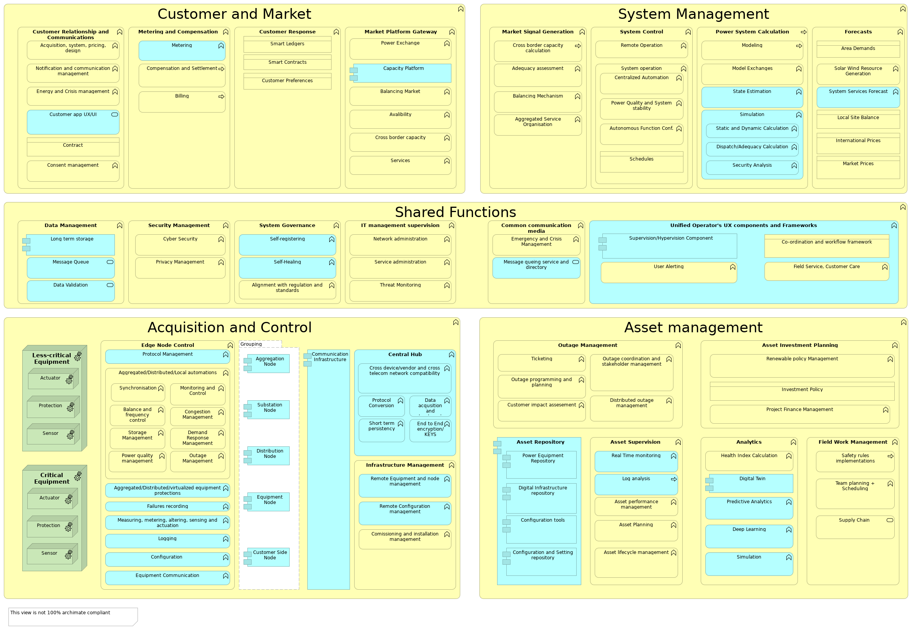
 | Documentation
 | This viewpoint is a draft version and work in progress. It is based on LF Energy Functional Architecture v1.0 - CC 4.0 (can be found LFE GitHub repository).
 | Elements
 | Element | Type
 | Acquisition and Control | Business Function
 | Acquisition, system, pricing, design | Business Function
 | Actuator | Equipment
 | Actuator | Equipment
 | Adequacy assessment | Business Function
 | Aggregated Service Organisation | Business Function
 | Aggregated/Distributed/Local automations | Business Function
 | Aggregated/Distributed/virtualized equipment protections | Application Function
 | Aggregation Node | Application Component
 | Alignment with regulation and standards | Business Function
 | Analytics | Business Function
 | Area Demands | Business Object
 | Asset Investment Planning | Business Function
 | LFEnergyFunctionalArchitectureModel |  | 20 | / 214
 | Element | Type
 | Asset lifecycle management | Business Function
 | Asset management | Business Function
 | Asset performance management | Business Function
 | Asset Planning | Business Function
 | Asset Repository | Application Component
 | Asset Supervision | Business Function
 | Autonomous Function Conf. | Business Function
 | Avalibility | Business Function
 | Balance and frequency control | Business Function
 | Balancing Market | Business Function
 | Balancing Mechanism | Business Function
 | Billing | Business Process
 | Capacity Platform | Application Component
 | Central Hub | Application Function
 | Centralized Automation | Business Function
 | Co-ordination and workflow framework | Business Object
 | Comissioning and installation management | Business Function
 | Common communication media | Business Function
 | Communication Infrastructure | Application Component
 | Compensation and Settlement | Business Process
 | Configuration | Application Function
 | Configuration and Setting repository | Application Component
 | Configuration tools | Application Component
 | Congestion Management | Business Function
 | Consent management | Business Function
 | Contract | Business Object
 | Critical Equipment | Equipment
 | Cross border capacity | Business Function
 | Cross border capacity calculation | Business Process
 | Cross device/vendor and cross telecom network compatibility | Application Function
 | Customer and Market | Business Function
 | Customer app UX/UI | Application Service
 | Customer impact assesement | Business Function
 | Customer Preferences | Business Object
 | Customer Relationship and Communications | Business Function
 | Customer Response | Business Function
 | Customer Side Node | Application Component
 | Cyber Security | Business Function
 | Data acqusition and treatment | Application Function
 | Data Management | Business Function
 | Data Validation | Application Service
 | Deep Learning | Application Function
 | Demand Response Management | Business Function
 | Digital Infrastructure repository | Application Component
 | LFEnergyFunctionalArchitectureModel |  | 21 | / 214
 | Element | Type
 | Digital Twin | Application Component
 | Dispatch/Adequacy Calculation | Application Function
 | Distributed outage management | Business Function
 | Distribution Node | Application Component
 | Edge Node Control | Business Function
 | Emergency and Crisis Management | Business Function
 | End to End encryption/KEYS | Application Function
 | Energy and Crisis management | Business Function
 | Equipment Communication | Application Function
 | Equipment Node | Application Component
 | Failures recording | Application Function
 | Field Service, Customer Care | Business Function
 | Field Work Management | Business Function
 | Forecasts | Business Function
 | Grouping | Grouping
 | Health Index Calculation | Business Function
 | Infrastructure Management | Business Function
 | International Prices | Business Object
 | Investment Policy | Business Object
 | IT management supervision | Business Function
 | Less-critical Equipment | Equipment
 | Local Site Balance | Business Object
 | Log analysis | Application Process
 | Logging | Application Function
 | Long term storage | Application Component
 | Market Platform Gateway | Business Function
 | Market Prices | Business Object
 | Market Signal Generation | Business Function
 | Measuring, metering, altering, sensing and actuation | Application Function
 | Message queing service and directory | Application Service
 | Message Queue | Application Service
 | Metering | Application Function
 | Metering and Compensation | Business Function
 | Model Exchanges | Business Function
 | Modeling | Business Process
 | Monitoring and Control | Business Function
 | Network administration | Business Function
 | Notification and communication management | Business Function
 | Outage coordination and stakeholder management | Business Function
 | Outage Management | Business Function
 | Outage Management | Business Function
 | Outage programming and planning | Business Function
 | Power Equipment Repository | Application Component
 | LFEnergyFunctionalArchitectureModel |  | 22 | / 214
 | Element | Type
 | Power Exchange | Business Function
 | Power Quality and System stability | Business Function
 | Power quality management | Business Function
 | Power System Calculation | Business Process
 | Predictive Analytics | Application Function
 | Privacy Management | Business Function
 | Project Finance Management | Business Function
 | Protection | Equipment
 | Protection | Equipment
 | Protocol Conversion | Application Function
 | Protocol Management | Application Function
 | Real Time monitoring | Application Function
 | Remote Configuration management | Application Function
 | Remote Equipment and node management | Application Function
 | Remote Operation | Business Function
 | Renewable policy Management | Business Function
 | Safety rules implementations | Business Process
 | Schedules | Business Object
 | Security Analysis | Application Function
 | Security Management | Business Function
 | Self-Healing | Application Function
 | Self-registering | Application Function
 | Sensor | Equipment
 | Sensor | Equipment
 | Service administration | Business Function
 | Services | Business Function
 | Shared Functions | Business Function
 | Short term persistency | Application Function
 | Simulation | Application Function
 | Simulation | Application Function
 | Smart Contracts | Business Object
 | Smart Ledgers | Business Object
 | Solar Wind Resource Generation | Business Function
 | State Estimation | Application Function
 | Static and Dynamic Calculation | Application Function
 | Storage Management | Business Function
 | Substation Node | Application Component
 | Supervision/Hypervision Component | Application Component
 | Supply Chain | Business Service
 | Synchronisation | Business Function
 | System Control | Business Function
 | System Governance | Business Function
 | System Management | Business Function
 | System operation | Business Function
 | LFEnergyFunctionalArchitectureModel |  | 23 | / 214
 | Element | Type
 | System Services Forecast | Application Function
 | Team planning + Scheduling | Business Function
 | Threat Monitoring | Business Function
 | Ticketing | Business Function
 | Unified Operator's UX components and Frameworks | Application Function
 | User Alerting | Business Function
 | LFEnergyFunctionalArchitectureModel |  | 24 | / 214
 | LFE High-Level Functional Architecture V1.0 - Business functions only
 | No viewpoint
 | 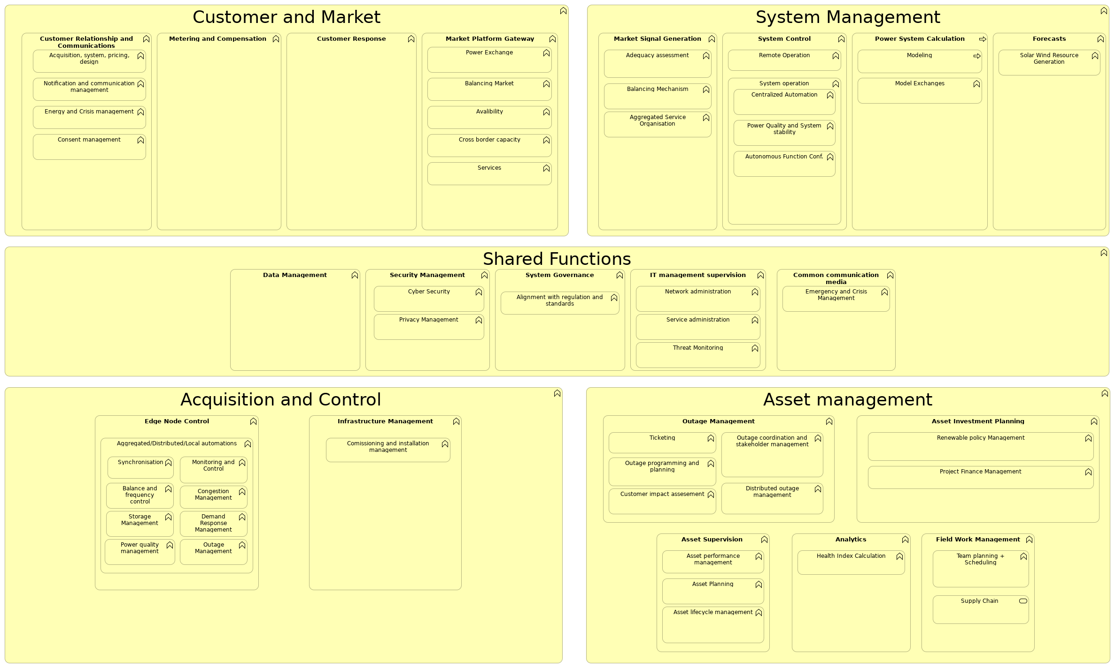
 | Documentation
 | This viewpoint is a draft version and work in progress. It is based on LF Energy Functional Architecture v1.0 - CC 4.0 (can be found LFE GitHub repository).
 | Elements
 | Element | Type
 | Acquisition and Control | Business Function
 | Acquisition, system, pricing, design | Business Function
 | Adequacy assessment | Business Function
 | Aggregated Service Organisation | Business Function
 | Aggregated/Distributed/Local automations | Business Function
 | Alignment with regulation and standards | Business Function
 | Analytics | Business Function
 | Asset Investment Planning | Business Function
 | Asset lifecycle management | Business Function
 | Asset management | Business Function
 | Asset performance management | Business Function
 | Asset Planning | Business Function
 | Asset Supervision | Business Function
 | Autonomous Function Conf. | Business Function
 | Avalibility | Business Function
 | LFEnergyFunctionalArchitectureModel |  | 25 | / 214
 | Element | Type
 | Balance and frequency control | Business Function
 | Balancing Market | Business Function
 | Balancing Mechanism | Business Function
 | Centralized Automation | Business Function
 | Comissioning and installation management | Business Function
 | Common communication media | Business Function
 | Congestion Management | Business Function
 | Consent management | Business Function
 | Cross border capacity | Business Function
 | Customer and Market | Business Function
 | Customer impact assesement | Business Function
 | Customer Relationship and Communications | Business Function
 | Customer Response | Business Function
 | Cyber Security | Business Function
 | Data Management | Business Function
 | Demand Response Management | Business Function
 | Distributed outage management | Business Function
 | Edge Node Control | Business Function
 | Emergency and Crisis Management | Business Function
 | Energy and Crisis management | Business Function
 | Field Work Management | Business Function
 | Forecasts | Business Function
 | Health Index Calculation | Business Function
 | Infrastructure Management | Business Function
 | IT management supervision | Business Function
 | Market Platform Gateway | Business Function
 | Market Signal Generation | Business Function
 | Metering and Compensation | Business Function
 | Model Exchanges | Business Function
 | Modeling | Business Process
 | Monitoring and Control | Business Function
 | Network administration | Business Function
 | Notification and communication management | Business Function
 | Outage coordination and stakeholder management | Business Function
 | Outage Management | Business Function
 | Outage Management | Business Function
 | Outage programming and planning | Business Function
 | Power Exchange | Business Function
 | Power Quality and System stability | Business Function
 | Power quality management | Business Function
 | Power System Calculation | Business Process
 | Privacy Management | Business Function
 | Project Finance Management | Business Function
 | Remote Operation | Business Function
 | LFEnergyFunctionalArchitectureModel |  | 26 | / 214
 | Element | Type
 | Renewable policy Management | Business Function
 | Security Management | Business Function
 | Service administration | Business Function
 | Services | Business Function
 | Shared Functions | Business Function
 | Solar Wind Resource Generation | Business Function
 | Storage Management | Business Function
 | Supply Chain | Business Service
 | Synchronisation | Business Function
 | System Control | Business Function
 | System Governance | Business Function
 | System Management | Business Function
 | System operation | Business Function
 | Team planning + Scheduling | Business Function
 | Threat Monitoring | Business Function
 | Ticketing | Business Function
 | LFEnergyFunctionalArchitectureModel |  | 27 | / 214
 | LFE High-Level Functional Architecture V1.0 - Layered architecture
 | No viewpoint
 | 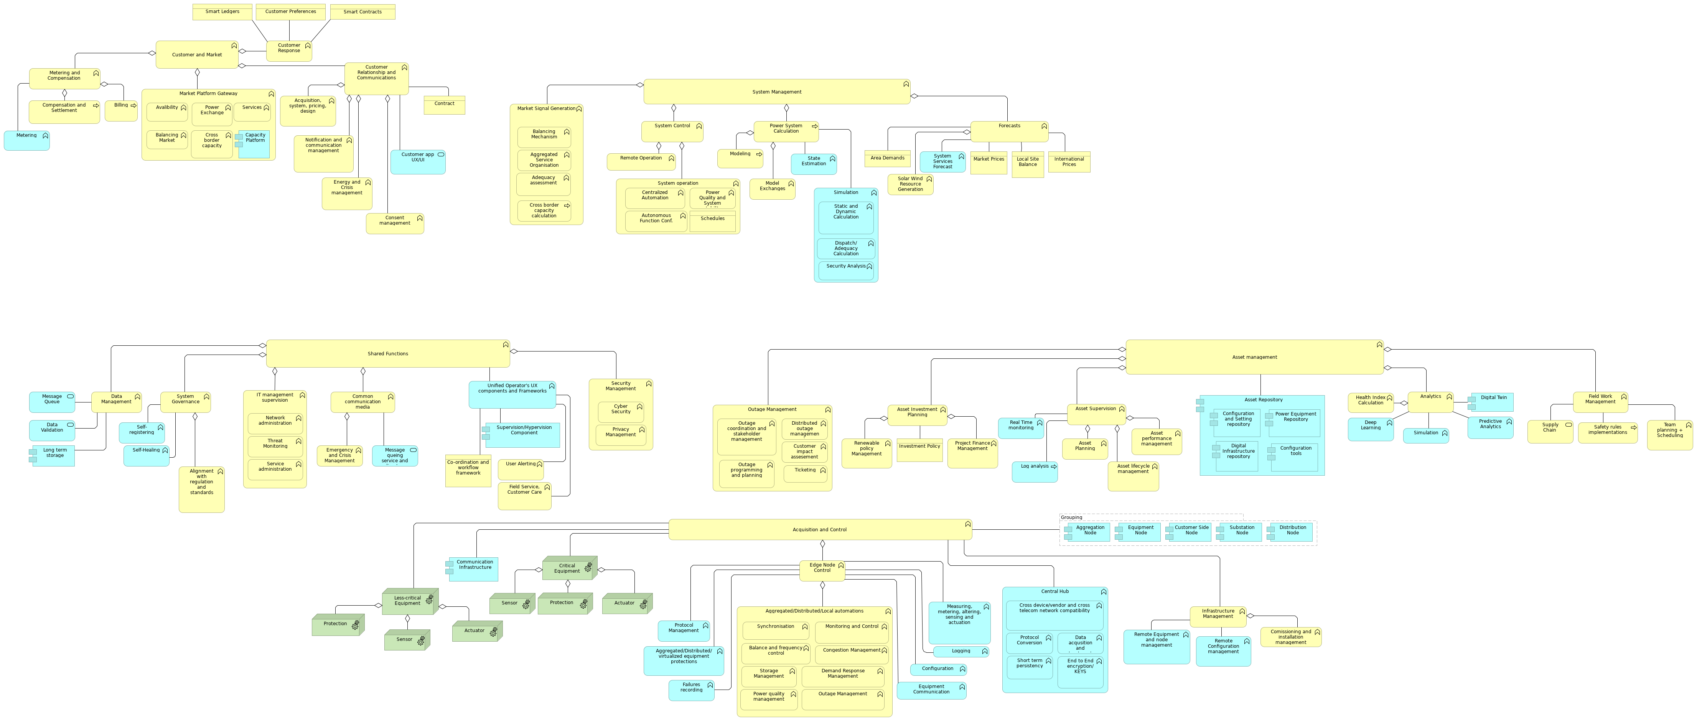
 | Documentation
 | This viewpoint is a draft version and work in progress. It is based on LF Energy Functional Architecture v1.0 - CC 4.0 (can be found LFE GitHub repository).
 | Elements
 | Element | Type
 | Acquisition and Control | Business Function
 | Acquisition, system, pricing, design | Business Function
 | Actuator | Equipment
 | Actuator | Equipment
 | Adequacy assessment | Business Function
 | Aggregated Service Organisation | Business Function
 | Aggregated/Distributed/Local automations | Business Function
 | Aggregated/Distributed/virtualized equipment protections | Application Function
 | Aggregation Node | Application Component
 | Alignment with regulation and standards | Business Function
 | Analytics | Business Function
 | Area Demands | Business Object
 | Asset Investment Planning | Business Function
 | Asset lifecycle management | Business Function
 | Asset management | Business Function
 | Asset performance management | Business Function
 | Asset Planning | Business Function
 | Asset Repository | Application Component
 | Asset Supervision | Business Function
 | Autonomous Function Conf. | Business Function
 | LFEnergyFunctionalArchitectureModel |  | 28 | / 214
 | Element | Type
 | Avalibility | Business Function
 | Balance and frequency control | Business Function
 | Balancing Market | Business Function
 | Balancing Mechanism | Business Function
 | Billing | Business Process
 | Capacity Platform | Application Component
 | Central Hub | Application Function
 | Centralized Automation | Business Function
 | Co-ordination and workflow framework | Business Object
 | Comissioning and installation management | Business Function
 | Common communication media | Business Function
 | Communication Infrastructure | Application Component
 | Compensation and Settlement | Business Process
 | Configuration | Application Function
 | Configuration and Setting repository | Application Component
 | Configuration tools | Application Component
 | Congestion Management | Business Function
 | Consent management | Business Function
 | Contract | Business Object
 | Critical Equipment | Equipment
 | Cross border capacity | Business Function
 | Cross border capacity calculation | Business Process
 | Cross device/vendor and cross telecom network compatibility | Application Function
 | Customer and Market | Business Function
 | Customer app UX/UI | Application Service
 | Customer impact assesement | Business Function
 | Customer Preferences | Business Object
 | Customer Relationship and Communications | Business Function
 | Customer Response | Business Function
 | Customer Side Node | Application Component
 | Cyber Security | Business Function
 | Data acqusition and treatment | Application Function
 | Data Management | Business Function
 | Data Validation | Application Service
 | Deep Learning | Application Function
 | Demand Response Management | Business Function
 | Digital Infrastructure repository | Application Component
 | Digital Twin | Application Component
 | Dispatch/Adequacy Calculation | Application Function
 | Distributed outage management | Business Function
 | Distribution Node | Application Component
 | Edge Node Control | Business Function
 | Emergency and Crisis Management | Business Function
 | End to End encryption/KEYS | Application Function
 | LFEnergyFunctionalArchitectureModel |  | 29 | / 214
 | Element | Type
 | Energy and Crisis management | Business Function
 | Equipment Communication | Application Function
 | Equipment Node | Application Component
 | Failures recording | Application Function
 | Field Service, Customer Care | Business Function
 | Field Work Management | Business Function
 | Forecasts | Business Function
 | Grouping | Grouping
 | Health Index Calculation | Business Function
 | Infrastructure Management | Business Function
 | International Prices | Business Object
 | Investment Policy | Business Object
 | IT management supervision | Business Function
 | Less-critical Equipment | Equipment
 | Local Site Balance | Business Object
 | Log analysis | Application Process
 | Logging | Application Function
 | Long term storage | Application Component
 | Market Platform Gateway | Business Function
 | Market Prices | Business Object
 | Market Signal Generation | Business Function
 | Measuring, metering, altering, sensing and actuation | Application Function
 | Message queing service and directory | Application Service
 | Message Queue | Application Service
 | Metering | Application Function
 | Metering and Compensation | Business Function
 | Model Exchanges | Business Function
 | Modeling | Business Process
 | Monitoring and Control | Business Function
 | Network administration | Business Function
 | Notification and communication management | Business Function
 | Outage coordination and stakeholder management | Business Function
 | Outage Management | Business Function
 | Outage Management | Business Function
 | Outage programming and planning | Business Function
 | Power Equipment Repository | Application Component
 | Power Exchange | Business Function
 | Power Quality and System stability | Business Function
 | Power quality management | Business Function
 | Power System Calculation | Business Process
 | Predictive Analytics | Application Function
 | Privacy Management | Business Function
 | Project Finance Management | Business Function
 | LFEnergyFunctionalArchitectureModel |  | 30 | / 214
 | Element | Type
 | Protection | Equipment
 | Protection | Equipment
 | Protocol Conversion | Application Function
 | Protocol Management | Application Function
 | Real Time monitoring | Application Function
 | Remote Configuration management | Application Function
 | Remote Equipment and node management | Application Function
 | Remote Operation | Business Function
 | Renewable policy Management | Business Function
 | Safety rules implementations | Business Process
 | Schedules | Business Object
 | Security Analysis | Application Function
 | Security Management | Business Function
 | Self-Healing | Application Function
 | Self-registering | Application Function
 | Sensor | Equipment
 | Sensor | Equipment
 | Service administration | Business Function
 | Services | Business Function
 | Shared Functions | Business Function
 | Short term persistency | Application Function
 | Simulation | Application Function
 | Simulation | Application Function
 | Smart Contracts | Business Object
 | Smart Ledgers | Business Object
 | Solar Wind Resource Generation | Business Function
 | State Estimation | Application Function
 | Static and Dynamic Calculation | Application Function
 | Storage Management | Business Function
 | Substation Node | Application Component
 | Supervision/Hypervision Component | Application Component
 | Supply Chain | Business Service
 | Synchronisation | Business Function
 | System Control | Business Function
 | System Governance | Business Function
 | System Management | Business Function
 | System operation | Business Function
 | System Services Forecast | Application Function
 | Team planning + Scheduling | Business Function
 | Threat Monitoring | Business Function
 | Ticketing | Business Function
 | Unified Operator's UX components and Frameworks | Application Function
 | User Alerting | Business Function
 | LFEnergyFunctionalArchitectureModel |  | 31 | / 214
 | LFEnergyFunctionalArchitectureModel | 32 | / 214
 | Metamodel
 | No viewpoint
 | 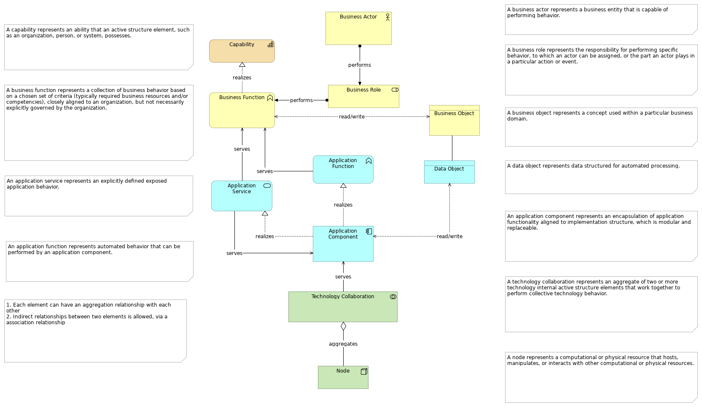
 | Documentation
 | In order to maintain consitency in the model whilst facilitating collaboration and contributions from all parties, a set of modelling guidelines have been created. If you wish to contribute to the model, please follow the LF Energy Meta model.
 | Elements
 | Element | Type
 | Application Component | Application Component
 | Application Function | Application Function
 | Application Service | Application Service
 | Business Actor | Business Actor
 | Business Function | Business Function
 | Business Object | Business Object
 | Business Role | Business Role
 | Capability | Capability
 | Data Object | Data Object
 | Node | Node
 | Technology Collaboration | Technology Collaboration
 | LFEnergyFunctionalArchitectureModel |  | 33 | / 214
 | OpenSTEF Realization
 | No viewpoint
 | 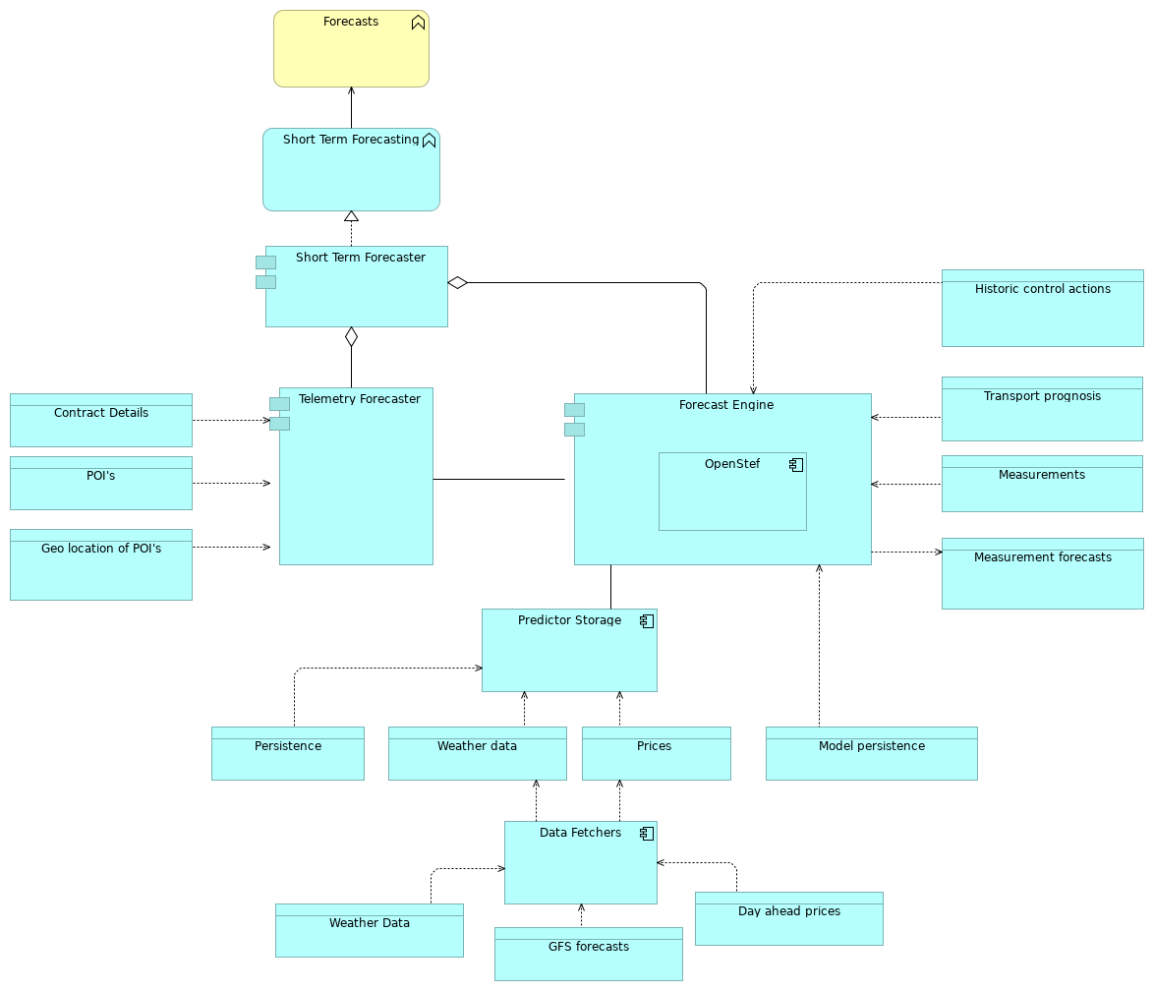
 | Elements
 | Element | Type
 | Contract Details | Data Object
 | Data Fetchers | Application Component
 | Day ahead prices | Data Object
 | Forecast Engine | Application Component
 | Forecasts | Business Function
 | Geo location of POI's | Data Object
 | GFS forecasts | Data Object
 | Historic control actions | Data Object
 | Measurement forecasts | Data Object
 | Measurements | Data Object
 | Model persistence | Data Object
 | OpenStef | Application Component
 | LFEnergyFunctionalArchitectureModel |  | 34 | / 214
 | Element | Type
 | Persistence | Data Object
 | POI's | Data Object
 | Predictor Storage | Application Component
 | Prices | Data Object
 | Short Term Forecaster | Application Component
 | Short Term Forecasting | Application Function
 | Telemetry Forecaster | Application Component
 | Transport prognosis | Data Object
 | Weather data | Data Object
 | Weather Data | Data Object
 | LFEnergyFunctionalArchitectureModel |  | 35 | / 214
 | OperatorFabric Realization
 | No viewpoint
 | 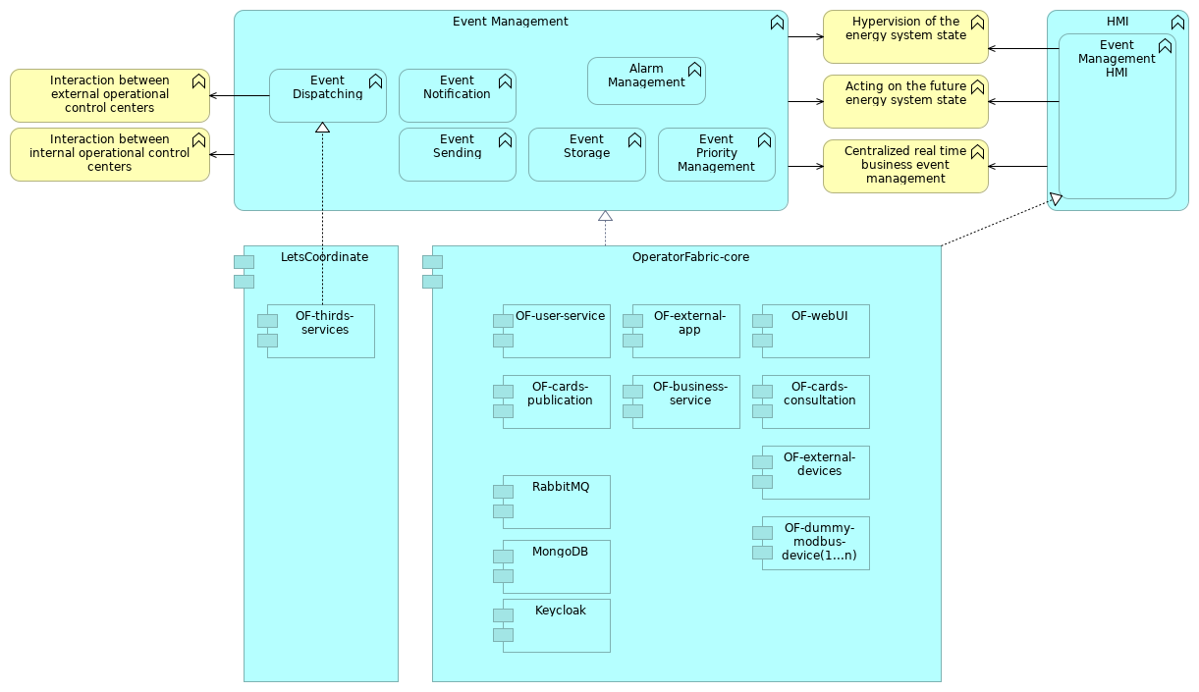
 | Documentation
 | This is the project achitecture view of the OperatorFabric project. OperatorFabric provides a dashboard for the system operator that is designed to aggregate notifications on expectations and alerts from all applications into a single screen and allow the system operator to act on them. The notifications are materialized by cards sorted in a feed according to their period of relevance and their severity. For more information on OperatorFabric, check out the project's page: https://lfenergy.org/projects/operatorfabric/
 | Elements
 | Element | Type
 | Acting on the future energy system state | Business Function
 | Alarm Management | Application Function
 | Centralized real time business event management | Business Function
 | Event Dispatching | Application Function
 | Event Management | Application Function
 | Event Management HMI | Application Function
 | Event Notification | Application Function
 | Event Priority Management | Application Function
 | Event Sending | Application Function
 | Event Storage | Application Function
 | HMI | Application Function
 | Hypervision of the energy system state | Business Function
 | LFEnergyFunctionalArchitectureModel |  | 36 | / 214
 | Element | Type
 | Interaction between external operational control centers | Business Function
 | Interaction between internal operational control centers | Business Function
 | Keycloak | Application Component
 | LetsCoordinate | Application Component
 | MongoDB | Application Component
 | OF-business-service | Application Component
 | OF-cards-consultation | Application Component
 | OF-cards-publication | Application Component
 | OF-dummy-modbus-device(1...n) | Application Component
 | OF-external-app | Application Component
 | OF-external-devices | Application Component
 | OF-thirds-services | Application Component
 | OF-user-service | Application Component
 | OF-webUI | Application Component
 | OperatorFabric-core | Application Component
 | RabbitMQ | Application Component
 | LFEnergyFunctionalArchitectureModel |  | 37 | / 214
 | Power Grid Model Realisation
 | No viewpoint
 | 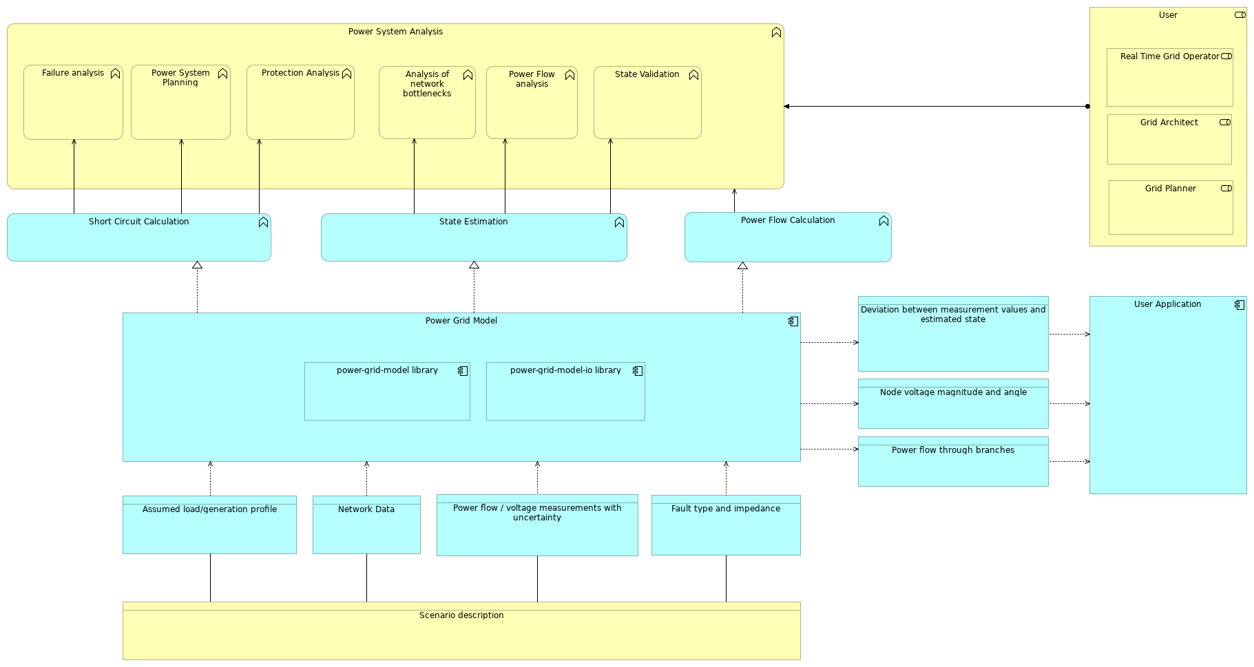
 | Elements
 | Element | Type
 | Analysis of network bottlenecks | Business Function
 | Assumed load/generation profile | Data Object
 | Deviation between measurement values and estimated state | Data Object
 | Failure analysis | Business Function
 | Fault type and impedance | Data Object
 | Grid Architect | Business Role
 | Grid Planner | Business Role
 | Network Data | Data Object
 | Node voltage magnitude and angle | Data Object
 | Power flow / voltage measurements with uncertainty | Data Object
 | Power Flow analysis | Business Function
 | Power Flow Calculation | Application Function
 | Power flow through branches | Data Object
 | Power Grid Model | Application Component
 | Power System Analysis | Business Function
 | Power System Planning | Business Function
 | power-grid-model library | Application Component
 | power-grid-model-io library | Application Component
 | Protection Analysis | Business Function
 | Real Time Grid Operator | Business Role
 | Scenario description | Business Object
 | LFEnergyFunctionalArchitectureModel |  | 38 | / 214
 | Element | Type
 | Short Circuit Calculation | Application Function
 | State Estimation | Application Function
 | State Validation | Business Function
 | User | Business Role
 | User Application | Application Component
 | LFEnergyFunctionalArchitectureModel |  | 39 | / 214
 | Power System State Aggregation
 | No viewpoint
 | 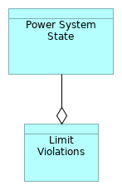
 | Elements
 | Element |  | Type
 | Limit Violations |  | Data Object
 | Power System State |  | Data Object
 | LFEnergyFunctionalArchitectureModel |  |  | 40 | / 214
 | Power System State Hierarchy
 | No viewpoint
 | 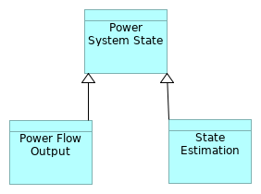
 | Elements
 | Element | Type
 | Power Flow Output | Data Object
 | Power System State | Data Object
 | State Estimation | Data Object
 | LFEnergyFunctionalArchitectureModel |  |  | 41 | / 214
 | PowSyBI - OpenLoadFlow Detailed
 | No viewpoint
 | 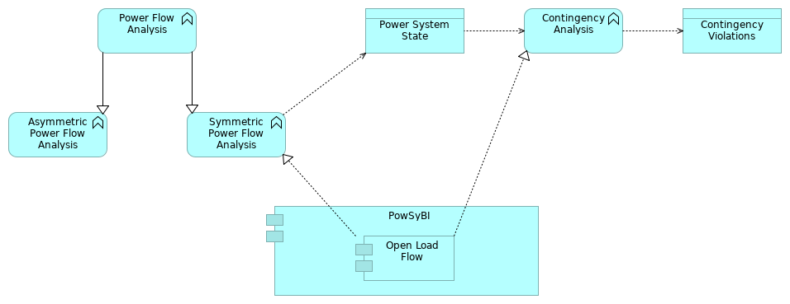
 | Elements
 | Element | Type
 | Asymmetric Power Flow Analysis | Application Function
 | Contingency Analysis | Application Function
 | Contingency Violations | Data Object
 | Open Load Flow | Application Component
 | Power Flow Analysis | Application Function
 | Power System State | Data Object
 | PowSyBI | Application Component
 | Symmetric Power Flow Analysis | Application Function
 | LFEnergyFunctionalArchitectureModel |  | 42 | / 214
 | PowSyBI - OpenLoadFlow Realization
 | No viewpoint
 | 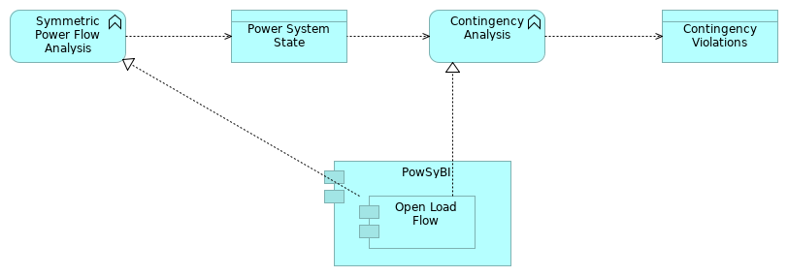
 | Elements
 | Element | Type
 | Contingency Analysis | Application Function
 | Contingency Violations | Data Object
 | Open Load Flow | Application Component
 | Power System State | Data Object
 | PowSyBI | Application Component
 | Symmetric Power Flow Analysis | Application Function
 | LFEnergyFunctionalArchitectureModel |  | 43 | / 214
 | PowSyBI Detailed
 | No viewpoint
 | 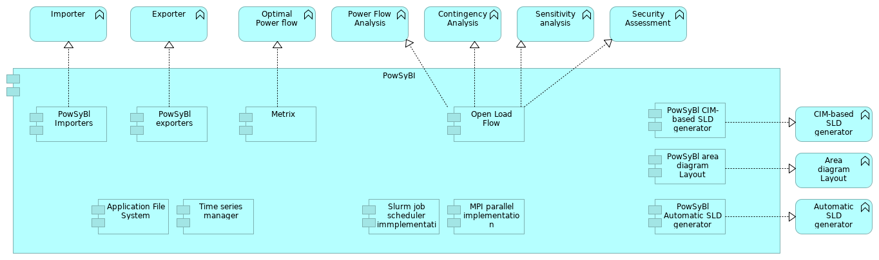
 | Documentation
 | This is the detailed project achitecture view of the PowSyBl project. PowSyBl is an open source library dedicated to electrical grid modeling and simulation. For more information on PowSyBl, check out the project's page: https://lfenergy.org/projects/powsybl/
 | Elements
 | Element | Type
 | Application File System | Application Component
 | Area diagram Layout | Application Function
 | Automatic SLD generator | Application Function
 | CIM-based SLD generator | Application Function
 | Contingency Analysis | Application Function
 | Exporter | Application Function
 | Importer | Application Function
 | Metrix | Application Component
 | MPI parallel implementation | Application Component
 | Open Load Flow | Application Component
 | Optimal Power flow | Application Function
 | Power Flow Analysis | Application Function
 | PowSyBI | Application Component
 | PowSyBl area diagram Layout | Application Component
 | PowSyBl Automatic SLD generator | Application Component
 | PowSyBl CIM-based SLD generator | Application Component
 | PowSyBl exporters | Application Component
 | PowSyBl Importers | Application Component
 | Security Assessment | Application Function
 | Sensitivity analysis | Application Function
 | Slurm job scheduler immplementation | Application Component
 | Time series manager | Application Component
 | LFEnergyFunctionalArchitectureModel |  | 44 | / 214
 | LFEnergyFunctionalArchitectureModel | 45 | / 214
 | PowSyBl Realization
 | No viewpoint
 | 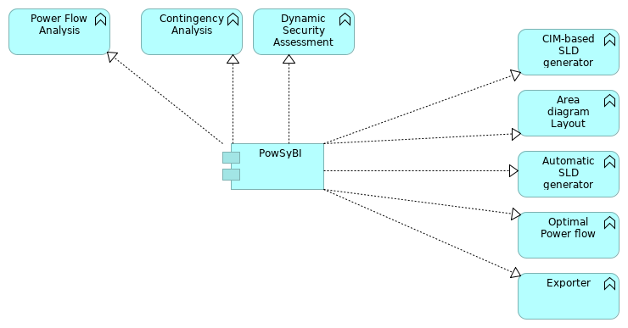
 | Documentation
 | This is the project achitecture view of the PowSyBl project. PowSyBl is an open source library dedicated to electrical grid modeling and simulation. For more information on PowSyBl, check out the project's page: https://lfenergy.org/projects/powsybl/
 | Elements
 | Element | Type
 | Area diagram Layout | Application Function
 | Automatic SLD generator | Application Function
 | CIM-based SLD generator | Application Function
 | Contingency Analysis | Application Function
 | Dynamic Security Assessment | Application Function
 | Exporter | Application Function
 | Optimal Power flow | Application Function
 | Power Flow Analysis | Application Function
 | PowSyBI | Application Component
 | LFEnergyFunctionalArchitectureModel |  | 46 | / 214
 | RTDIP Realization
 | No viewpoint
 | 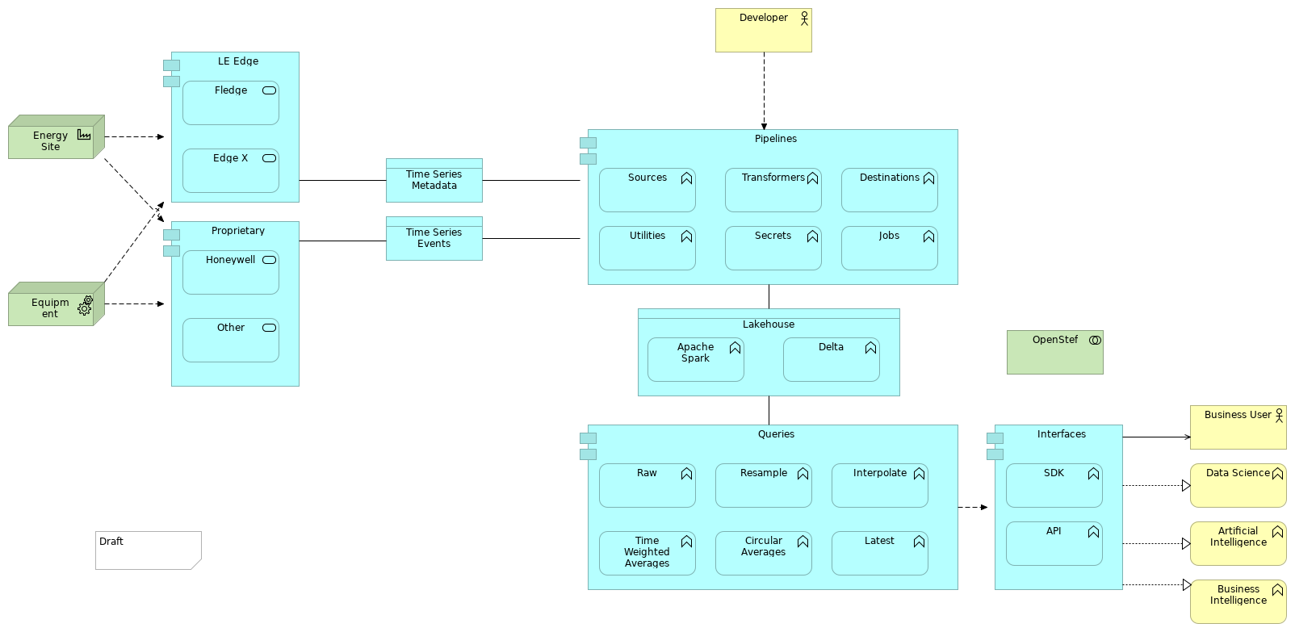
 | Elements
 | Element | Type
 | Apache Spark | Application Function
 | API | Application Function
 | Artificial Intelligence | Business Function
 | Business Intelligence | Business Function
 | Business User | Business Actor
 | Circular Averages | Application Function
 | Data Science | Business Function
 | Delta | Application Function
 | Destinations | Application Function
 | Developer | Business Actor
 | Edge X | Application Service
 | Energy Site | Facility
 | Equipment | Equipment
 | Fledge | Application Service
 | Honeywell | Application Service
 | Interfaces | Application Component
 | Interpolate | Application Function
 | Jobs | Application Function
 | Lakehouse | Data Object
 | Latest | Application Function
 | LE Edge | Application Component
 | OpenStef | Technology Collaboration
 | Other | Application Service
 | Pipelines | Application Component
 | LFEnergyFunctionalArchitectureModel |  | 47 | / 214
 | Element | Type
 | Proprietary | Application Component
 | Queries | Application Component
 | Raw | Application Function
 | Resample | Application Function
 | SDK | Application Function
 | Secrets | Application Function
 | Sources | Application Function
 | Time Series Events | Data Object
 | Time Series Metadata | Data Object
 | Time Weighted Averages | Application Function
 | Transformers | Application Function
 | Utilities | Application Function
 | LFEnergyFunctionalArchitectureModel |  | 48 | / 214
 | Scheduled Outages
 | No viewpoint
 | 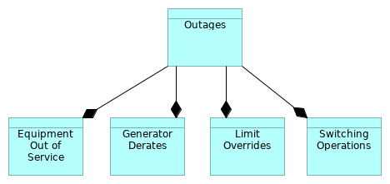
 | Elements
 | Element | Type
 | Equipment Out of Service | Data Object
 | Generator Derates | Data Object
 | Limit Overrides | Data Object
 | Outages | Data Object
 | Switching Operations | Data Object
 | LFEnergyFunctionalArchitectureModel |  | 49 |  | / 214
 | Short Term Load Forecasting
 | No viewpoint
 | 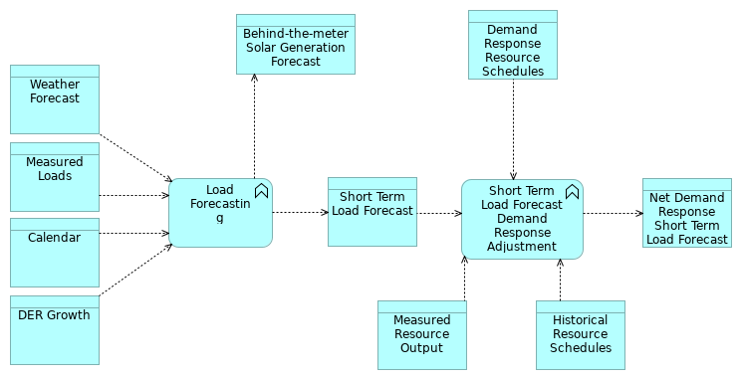
 | Elements
 | Element | Type
 | Behind-the-meter Solar Generation Forecast | Data Object
 | Calendar | Data Object
 | Demand Response Resource Schedules | Data Object
 | DER Growth | Data Object
 | Historical Resource Schedules | Data Object
 | Load Forecasting | Application Function
 | Measured Loads | Data Object
 | Measured Resource Output | Data Object
 | Net Demand Response Short Term Load Forecast | Data Object
 | Short Term Load Forecast | Data Object
 | Short Term Load Forecast Demand Response Adjustment | Application Function
 | Weather Forecast | Data Object
 | LFEnergyFunctionalArchitectureModel |  | 50 | / 214
 | Short Term Variable Generation Forecasting
 | No viewpoint
 | 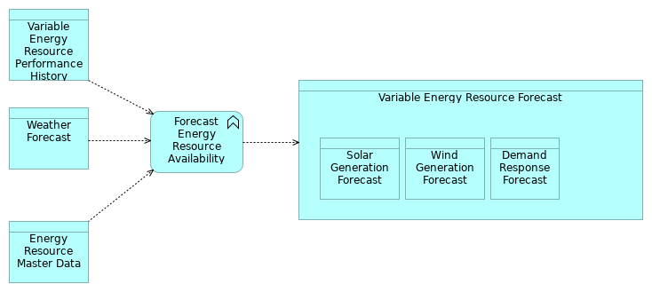
 | Elements
 | Element | Type
 | Demand Response Forecast | Data Object
 | Energy Resource Master Data | Data Object
 | Forecast Energy Resource Availability | Application Function
 | Solar Generation Forecast | Data Object
 | Variable Energy Resource Forecast | Data Object
 | Variable Energy Resource Performance History | Data Object
 | Weather Forecast | Data Object
 | Wind Generation Forecast | Data Object
 | LFEnergyFunctionalArchitectureModel |  | 51 | / 214
 | SOGNO Forecasting Detailed
 | No viewpoint
 | 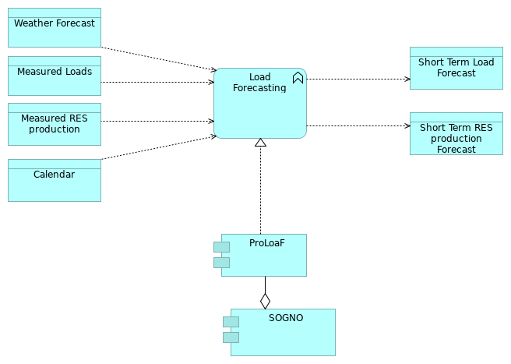
 | Elements
 | Element | Type
 | Calendar | Data Object
 | Load Forecasting | Application Function
 | Measured Loads | Data Object
 | Measured RES production | Data Object
 | ProLoaF | Application Component
 | Short Term Load Forecast | Data Object
 | Short Term RES production Forecast | Data Object
 | SOGNO | Application Component
 | Weather Forecast | Data Object
 | LFEnergyFunctionalArchitectureModel |  | 52 | / 214
 | SOGNO Realization
 | No viewpoint
 | 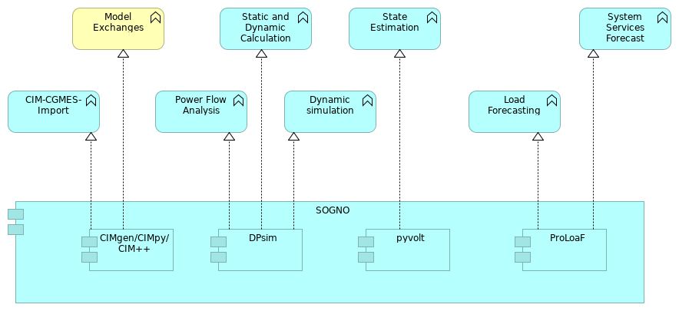
 | Elements
 | Element | Type
 | CIM-CGMES-Import | Application Function
 | CIMgen/CIMpy/CIM++ | Application Component
 | DPsim | Application Component
 | Dynamic simulation | Application Function
 | Load Forecasting | Application Function
 | Model Exchanges | Business Function
 | Power Flow Analysis | Application Function
 | ProLoaF | Application Component
 | pyvolt | Application Component
 | SOGNO | Application Component
 | State Estimation | Application Function
 | Static and Dynamic Calculation | Application Function
 | System Services Forecast | Application Function
 | LFEnergyFunctionalArchitectureModel |  | 53 | / 214
 | SOGNO Simulation Detailed
 | No viewpoint
 | 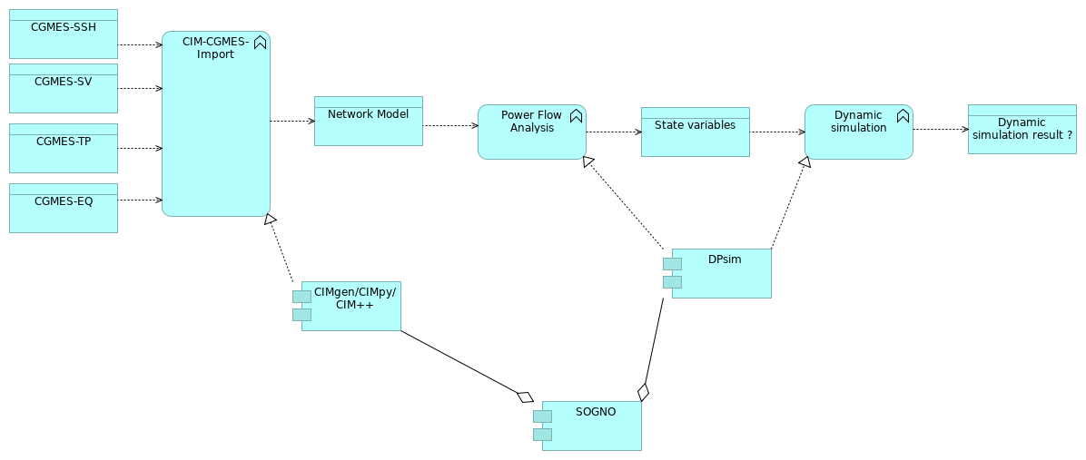
 | Elements
 | Element | Type
 | CGMES-EQ | Data Object
 | CGMES-SSH | Data Object
 | CGMES-SV | Data Object
 | CGMES-TP | Data Object
 | CIM-CGMES-Import | Application Function
 | CIMgen/CIMpy/CIM++ | Application Component
 | DPsim | Application Component
 | Dynamic simulation | Application Function
 | Dynamic simulation result ? | Data Object
 | Network Model | Data Object
 | Power Flow Analysis | Application Function
 | SOGNO | Application Component
 | State variables | Data Object
 | LFEnergyFunctionalArchitectureModel |  | 54 | / 214
 | SOGNO State Estimation Detailed
 | No viewpoint
 | 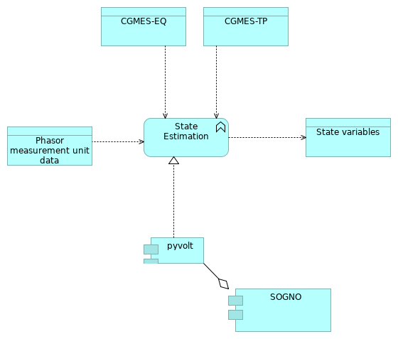
 | Elements
 | Element | Type
 | CGMES-EQ | Data Object
 | CGMES-TP | Data Object
 | Phasor measurement unit data | Data Object
 | pyvolt | Application Component
 | SOGNO | Application Component
 | State Estimation | Application Function
 | State variables | Data Object
 | LFEnergyFunctionalArchitectureModel |  | 55 | / 214
 | Weather Forecasting
 | No viewpoint
 | 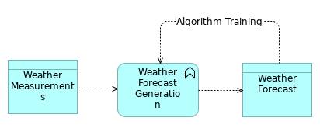
 | Elements
 | Element | Type
 | Weather Forecast | Data Object
 | Weather Forecast Generation | Application Function
 | Weather Measurements | Data Object
 | LFEnergyFunctionalArchitectureModel |  | 56 |  | / 214
 | Strategy Layer
 | Capability
 | Type |  | Capability
 |  | A capability represents an ability that an active structure element, such as an organization, person, or system, possesses. In the field of business, strategic thinking and planning delivers strategies and high-level goals that are often not directly implementable in the architecture of an organization. These long-term or generic plans need to be specified and made actionable in a way that both business leaders and Enterprise Architects can relate to, and at a relatively high abstraction level. Capabilities help to reduce this gap by focusing on business outcomes. On the one hand, they provide a high-level view of the current and desired abilities of an organization, in relation to its strategy and its environment. On the other hand, they are realized by various elements (people, processes, systems, and so on) that can be described, designed, and implemented using Enterprise Architecture approaches. Capabilities may also have serving relationships; for example, to denote that one capability contributes to another. Capabilities are expressed in general and high-level terms and are typically realized by a combination of organization, people, processes, information, and technology. For example, marketing, customer contact, or outbound telemarketing
 | LFEnergyFunctionalArchitectureModel |  |  | 57 | / 214
 | Business Layer
 | Acquisition and Control
 | Type |  | Business Function
 |  | Covering the digitial capabilities to monitor and control our assets.
 | Acquisition, system, pricing, design
 | Type |  | Business Function
 |  | Functions required to acquire the right assets with the right capabilities both in long term and dynamically in short term for services
 | Acting on the future energy system state
 | Type |  | Business Function
 | Adequacy assessment
 | Type |  | Business Function
 |  | Estimating the adequacy of the generation to meet the demand (possibly taking into account the limits of the grid).
 | Aggregated Service Organisation
 | Type |  | Business Function
 |  | Hierarchically organizing an optimal distribution of individual customer contributions to provide an aggregated service (power, frequency, voltage, power quality services ...) to the system. (consider maybe rename the item)
 | Aggregated/Distributed/Local automations
 | Type |  | Business Function
 |  | Covering the automations functionalities that are shared amongst all nodes .
 | Alignment with regulation and standards
 | Type |  | Business Function
 |  | To allow a system to configure workflow and processes in compliance with national regulatory frameworks. Should be also configurable to merging of regulatory frameworks. eg. european regulatory framework
 | Analysis of network bottlenecks
 | Type |  | Business Function
 | Analytics
 | Type |  | Business Function
 |  | Covering the digital functionalities used to determine causes, draw conclusions and give advice (e.g. predicting fault locations).
 | LFEnergyFunctionalArchitectureModel |  |  | 58 | / 214
 | Anomaly detection system / substation configurations
 | Type |  | Business Function
 | Area Demands
 | Type |  | Business Object
 |  | Forecast of the power demand at an area level
 | Artificial Intelligence
 | Type |  | Business Function
 | Asset Investment Planning
 | Type |  | Business Function
 |  | Covering the planning of the asset investments on strategic, tactical and operation level.
 | Asset lifecycle management
 | Type |  | Business Function
 |  | To monitor the status and programme scheduled maintenance and replacement on deployed assets.
 | Asset management
 | Type |  | Business Function
 |  | Covering the digital functionalities required to manage your assets.
 | Asset performance management
 | Type |  | Business Function
 |  | Capabilities of data capture, integration, visualization and analytics tied together for the explicit purpose of improving the reliability and availability of physical assets, including the concepts of condition monitoring, predictive forecasting and reliability-centered maintenance ( RCM ).
 | Asset Planning
 | Type |  | Business Function
 |  | To support the process of developing, operating, maintaining, upgrading, and disposing of assets in the most cost-effective manner (including all costs, risks and performance attributes).
 | Asset Supervision
 | Type |  | Business Function
 |  | Covering the digital functionalities used to determine asset status and replacement plans (e.g. using condition monitoring for predictive maintenance plans).
 | LFEnergyFunctionalArchitectureModel |  |  | 59 | / 214
 | Autonomous Function Conf.
 | Type |  | Business Function
 |  | Remote operational functional configuration of decentralized automations (potentially via aggregation of customer side assets)
 | Avalibility
 | Type |  | Business Function
 |  | Availablility Platform calculates the proportion, expressed as a percentage, of the total Available Time during which assets or services are available.
 | Balance and frequency control
 | Type |  | Business Function
 |  | To maintain frequency stability, balances the power generation and load consumption in the grid
 | Balance Responsible Party
 | Type |  | Business Role
 |  | A party that has a contract proving financial security and identifying balance responsibility with the Imbalance Settlement Responsible of the Market Balance Area entitling the party to operate in the market. This is the only role allowing a party to nominate energy on a wholesale level. The meaning of the word “balance” in this context signifies that the quantity contracted to provide or to consume must be equal to the quantity really provided or consumed.
 | Balance Supplier
 | Type |  | Business Actor
 |  | A party that markets the difference between actual metered energy consumption and the energy bought with firm energy contracts by the Party Connected to the Grid. In addition, the Balance Supplier markets any difference with the firm energy contract (of the Party Connected to the Grid) and the metered production. There is only one Balance Supplier for each Accounting Point.
 | Balancing Market
 | Type |  | Business Function
 |  | Trading Platform to insure system balance and frequency, as production and consumption levels must match during the operation of electric power systems.
 | Balancing Mechanism
 | Type |  | Business Function
 |  | Managing the real time strategy to balance the system and cope with contingency: identification the appropriate services (demand side response / generation / aggregator / storage ...) to trigger to sustain the system for the next few hours.
 | LFEnergyFunctionalArchitectureModel |  |  | 60 | / 214
 | Billing
 | Type |  | Business Process
 |  | Billing is supported by a combination of software and hardware components that receive consumption details and service usage information, groups this information for specific accounts or customers, produces invoices, creates reports for management / investors, and records (posts) payments made to customer accounts. Includes Auditing / Verfication Activities
 | Business Actor
 | Type |  | Business Actor
 |  | A business actor represents a business entity that is capable of performing behavior. A business actor is a business entity as opposed to a technical entity; i.e., it belongs to the Business Layer. Actors may, however, include entities outside the actual organization; e.g., customers and partners. A business actor may be assigned to one or more business roles. It can then perform the behavior to which these business roles are assigned. A business actor can be aggregated in a location. The name of a business actor should preferably be a noun.
 | Business Function
 | Type |  | Business Function
 | Business Function
 | Type |  | Business Function
 |  | Business Function A business function represents a collection of business behavior based on a chosen set of criteria (typically required business resources and/or competencies), closely aligned to an organization, but not necessarily explicitly governed by the organization. Just like a business process, a business function also describes internal behavior performed by a business role. However, while a business process groups behavior based on a sequence or flow of activities that is needed to realize a product or service, a business function typically groups behavior based on required business resources, skills, competencies, knowledge, etc. There is a potential many-to-many relation between business processes and business functions. Complex processes in general involve activities that offer various functions. In this sense, a business process forms a string of business functions. In general, a business function delivers added value from a business point of view. Organizational units or applications may coincide with business functions due to their specific grouping of business activities. A business function may be triggered by, or trigger, any other business behavior element (business event, business process, business function, or business interaction). A business function may access business objects. A business function may realize one or more business services and may be served by business, application, or technology services. A business role may be assigned to a business function. The name of a business function should clearly indicate a well-defined behavior. Examples are customer management, claims administration, member services, recycling, or payment processing
 | Business Intelligence
 | Type |  | Business Function
 | LFEnergyFunctionalArchitectureModel |  |  | 61 | / 214
 | Business Interaction
 | Type |  | Business Interaction
 | Business Object
 | Type |  | Business Object
 | Business Object
 | Type |  | Business Object
 | Business Object
 | Type |  | Business Object
 | Business Object
 | Type |  | Business Object
 |  | Business Object A business object represents a concept used within a particular business domain. The ArchiMate language in general focuses on the modeling of types, not instances, since this is the most relevant at the Enterprise Architecture level of description. Hence a business object typically models an object type (cf. a UML class) of which multiple instances may exist in operations. Only occasionally, business objects represent actual instances of information produced and consumed by behavior elements such as business processes. This is in particular the case for singleton types; i.e., types that have only one instance. A wide variety of types of business objects can be defined. Business objects are passive in the sense that they do not trigger or perform processes. A business object could be used to represent information assets that are relevant from a business point of view and can be realized by data objects. Business objects may be accessed (e.g., in the case of information objects, they may be created, read, or written) by a business process, function, business interaction, business event, or business service. A business object may have association, specialization, aggregation, or composition relationships with other business objects. A business object may be realized by a representation or by a data object (or both). The name of a business object should preferably be a noun.
 | Business Role
 | Type |  | Business Role
 |  | A business role represents the responsibility for performing specific behavior, to which an actor can be assigned, or the part an actor plays in a particular action or event. Business roles with certain responsibilities or skills are assigned to business processes or business functions. A business actor that is assigned to a business role is responsible for ensuring that the corresponding behavior is carried out, either by performing it or by delegating and managing its performance. In addition to the relation of a business role with behavior, a business role is also useful in a (structural) organizational sense; for instance, in the division of labor within an organization. A business role may be assigned to one or more business processes or business functions, while a business actor may be assigned to one or more business roles. A business interface or an application interface may serve a business role,
 | LFEnergyFunctionalArchitectureModel |  |  | 62 | / 214
 |  | while a business interface may be part of a business role. The name of a business role should preferably be a noun.
 | Business User
 | Type |  | Business Actor
 | Capacity Co-ordinator
 | Type |  | Business Role
 |  | A party, acting on behalf of the System Operators involved, responsible for establishing a coordinated Offered Capacity and/or NTC and/or ATC between several Market Balance Areas.
 | Capacity Trader
 | Type |  | Business Actor
 |  | A party that has a contract to participate in the Capacity Market to acquire capacity through a Transmission Capacity Allocator. The capacity may be acquired on behalf of an Interconnection Trade Responsible or for sale on secondary capacity markets.
 | Centralized Automation
 | Type |  | Business Function
 |  | Based on a real time assessment of the power system state, providing real time technical signals (toward internal or external recipient) to sustain the system within its normal operational conditions (e.g. frequency or voltage secondary or tertiary control automation).
 | Centralized real time business event management
 | Type |  | Business Function
 | Co-ordination and workflow framework
 | Type |  | Business Object
 |  | To allowe the creation, monitoring and steering of workflows providing the ability to manage people and equipment with flexible scheduling options.
 | Co-ordination center operator
 | Type |  | Business Role
 |  | Responsible for: 1. The coordination of exchange programs between its related Control Blocks and for the exchanges between its associated Coordination Center Zones. 2. Ensuring that its Control Blocks respect their obligations in respect to load frequency control. 3. Calculating the time deviation in cooperation with the associated coordination centers. 4. Carrying out the settlement and/or compensation between its Control Blocks and against the other Coordination Center Zones.
 | Comissioning and installation management
 | Type |  | Business Function
 | LFEnergyFunctionalArchitectureModel |  |  | 63 | / 214
 |  | To support the process through with a piece of equipment, facility, or plant (which is installed, or is complete or near completion) is tested to verify if it functions according to its design objectives or specifications.
 | Common communication media
 | Type |  | Business Function
 |  | Covering the digital functionalities supporting emergency and crisis management.
 | Compare Configuration
 | Type |  | Business Function
 |  | Compare configurations in order to find differences.
 | Compensation and Settlement
 | Type |  | Business Process
 |  | Compensation and Settlement represents payment or trade of value for transactions between market actors as distinct from customer billing. Includes auditing / verfication activities. Settlements are often bi-directional in nature
 | Configuration management
 | Type |  | Business Function
 |  | Container function for configuration management consist of (agrregate) 1. Make system configuration 1.1. Make substation configuration 1.2 Make IED configuration (bij. DER) 2. Edit system configuration 2.1 Idem 2.2 Idem 2.3 Grid planning import 3. Store system configuration 3.1 Idem 3.3 Version Management 4. Validate 5. Compare
 | Congestion Management
 | Type |  | Business Function
 |  | To avoid a situation where the electricity supply exceeds the grid capacity (congestion).
 | Consent management
 | Type |  | Business Function
 |  | Consent management is a system, process or set of policies for allowing consumers to determine what information they are willing to permit their various energy componanies to access.
 | Consumer
 | Type |  | Business Role
 |  | A party that consumes electricity. This is a Type of Party Connected to the Grid.
 | LFEnergyFunctionalArchitectureModel |  |  | 64 | / 214
 | Consumption Responsible Party
 | Type |  | Business Role
 | Contract
 | Type |  | Business Object
 |  | Contractual commitment enabling development / funding of the resource, will typically include perfornance requirements and reporting
 | Control Area Operator
 | Type |  | Business Role
 |  | Responsible for: 1. The coordination of exchange programs between its related Market Balance Areas and for the exchanges between its associated Control Areas. 2. The load frequency control for its own area. 3. The coordination of the correction of time deviations.
 | Control Block Operator
 | Type |  | Business Role
 |  | Responsible for: 1. The coordination of exchanges between its associated Control Blocks and the organisation of the coordination of exchange programs between its related Control Areas. 2. The load frequency control within its own block and ensuring that its Control Areas respect their obligations in respect to load frequency control and time deviation. 3. The organisation of the settlement and/or compensation between its Control Areas.
 | Control Entity
 | Type |  | Business Actor
 | Cross border capacity
 | Type |  | Business Function
 |  | Trading Platform to allocate energy throughout borders between market areas
 | Cross border capacity calculation
 | Type |  | Business Process
 |  | For a given timeframe, calculation of the limits of feasible power exchanges between market areas for a given timeframe under physical and security limitations
 | Customer and Market
 | Type |  | Business Function
 |  | Covering all the functionalitites related to the customer and interaction with markets and other thrid parties
 | Customer impact assesement
 | Type |  | Business Function
 | LFEnergyFunctionalArchitectureModel |  |  | 65 | / 214
 |  | To identify customers / stakeholders with reference to a service outage.
 | Customer Preferences
 | Type |  | Business Object
 |  | A register of customer needs, goals and economics that allows energy system to optimize delivery. Allows users to configure various ied interacting with digital energy services provided by the utility/local energy community, -> device settings: thermostat settings, storage back-up reserve, water heater settings, over-ride, EV charge schedule
 | Customer Relationship and Communications
 | Type |  | Business Function
 |  | Functions required to support customer / investor relationship management and communication.
 | Customer Response
 | Type |  | Business Function
 |  | Covering the digital functionalities supporting customers providing information.
 | Cyber Security
 | Type |  | Business Function
 | Data Management
 | Type |  | Business Function
 |  | Covering the digital functionalities supporting data retrieval and management.
 | Data Science
 | Type |  | Business Function
 | Demand Control
 | Type |  | Business Function
 | Demand Response Management
 | Type |  | Business Function
 |  | To encourage customers to make short-term reductions in energy demand in response to a price signal from the electricity hourly market, or a trigger initiated by the electricity grid operator.
 | Developer
 | Type |  | Business Actor
 | LFEnergyFunctionalArchitectureModel |  |  | 66 | / 214
 | Distributed energy resource management
 | Type |  | Business Function
 | Distributed outage management
 | Type |  | Business Function
 |  | To restore the network model after an outage.
 | Dynamic Safety Assessment
 | Type |  | Business Function
 | Edge device management
 | Type |  | Business Function
 | Edge Node Control
 | Type |  | Business Function
 |  | Covering the digital functionalities that are shared amongst all nodes .
 | Edge to (virtual) control center communication
 | Type |  | Business Function
 | Edit IED configuration
 | Type |  | Business Function
 |  | Edit device specifc configuration
 | Edit system configuration
 | Type |  | Business Function
 | Edit system configuration
 | Type |  | Business Function
 |  | Edit system wide configurations.
 | electrival vehicle (EV) interaction and monitoring
 | Type |  | Business Function
 | Emergency and Crisis Management
 | Type |  | Business Function
 |  | To support communications with stakeholders during a emergency or crisis
 | Energy and Crisis management
 | Type |  | Business Function
 | LFEnergyFunctionalArchitectureModel |  |  | 67 | / 214
 |  | Communication to customers in event of outage or other reduction in services
 | Energy Service Company
 | Type |  | Business Actor
 |  | A party offering energy-related services to the Party Connected to Grid, but not directly active in the energy value chain or the physical infrastructure itself. The ESCO may provide insight services as well as energy management services.
 | Failure analysis
 | Type |  | Business Function
 | Field Service, Customer Care
 | Type |  | Business Function
 | Field Work Management
 | Type |  | Business Function
 |  | Covering the digital functionalities used to prepare and execute work with the right resources.
 | Forecasts
 | Type |  | Business Function
 | Forecasts
 | Type |  | Business Function
 | Forecasts
 | Type |  | Business Function
 |  | Forecast are used in a variety of processes that span from multi years ahead to a few minutes ahead timeframes
 | Generating single line diagram (digram layout)
 | Type |  | Business Function
 |  | CGMES diagram layout (corelate on data object ).
 | Grid Access Provider
 | Type |  | Business Actor
 |  | A party responsible for providing access to the grid through a Metering Point for energy consumption or production to the Party Connected to the Grid. The party is also responsible for creating and terminating Metering Points.
 | Grid Architect
 | Type |  | Business Role
 | LFEnergyFunctionalArchitectureModel |  |  | 68 | / 214
 | Grid management
 | Type |  | Business Function
 | Grid Operator
 | Type |  | Business Role
 |  | A party that operates one or more grids.
 | Grid Planner
 | Type |  | Business Role
 | Grid planning import
 | Type |  | Business Function
 |  | Import exsisting grid plan as a basis for the configuration.
 | Health Index Calculation
 | Type |  | Business Function
 |  | Computing of health of asset from available data and predictions
 | Hypervision of the energy system state
 | Type |  | Business Function
 | Imbalance Settlement Responsible Party
 | Type |  | Business Role
 |  | A party that is responsible for settlement of the difference between the contracted quantities and the realised quantities of energy products for the Balance Responsible Parties in a Market Balance Area. The Imbalance Settlement Responsible has not the responsibility to invoice. The Imbalance Settlement Responsible may delegate the invoicing responsibility to a more generic role such as a Billing Agent.
 | Infrastructure Management
 | Type |  | Business Function
 |  | A central platform management equipment and nodes in the smart grid remotely.
 | inter control center (interaction and) monitoring
 | Type |  | Business Function
 | Interaction between external operational control centers
 | Type |  | Business Function
 | Interaction between internal operational control centers
 | Type |  | Business Function
 | LFEnergyFunctionalArchitectureModel |  |  | 69 | / 214
 | Interconnection Trade Responsible Party
 | Type |  | Business Role
 |  | Is a Balance Responsible Party or depends on one. He is recognised by the Nomination Validator for the nomination of already allocated capacity. This is a type of Balance Responsible Party.
 | International Prices
 | Type |  | Business Object
 |  | Forecast the exchange between market areas
 | Investment Policy
 | Type |  | Business Object
 |  | Covering the financial investment strategy
 | IT management supervision
 | Type |  | Business Function
 |  | Covering the digital functionalities supporting IT systems, infrastructure and security management.
 | Local Site Balance
 | Type |  | Business Object
 |  | Forecast the power balance aggregated at the level of a substation or a site
 | Make IED configuration
 | Type |  | Business Function
 |  | Create single device configurations.
 | Make specification
 | Type |  | Business Function
 |  | Make configuration specifications
 | Make System Configuration
 | Type |  | Business Function
 |  | Create system configurations
 | Make System Configuration
 | Type |  | Business Function
 |  | Create system wide configurations.
 | LFEnergyFunctionalArchitectureModel |  |  | 70 | / 214
 | Market Information Aggregator
 | Type |  | Business Role
 |  | A party that provides market related information that has been compiled from the figures supplied by different actors in the market. This information may also be published or distributed for general use. The Market Information Aggregator may receive information from any market participant that is relevant for publication or distribution.
 | Market Platform Gateway
 | Type |  | Business Function
 |  | Platforms allowing energy market participants to retrieve and provide market information and engagements (e.g. providing energy consumption details to energy suppliers).
 | Market Prices
 | Type |  | Business Object
 |  | Forecast the prices of energy products and multiple services
 | Market Signal Generation
 | Type |  | Business Function
 |  | Assessing the physical state of the system to provide information toward market actors to inflence their positions in response to physical needs.
 | Merit Order List Responsible Party
 | Type |  | Business Role
 |  | Responsible for the management of the available tenders for all Acquiring System Operators to establish the order of the reserve capacity that can be activated.
 | Meter Administrator
 | Type |  | Business Role
 |  | A party responsible for keeping a database of meters.
 | Meter Operator
 | Type |  | Business Role
 |  | A party responsible for installing, maintaining, testing, certifying and decommissioning physical meters.
 | Metered Data Aggregator
 | Type |  | Business Role
 |  | A party responsible for the establishment and qualification of metered data from the Metered Data Responsible. This data is aggregated according to a defined set of market rules.
 | LFEnergyFunctionalArchitectureModel |  |  | 71 | / 214
 | Metered Data Collector
 | Type |  | Business Role
 |  | A party responsible for meter reading and quality control of the reading.
 | Metered Data Responsible Party
 | Type |  | Business Role
 |  | A party responsible for the establishment and validation of metered data based on the collected data received from the Metered Data Collector. The party is responsible for the history of metered data for a Metering Point.
 | Metering and Compensation
 | Type |  | Business Function
 |  | Determination and financially handling realization of market contracts and consequences of system operation.
 | Metering Point Administrator
 | Type |  | Business Role
 |  | A party responsible for registering the parties linked to the metering points in a Metering Grid Area. The party is also responsible for registering and making available the Metering Point characteristics.
 | Model Exchanges
 | Type |  | Business Function
 |  | format change
 | Modeling
 | Type |  | Business Process
 |  | Build a model of the system for simulation, and modify it: merge of submodels, change parameters, include forecasted hypothesis
 | Monitoring and Control
 | Type |  | Business Function
 |  | To monitor and control power assets both on grid and customer controlled in the edge
 | Network administration
 | Type |  | Business Function
 |  | To help a network to run smoothly and efficiently.
 | Nomination Validator
 | Type |  | Business Role
 | LFEnergyFunctionalArchitectureModel |  |  | 72 | / 214
 |  | Has the responsibility of ensuring that all capacity nominated is within the allowed limits and confirming all valid nominations to all involved parties. He informs the Interconnection Trade Responsible of the maximum nominated capacity allowed. Depending on market rules for a given interconnection the corresponding System Operators may appoint one Nomination Validator.
 | Notification and communication management
 | Type |  | Business Function
 |  | Enables the delivery of information (regularly or in case of specific occurrencies) to consumers / partners
 | Outage coordination and stakeholder management
 | Type |  | Business Function
 |  | To provide accurate information about the extent of the outage and its impact on customers / stakeholders
 | Outage Management
 | Type |  | Business Function
 |  | Covering the digital functionalities used to prepare and execute service calls related to planned and unplanned outages.
 | Outage Management
 | Type |  | Business Function
 |  | To identify outages and provide instant alerts.
 | Outage programming and planning
 | Type |  | Business Function
 |  | To prepare processes and workflows for scheduled outages (eg., necessary for system maintenance)
 | Party Connected to grid
 | Type |  | Business Actor
 |  | A party that contracts for the right to consume or produce electricity at an Accounting Point.
 | Power Exchange
 | Type |  | Business Function
 |  | Trading Platform to ensure short-grid stabiity by injecting or absorbing power depending on observed local conditions or based on remote dispatch request
 | Power Flow analysis
 | Type |  | Business Function
 | LFEnergyFunctionalArchitectureModel |  |  | 73 | / 214
 | Power Quality and System stability
 | Type |  | Business Function
 |  | Automation of the power system to return to its normal or stable conditions after disturbances like sudden changes of load, the sudden short circuit between line and ground, line-to-line fault, all three line faults, switching, including distributed assets.
 | Power quality management
 | Type |  | Business Function
 |  | To ensure the good power quality. Good power quality can be defined as a steady supply voltage that stays within the prescribed range, steady a.c. frequency close to the rated value, and smooth voltage curve waveform (resembles a sine wave).
 | Power System Analysis
 | Type |  | Business Function
 | Power System Calculation
 | Type |  | Business Process
 |  | Simulations that are done to support decision making
 | Power System Planning
 | Type |  | Business Function
 | Privacy Management
 | Type |  | Business Function
 | Producer
 | Type |  | Business Role
 |  | A party that produces electricity. This is a type of Party Connected to the Grid.
 | Production Responsible Party
 | Type |  | Business Role
 |  | A party who can be brought to rights, legally and financially, for any imbalance between energy nominated and produced for all associated Accounting Points. This is a type of Balance Responsible Party.
 | Project Finance Management
 | Type |  | Business Function
 |  | To support the long-term financing of infrastructure and industrial projects based upon the projected cash flows of the project rather than the balance sheets of its sponsors.
 | Protection Analysis
 | Type |  | Business Function
 | LFEnergyFunctionalArchitectureModel |  |  | 74 | / 214
 | Real Time Grid Operator
 | Type |  | Business Role
 | Reconcillation Accountable
 | Type |  | Business Actor
 |  | A party that is financially accountable for the reconciled volume of energy products for a profiled Accounting Point.
 | Reconcillation Responsible Party
 | Type |  | Business Role
 |  | A party that is responsible for reconciling, within a Metering Grid Area, the volumes used in the imbalance settlement process for profiled Accounting Points and the actual metered quantities. The Reconciliation Responsible may delegate the invoicing responsibility to a more generic role such as a Billing Agent.
 | Remote Operation
 | Type |  | Business Function
 |  | Supervise a control area, and trigger remote actions (SCADA console)
 | renewable energy resources interaction and monitoring
 | Type |  | Business Function
 | Renewable policy Management
 | Type |  | Business Function
 |  | Covering the renewal strategy to assure that, after replacement, assets are able to operate with th same fetures of the ones they have replaced.
 | Reserve Allocator
 | Type |  | Business Role
 |  | Informs the market of reserve requirements, receives tenders against the requirements and in compliance with the prequalification criteria, determines what tenders meet requirements and assigns tenders.
 | Resource provider
 | Type |  | Business Role
 |  | A role that manages a resource and provides the schedules for it, if required.
 | Safety rules implementations
 | Type |  | Business Process
 |  | Training and tracking tools to insure compliance
 | LFEnergyFunctionalArchitectureModel |  |  | 75 | / 214
 | Scenario description
 | Type |  | Business Object
 | Schedules
 | Type |  | Business Object
 |  | Define frequency and parameters of pre-programmed events
 | Scheduling Co-ordinator
 | Type |  | Business Role
 |  | A party that is responsible for the schedule information and its exchange on behalf of a Balance Responsible Party. For example, in the Polish market a Scheduling Coordinator is responsible for information interchange for scheduling and settlement.
 | secure remote device communication
 | Type |  | Business Function
 | secure remote processing
 | Type |  | Business Function
 | Security Management
 | Type |  | Business Function
 | Service administration
 | Type |  | Business Function
 |  | To allow service configuration, monitoring and steering
 | Services
 | Type |  | Business Function
 |  | 3rd Party or Customer owned assets providing supporting functions to grid
 | Shared Functions
 | Type |  | Business Function
 |  | Covering the digitial functionalities that are required by each of category.
 | Smart Contracts
 | Type |  | Business Object
 |  | A smart contract is a protocol intended to digitally facilitate, verify, or enforce the negotiation or performance of credible transactions without third party intervention, in a trackable and irreversible way.
 | LFEnergyFunctionalArchitectureModel |  |  | 76 | / 214
 | Smart Device Control
 | Type |  | Business Function
 | Smart Device Monitoring
 | Type |  | Business Function
 | Smart Device Monitoring and Control
 | Type |  | Business Function
 | Smart Ledgers
 | Type |  | Business Object
 |  | A distributed ledger (also called a shared ledger or distributed ledger technology or DLT) is a consensus of replicated, shared, and synchronized digital data geographically spread across multiple sites, countries, or institutions, without a central administrator or centralized data storage
 | Solar Wind Resource Generation
 | Type |  | Business Function
 |  | Forecast solar and wind generation (non-controlable generation)
 | State Validation
 | Type |  | Business Function
 | Storage Management
 | Type |  | Business Function
 |  | To trigger energy storage devices to act as spinning reserves for providing short-term power supply or demand to manage instant variability in DG-generated power
 | Store IED Configuration
 | Type |  | Business Function
 |  | Store IED specific configurations.
 | Store system configuration
 | Type |  | Business Function
 |  | Manage (store/load) configuratons files.
 | Store system configuration
 | Type |  | Business Function
 |  | Store system configurations for later use.
 | LFEnergyFunctionalArchitectureModel |  |  | 77 | / 214
 | substation automation interaction and monitoring
 | Type |  | Business Function
 | Supply Chain
 | Type |  | Business Service
 |  | To assure that the consumables, assets replacement and additional goods and services are always available to support assets management and maintenance schedules
 | Synchronisation
 | Type |  | Business Function
 |  | To match the speed and frequency of a generator or other source to a running network. If two segments of a grid are disconnected, they cannot exchange AC power again until they are brought back into exact synchronization.
 | System Control
 | Type |  | Business Function
 |  | Real time management of power systems
 | System Governance
 | Type |  | Business Function
 |  | Covering the digital functionalities supporting systems monitoring, registering and healing to make sure that all systems together establish a grid that is stable, reliable and flexible.
 | System Management
 | Type |  | Business Function
 |  | Managing the physical flow and balance of a power system.
 | System operation
 | Type |  | Business Function
 |  | Deals with automation operations that are implemented at a central level
 | System Operator
 | Type |  | Business Role
 |  | A party that is responsible for a stable power system operation (including the organisation of physical balance) through a transmission grid in a geographical area. The System Operator will also determine and be responsible for cross border capacity and exchanges. If necessary he may reduce allocated capacity to ensure operational stability. Transmission as mentioned above means “the transport of electricity on the extra high or high voltage network with a view to its delivery to final customers or to distributors. Operation of transmission includes as well the tasks of system operation concerning its management of energy flows, reliability of
 | LFEnergyFunctionalArchitectureModel |  |  | 78 | / 214
 |  | the system and availability of all necessary system services”. (definition taken from the ENTSO-E RGCE Operation handbook Glossary). Additional obligations may be imposed through local market rules.
 | Team planning + Scheduling
 | Type |  | Business Function
 |  | To assure the corect allocation of human resoures to scheduled assets related maintenance plans
 | Threat Monitoring
 | Type |  | Business Function
 | Ticketing
 | Type |  | Business Function
 |  | To create work tickets to track and facilitate outage remediation work required
 | Trade Responsible Party
 | Type |  | Business Role
 |  | A party who can be brought to rights, legally and financially, for any imbalance between energy nominated and consumed for all associated Accounting Points. A power exchange without any privileged responsibilities acts as a Trade Responsible Party. This is a type of Balance Responsible Party.
 | Trader
 | Type |  | Business Role
 |  | A party that is selling or buying energy.
 | Transmission Capacity Allocator
 | Type |  | Business Role
 |  | Manages the allocation of transmission capacity for an Allocated Capacity Area. For explicit auctions: The Transmission Capacity Allocator manages, on behalf of the System Operators, the allocation of available transmission capacity for an Allocated Capacity Area. He offers the available transmission capacity to the market, allocates the available transmission capacity to individual Capacity Traders and calculates the billing amount of already allocated capacities to the Capacity Traders.
 | User
 | Type |  | Business Role
 | User Alerting
 | Type |  | Business Function
 |  | To notificate a user that certain parameters are either above or below a specific threshold.
 | LFEnergyFunctionalArchitectureModel |  |  | 79 | / 214
 | Validate
 | Type |  | Business Function
 |  | Validate configurations based on known rules.
 | Validation measuring values and tagging
 | Type |  | Business Function
 | Version Management
 | Type |  | Business Function
 |  | Manage configuration versions.
 | LFEnergyFunctionalArchitectureModel |  |  | 80 | / 214
 | Application Layer
 | (Edge) System Configuration
 | Type |  | Data Object
 | (Standard) Menu Entry Functions
 | Type |  | Application Function
 |  | Menu items in LF energy CoMPAS to interface with the software.
 | 104 address to 61850 SCL Editor
 | Type |  | Application Function
 |  | Editor to show/change 104 adresses mapped on IEC61850 SCL adresses based on the IEC/TS 61850-80-1.
 | Aggregated measuring values
 | Type |  | Data Object
 | Aggregated/Distributed/virtualized equipment protections
 | Type |  | Application Function
 |  | To monitor systems failures and disconnect assets to prevent them from being damaged.
 | Aggregation Node
 | Type |  | Application Component
 |  | Covering the digital functionalities of a regional hub (e.g. set of connected substations)
 | Alarm Management
 | Type |  | Application Function
 |  | A specific form of event management
 | AMPL
 | Type |  | Data Object
 | Apache Spark
 | Type |  | Application Function
 | API
 | Type |  | Application Function
 | Application Component
 | Type |  | Application Component
 | LFEnergyFunctionalArchitectureModel |  |  | 81 | / 214
 |  | Application Component An application component represents an encapsulation of application functionality aligned to implementation structure, which is modular and replaceable. An application component is a self-contained unit. As such, it is independently deployable, re-usable, and replaceable. An application component performs one or more application functions. It encapsulates its behavior and data, exposes services, and makes them available through interfaces. Cooperating application components are connected via application collaborations. An application component may be assigned to one or more application functions. An application component has one or more application interfaces, which expose its functionality. Application interfaces of other application components may serve an application component. The name of an application component should preferably be a noun.
 | Application File System
 | Type |  | Application Component
 |  | This is mobule of PowSyBI
 | Application Function
 | Type |  | Application Function
 |  | An application function represents automated behavior that can be performed by an application component. An application function describes the internal behavior of an application component. If this behavior is exposed externally, this is done through one or more services. An application function abstracts from the way it is implemented. Only the necessary behavior is specified. An application function may realize one or more application services. Application services of other application functions and technology services may serve an application function. An application function may access data objects. An application component may be assigned to an application function (which means that the application component performs the application function). The name of an application function should preferably be a verb ending with “-ing”; e.g., “accounting”.
 | Application Service
 | Type |  | Application Service
 |  | Application Services An application service represents an explicitly defined exposed application behavior. An application service exposes the functionality of components to their environment. This functionality is accessed through one or more application interfaces. An application service is realized by one or more application functions that are performed by the component. It may require, use, and produce data objects. An application service should be meaningful from the point of view of the environment; it should provide a unit of behavior that is, in itself, useful to its users. It has a purpose, which states this utility to the environment. This means, for example, that if this environment includes business processes, application services should have business relevance.
 | Area diagram Layout
 | Type |  | Application Function
 | LFEnergyFunctionalArchitectureModel |  |  | 82 | / 214
 | Asset Repository
 | Type |  | Application Component
 |  | Covering the digital functionalities used to keep track of asset and asset related information and configuration.
 | Assumed load/generation profile
 | Type |  | Data Object
 | Asymmetric Power Flow Analysis
 | Type |  | Application Function
 | Auto Align SLD (Single Line Diagram)
 | Type |  | Application Function
 |  | Generate Single line diagram layout coordinates based on SCL input.
 | Automatic SLD generator
 | Type |  | Application Function
 | Available Frequency-Responsive Demand Response
 | Type |  | Data Object
 |  | Available Frequency-responsive demand response refers to on-line generation that can measure frequency locally and change their power consumption after a non-zero frequency deviation is observed, in order to achieve power balance between supply and demand. For example fans and pumps that are directly driven by synchronous or induction motors, will, therefore, inherently reduce demand during frequency declines (and increase when frequency increases). Source: PNNL https://www.pnnl.gov/main/publications/external/technical_reports/PNNL-23764.pdf
 | Available Non-spinning Reserves
 | Type |  | Data Object
 |  | A form of secondary frequency response, non-spinning reserves must be available within ten minutes, but can be offline.
 | Available Spinning Reserves
 | Type |  | Data Object
 |  | A form of secondary frequency response, spinning reserve refers to reserves that must be online and available within ten minutes.
 | Base profiles
 | Type |  | Data Object
 | Behind-the-meter Solar Generation Forecast
 | Type |  | Data Object
 | LFEnergyFunctionalArchitectureModel |  |  | 83 | / 214
 |  | A forecast of the behind-the-meter (non-dispatchable) solar generation, usually from residential and commercial rooftop panels, that is serving local load. This can be used to calculate a potential peak demand that could occur very quickly e.g. when a storm moves in.
 | Black Start Service Awards
 | Type |  | Data Object
 |  | An award to provide black start service in the event of a black out. Requires: "A generating unit(s) and its associated set of equipment which has the ability to be started without support from the System or is designed to remain energized without connection to the remainder of the System, with the ability to energize a bus, meeting the Transmission Operator’s restoration plan needs for Real and Reactive Power capability, frequency and voltage control, and that has been included in the Transmission Operator’s restoration plan" https://www.nerc.com/files/glossary_of_terms.pdf
 | Calendar
 | Type |  | Data Object
 |  | A record of demand-influencing events for a given day of the year, based on the season, holidays, day of the week etc.
 | Capacity Platform
 | Type |  | Application Component
 |  | Trading Platform long-term grid reliability by procuring the appropriate amount of power supply resources needed to meet predicted energy demand X years in the future
 | Central Hub
 | Type |  | Application Function
 |  | A central platform for data collection, monitoring and control equipment and nodes in the smart grid (e.g. SCADA or IoT platform).
 | CGMES Contingency Profile
 | Type |  | Application Service
 |  | Specification proposed to IEC TC57 WG 13 for standardization by ENTSO-E. https://eepublicdownloads.entsoe.eu/clean-documents/CIM_documents/Grid_Model_CIM/Contingency_Profile_Specification_v1.0.pdf
 | CGMES-EQ
 | Type |  | Data Object
 | CGMES-SSH
 | Type |  | Data Object
 | LFEnergyFunctionalArchitectureModel |  |  | 84 | / 214
 | CGMES-SV
 | Type |  | Data Object
 | CGMES-TP
 | Type |  | Data Object
 | CIM - CGMES
 | Type |  | Data Object
 | CIM CGMES-EQ specifications
 | Type |  | Data Object
 |  | The CGMES-EQ file format can used to convert into 61850 SCL to act as a start of an SCL based configuration.
 | CIM CGMES-EQ to 61850 SCL
 | Type |  | Application Function
 |  | Function convert CGMES-EQ into 61850 SCL.
 | CIM mapper
 | Type |  | Application Component
 |  | A component to map CGMES-EQ on IEC 61850 SCL based on the IEC/TS 62361-102. https://github.com/com-pas/compas-cim-mapping
 | CIM to 61850
 | Type |  | Application Service
 | CIM-based SLD generator
 | Type |  | Application Function
 | CIM-CGMES-Import
 | Type |  | Application Function
 |  | Imports CIM-CGMES data from XML files to make it available to other functions.
 | CIM-DL
 | Type |  | Data Object
 | CIMgen/CIMpy/CIM++
 | Type |  | Application Component
 |  | CIMgen is a template engine based tool for code generation from the CIM / CGMES data model for several programming languages. CIMpy and CIM++ are the generated python and C++ libraries. https://github.com/sogno-platform/cimgen https://github.com/sogno-platform/cimpy https://github.com/sogno-
 | LFEnergyFunctionalArchitectureModel |  |  | 85 | / 214
 |  | platform/libcimpp
 | Circular Averages
 | Type |  | Application Function
 | CleanUp
 | Type |  | Application Function
 |  | Function to check and cleanup unused SCL elements.
 | Communication Editing
 | Type |  | Application Function
 |  | Editor for the 61850 SCL communication subsection.
 | Communication Infrastructure
 | Type |  | Application Component
 |  | Communication infrastructure refers to the backbone of the communications system upon which various broadcasting and telecommunication services are operated. This can be built from copper cable, fiber, or wireless technologies utilizing the radio frequency spectrum, such as microwave and satellite.
 | Compare IED
 | Type |  | Application Function
 |  | Function to compare IED's. E.g. for comparing a IED with a template IED.
 | CoMPAS
 | Type |  | Application Component
 |  | Focus on IEC61850 SCL configurations. For more information, see: https://com-pas.github.io/compas-architecture/technical/TECHNICAL_ARCHITECTURE.html Organisation: https://github.com/com-pas
 | CoMPAS for Siemens SITIPE
 | Type |  | Application Function
 |  | Functions to interact with the Siemens SITIPE database.
 | CoMPAS OpenSCD Component
 | Type |  | Application Component
 |  | OpenSCD CoMPAS Edition Extensions on OpenSCD e.g. in order to work with the CoMPAS backend services https://github.com/com-pas/compas-open-scd
 | CoMPAS SCL Validator
 | Type |  | Application Component
 | LFEnergyFunctionalArchitectureModel |  |  | 86 | / 214
 |  | Validate SCL files based on OCL rules and the 6850 XSD. https://github.com/com-pas/compas-scl-validator
 | CoMPAS SCT tool
 | Type |  | Application Component
 | CoMPAS Settings
 | Type |  | Application Function
 |  | See/change CoMPAS specific settings
 | CoMPAS sitipe Service
 | Type |  | Application Component
 |  | Siemens SITIPE for CoMPAS This repository contains an CoMPAS extension in order to integrate with Siemens SITIPE. It is open source software to interact with Siemens SITIPE. https://github.com/com-pas/compas-sitipe-service
 | CoMPAS version
 | Type |  | Application Function
 |  | Show and manage the CoMPAS SCL files stored in the database.
 | conducting element
 | Type |  | Data Object
 | Configuration
 | Type |  | Application Function
 |  | To configure and interact with a device on side
 | Configuration and Setting repository
 | Type |  | Application Component
 |  | To store and track configurations and settings for all recorded and deployed assets: Configuration Management
 | Configuration Management
 | Type |  | Application Function
 |  | Container function for configuration management consist of (agrregate) 1. Make system configuration 1.1. Make substation configuration 1.2 Make IED configuration (bij. DER) 2. Edit system configuration 2.1 Idem 2.2 Idem 2.3 Grid planning import 3. Store system configuration 3.1 Idem 3.3 Version Management 4. Validate 5. Compare
 | Configuration Management
 | Type |  | Application Function
 | LFEnergyFunctionalArchitectureModel |  |  | 87 | / 214
 | Configuration tools
 | Type |  | Application Component
 |  | To track configuration tools to remotely configure assets
 | contingency
 | Type |  | Data Object
 | Contingency Analysis
 | Type |  | Application Function
 |  | In layman's terms, Contingency Analysis (CA) is a "what if" scenario simulator that evaluates, provides and prioritizes the impacts on an electric power system when problems occur. A contingency is the loss or failure of a small part of the power system (e.g. a transmission line), or the loss/failure of individual equipment such as a generator or transformer. Contingency analysis is an application function that uses a simulated model of the power system, to: • evaluate the effects, and • calculate any overloads, resulting from each contingency. Contingency Analysis is essentially a "preview" analysis tool. It simulates and quantifies the results of problems that could occur in the power system in the immediate future. CA is used as a study tool for the off-line analysis of contingency events, and as an on-line tool to show operators what would be the effects of future outages. This allows operators to be better prepared to react to outages by using pre-planned recovery scenarios. Definition from EPRI Smart Grid repository.https://smartgrid.epri.com/UseCases/ContingencyAnalysis-Baseline.pdf
 | contingency list
 | Type |  | Data Object
 | contingency violation
 | Type |  | Data Object
 | Contingency Violations
 | Type |  | Data Object
 | Contingency violations
 | Type |  | Data Object
 | Contract Details
 | Type |  | Data Object
 | Core Services Component
 | Type |  | Application Component
 | Create Virtual IED
 | Type |  | Application Function
 | LFEnergyFunctionalArchitectureModel |  |  | 88 | / 214
 |  | Function to create a virtual IED based on 61850 SCL data templates.
 | Cross device/vendor and cross telecom network compatibility
 | Type |  | Application Function
 |  | To ensure that your system works with the widest possible device, vendor and telecom network base.
 | Customer app UX/UI
 | Type |  | Application Service
 |  | Customer centric access to energy services, or information of current state of system vs. preferrences and economics.
 | Customer Side Node
 | Type |  | Application Component
 |  | Covering the digital function of customer-specific equipment (i.e. solar panels)
 | DarkSkyNet
 | Type |  | Data Object
 | Data
 | Type |  | Data Object
 | Data acqusition and treatment
 | Type |  | Application Function
 |  | To acquire data from the nodes in the smart grid
 | Data Fetchers
 | Type |  | Application Component
 | Data Lineage
 | Type |  | Application Function
 |  | Data lineage is the process of tracking the flow of data over time, providing a clear understanding of where the data originated, how it has changed, and its ultimate destination within the data pipeline.
 | Data Object
 | Type |  | Data Object
 |  | Data Object A data object represents data structured for automated processing. A data object should be a self-contained piece of information with a clear meaning to the business, not just to the application level. Typical examples of data objects are a customer record, a client database, or an insurance claim. The ArchiMate language in general focuses on the modeling of types, not instances, since this is
 | LFEnergyFunctionalArchitectureModel |  |  | 89 | / 214
 |  | the most relevant at the Enterprise Architecture level of description. Hence a data object typically models an object type (cf. a UML class) of which multiple instances may exist in operational applications. An important exception is when a data object is used to model a data collection such as a database, of which only one instance exists. An application function or process can operate on data objects. A data object may be communicated via interactions and used or produced by application services. A data object can be accessed by an application function, application interaction, or application service. A data object may realize a business object and may be realized by an artifact. A data object may have association, specialization, aggregation, or composition relationships with other data objects. The name of a data object should preferably be a noun.
 | Data Validation
 | Type |  | Application Service
 |  | To provide specific well-defined guarantees for fitness, accuracy, and consistency for “user inputs” into an application or automated system.
 | Day ahead prices
 | Type |  | Data Object
 | Deep Learning
 | Type |  | Application Function
 |  | Artificial intelligence functionality that imitates the workings of the human brain in processing data and creating patterns for use in decision making, capable of learning unsupervised from data that is unstructured or unlabeled.
 | Delta
 | Type |  | Application Function
 | Demand Response Forecast
 | Type |  | Data Object
 |  | A forecast of the available demand response from registered (dispatchable) resources.
 | Demand Response Resource Schedules
 | Type |  | Data Object
 |  | The list of energy schedules for Demand Response Resources
 | DER Growth
 | Type |  | Data Object
 |  | An estimate of the growth of Distributed Energy Resource (e.g. Rooftop solar and storage, that would reduce net demand or electric vehicles that would increase it) in the last year. Used to adjust load forecasts when using a "similar day" from the prior year.
 | LFEnergyFunctionalArchitectureModel |  |  | 90 | / 214
 | Destinations
 | Type |  | Application Function
 | Deviation between measurement values and estimated state
 | Type |  | Data Object
 | Device configuration data lineage
 | Type |  | Application Function
 |  | The check that every device in the energy system has the correct configuration
 | Device control
 | Type |  | Application Function
 | Device installation services
 | Type |  | Application Function
 | Device management
 | Type |  | Application Function
 | Device monitoring
 | Type |  | Application Function
 | Device Status Monitoring
 | Type |  | Application Function
 | Digital Infrastructure repository
 | Type |  | Application Component
 |  | To store and track data about the available digitial infrastructure assets
 | Digital Twin
 | Type |  | Application Component
 |  | To virtually replicate and simulate the performance of a specific assets over time
 | Dispatch/Adequacy Calculation
 | Type |  | Application Function
 |  | Simulation for balancing responsability management across power system domains to ensure power flow and resource participation for market integrated and non-market integrated services.
 | Distribution Node
 | Type |  | Application Component
 | LFEnergyFunctionalArchitectureModel |  |  | 91 | / 214
 |  | Covering the digital functionalities of a group of assets (e.g. bay, rail, circuit or group of bays).
 | DNP3
 | Type |  | Application Service
 | Domain Component
 | Type |  | Application Component
 | Domian specific functions
 | Type |  | Application Function
 | DPsim
 | Type |  | Application Component
 |  | DPsim is a solver library for dynamic power system simulation. It supports the electromagnetic transient (EMT), quasi-static and dynamic phasor (DP) domain for simulation. A powerflow solver is included for standalone usage or to initialize dynamic simulations. It provides a Python module which can be embedded in any Python 3 application / scripts. The simulation core is implemented in highly-efficient C++ code. It supports real-time execution with time-steps down to 50 uS. It can load models in the IEC61970 Common Information Model (CIM) / Common Grid Model Exchange Standard (CGMES) XML format. It can be interfaced to a variety of protocols and interfaces via VILLASnode. https://github.com/sogno-platform/dpsim
 | DSA Contingencies
 | Type |  | Data Object
 |  | DSA contingencies is a list of the largest generators and loads in the system. The DSA application function simulates the effects of these contingencies on the grid and outputs the impacts over time, including dropping frequency and stability.
 | Dynamic base-case
 | Type |  | Data Object
 | First Increment 1
 |  | Snapshot from the dynamic model Power flow solution with dynamic data
 | Dynamic parameters
 | Type |  | Data Object
 | Dynamic Security Assessment
 | Type |  | Application Function
 | First Increment 2
 |  | DSA focuses on the security of system dynamics in various timescales, from transients of several seconds to slow dynamics of several minutes or even hours. It refers to the analysis and quantification of the degree and risk in a power system’s ability to survive imminent disturbances (DSA contingencies) without interruption to
 | LFEnergyFunctionalArchitectureModel |  |  | 92 | / 214
 |  | customer service. 1. DSA contingencies is a list of the largest generators and loads in the system. The DSA application function simulates the effects of these contingencies on the grid and outputs the impacts over time, including dropping frequency and stability. 2. The DSA tool can also be used to simulate the behaviour of the grid over time, based on the current state of the grid and/or forecasted conditions, in the absence of DSA contingency events. There are four subareas in Dynamic Security/Stability Assessment: - Transient stability analysis - Small signal analysis - Frequency stability analysis - Voltage Stability Assessment
 | Dynamic Security Assessment
 | Type |  | Application Component
 | Dynamic Security Violations
 | Type |  | Data Object
 |  | A dynamic security violation is one that requires the operator to take a dispatch action.
 | Dynamic simulation
 | Type |  | Application Function
 | Dynamic simulation result ?
 | Type |  | Data Object
 | Dynamic Stability Limits
 | Type |  | Data Object
 | Edge configuration management
 | Type |  | Application Function
 |  | maintain configuration of all edge components. Enable software updates across all edge components Includes - Building & generating configurations - Change configurations - Store configurations - Version management
 | Edge process data
 | Type |  | Data Object
 | Edge X
 | Type |  | Application Service
 | Edit IED
 | Type |  | Application Function
 |  | Editor to show IED's (intelligent electronic device) and their content. This incluses functions (Logical nodes/LN) and parameters.
 | Edit Substation
 | Type |  | Application Function
 | LFEnergyFunctionalArchitectureModel |  |  | 93 | / 214
 |  | Editor to read/make changes to the IEC 61850 SCL substation section. This includes line and proces elements.
 | Electro-magnetic Transient Stability Assessment
 | Type |  | Application Function
 |  | Assessing the security and stability issues of HVDCs by modeling the dynamics between AC and DC susbystems during fault propagation.
 | EMS metingen
 | Type |  | Data Object
 | EMT Stability Violations
 | Type |  | Data Object
 |  | Violations of security and stability on HVDCs in sub-transient dynamics.
 | End to End encryption/KEYS
 | Type |  | Application Function
 |  | To prevent data being read or secretly modified, other than by the true sender and recipient(s).
 | Energy Resource Master Data
 | Type |  | Data Object
 |  | Behavioural attributes for an energy resource (gen, load, storage) including maximum power, ramp rate (curve), start up time, minimum run time etc.
 | Equipment
 | Type |  | Data Object
 | Equipment and Connectivity Model
 | Type |  | Data Object
 |  | A model of the grid; it's equipment and connectivity. (The EQ profile in CIM)
 | Equipment Communication
 | Type |  | Application Function
 |  | To allow interaction and control among distributed equiment. Facilities automous functions in the edge.
 | Equipment Dynamics Model
 | Type |  | Data Object
 |  | A mathematical model for an equipment's (synchronous machine, inverter based resources, transmission lines, load and energy storage) electro-mechanical and electro-magnetic response to control or grid changes. A mathematical model
 | LFEnergyFunctionalArchitectureModel |  |  | 94 | / 214
 |  | representing the sub-cycle behaviour needed for analysis of the steady state stability (small-signal stability) and/or transient stability of a power system or parts of it. (The DY profile of CIM.) More info here: https://www.nerc.com/comm/PC/Model%20Validation%20Working%20Group%20MVWG%202013/NERC%20Standardized%20Component%20Model%20Manual.pdf https://arxiv.org/pdf/1804.04933.pdf#:~:text=POWER%20SYSTEM%20MODELS,wind%20generators%20and%20PV%20generators.
 | Equipment Node
 | Type |  | Application Component
 |  | Covering the digital functionalities of a single asset or a small group of the same assets (e.g transformer, set of three circuit breakers in 3-phase system or in case smart meter: a single electricity connection) or
 | Equipment Out of Service
 | Type |  | Data Object
 |  | A planned outage for which equipment needs to be taken out of service.
 | Estimates
 | Type |  | Data Object
 | Event Dispatching
 | Type |  | Application Function
 | Event Management
 | Type |  | Application Function
 | Event Management HMI
 | Type |  | Application Function
 | Event Notification
 | Type |  | Application Function
 | Event Priority Management
 | Type |  | Application Function
 | Event Sending
 | Type |  | Application Function
 | Event Storage
 | Type |  | Application Function
 | Exchange model
 | Type |  | Data Object
 | LFEnergyFunctionalArchitectureModel |  |  | 95 | / 214
 | Export Communication Sections
 | Type |  | Application Function
 | Export IED Params
 | Type |  | Application Function
 |  | Function to export a (pre-defined) IED settings e.g. protection settings.
 | Exporter
 | Type |  | Application Function
 | Facility Ratings
 | Type |  | Data Object
 |  | The maximum or minimum voltage, current, frequency, or real or reactive power flow through a facility that does not violate the applicable equipment rating of any equipment comprising the facility. https://www.nerc.com/files/glossary_of_terms.pdf For context: NERC also defines Facility as a set of electrical equipment that operates as a single Bulk Electric System Element (e.g., a line, a generator, a shunt compensator, transformer, etc.)
 | Failures recording
 | Type |  | Application Function
 |  | To record data related to systems and device failures.
 | Fault type and impedance
 | Type |  | Data Object
 | Firmware management
 | Type |  | Application Function
 | Fledge
 | Type |  | Application Service
 | Fledge
 | Type |  | Application Component
 | FledgePower
 | Type |  | Application Component
 | Forecast Energy Resource Availability
 | Type |  | Application Function
 |  | Forecasting the available capacity of variable energy resources based on the historical performance for that resource, the characteristics of that resource, and
 | LFEnergyFunctionalArchitectureModel |  |  | 96 | / 214
 |  | the weather forecast.
 | Forecast Engine
 | Type |  | Application Component
 | Forecasts Requests
 | Type |  | Application Event
 |  | Based on the information on KTP team confluence page - icarus-GLDPM-service > message flow
 | Forecasts SO
 | Type |  | Data Object
 | Forecasts TenneT
 | Type |  | Data Object
 | Frequency Stability
 | Type |  | Application Function
 |  | Frequency stability analysis refers to the ability of a power system to maintain steady frequency following a severe disturbance between generation and load. This depends on the ability to restore equilibrium between system generation and load, with minimum loss of load. Frequency instability may lead to sustained frequency swings leading to tripping of generating units or loads. During frequency excursions, the characteristic times of the processes and devices that are activated will range from fraction of seconds like under frequency control to several minutes, corresponding to the response of devices such as prime mover and hence frequency stability may be a short-term phenomenon or a long-term phenomenon.
 | generation and Load Time series
 | Type |  | Data Object
 | Generator Derates
 | Type |  | Data Object
 |  | A derate is a partial generator outage with an associated reduction in capacity. A generator derate may be scheduled to do maintenance in the future minutes, days or months.
 | Geo location of POI's
 | Type |  | Data Object
 |  | Geo location of contingencies ?
 | GFS
 | Type |  | Data Object
 | LFEnergyFunctionalArchitectureModel |  |  | 97 | / 214
 | GFS forecasts
 | Type |  | Data Object
 | Granular RES Models
 | Type |  | Data Object
 | First Increment 3
 |  | The equipment and dynamics model for renewable energy sources.
 | Grid Measurements and Limits
 | Type |  | Data Object
 |  | The definition of measurements and limits that apply to a particular grid. It must be transferred with the corresponding EQ profile. Supported by the operation (OP) profile IEC 61970-452. https://webstore.iec.ch/publication/64844
 | Grid Model Assembly
 | Type |  | Data Object
 |  | A cohesive collection of Models (Physical, Situation or both) that has a specified purpose, which is often to serve as the starting point for the execution of some form of network analysis.
 | Grid Physical Model
 | Type |  | Data Object
 |  | A representation of the physical characteristics of the electrical grid including equipment, connectivity, short circuit properties, measurements and limits. Supported by the CIM EQ, OP and SC profiles IEC 61970-452.
 | Grid Scenario
 | Type |  | Data Object
 |  | A representation of a possible state (energy injections, switch states, control settings) of the grid for planning and coordination. Is additional to the equipment model, therefore a steady state analysis would require both an Equipment and a scenario (Steady State Hypothesis, SSH profile, in CIM)
 | Grid-Following IBR Dynamics Model
 | Type |  | Data Object
 | Grid-Forming IBR Dynamics Models
 | Type |  | Data Object
 |  | Grid-following inverters mimic current sources at their output terminals, whereas grid-forming inverters act like voltage sources and have control of voltage magnitude of frequency/phase. In contrast to inverter-based grid-following sources, inverter-based grid-forming sources would be designed to establish frequency and control voltage autonomously, and therefore they might be designed to both provide black-start capability and facilitate system restoration following a blackout.
 | LFEnergyFunctionalArchitectureModel |  |  | 98 | / 214
 |  | Source: https://www.nrel.gov/docs/fy21osti/73476.pdf
 | GXF
 | Type |  | Application Component
 | Help
 | Type |  | Application Function
 |  | Help users to use the software.
 | Historic control actions
 | Type |  | Data Object
 | Historical load
 | Type |  | Data Object
 | Historical Resource Schedules
 | Type |  | Data Object
 |  | Historical resource schedules
 | HMI
 | Type |  | Application Function
 | Honeywell
 | Type |  | Application Service
 | IEC 20922 (MQTT)
 | Type |  | Application Service
 | IEC 60870-5-103
 | Type |  | Application Service
 | IEC 60870-5-104
 | Type |  | Application Service
 | IEC 60870-6 (ICCP/TASE.2)
 | Type |  | Application Service
 | IEC 61158 (Modbus)
 | Type |  | Application Service
 | IEC 61850 Specification
 | Type |  | Data Object
 | LFEnergyFunctionalArchitectureModel |  |  | 99 | / 214
 |  | CoMPAS can handle all kinds of SCL files, including specification files.
 | IEC 61850-6 (SCL)
 | Type |  | Application Service
 | IEC 61850-8-1 (MMS)
 | Type |  | Application Service
 | IEC 61850-9-2 (Sampled Values)
 | Type |  | Application Service
 | IEC 61970-451 Discrete Measurements
 | Type |  | Application Service
 | IEC 61970-451 Measurements
 | Type |  | Application Service
 | IEC 61970-452 Equipment (EQ)
 | Type |  | Application Service
 | IEC 61970-452 Short Circuit (SC)
 | Type |  | Application Service
 | IEC 61970-456 State Variables (SV)
 | Type |  | Application Service
 | IEC 61970-456 Steady State Hypothesis (SSH)
 | Type |  | Application Service
 | IEC 61970-456 Topology (TP)
 | Type |  | Application Service
 | IEC 61970-457 Dynamics
 | Type |  | Application Service
 | IEC 62056 (DLSM/COSEM)
 | Type |  | Application Service
 | IEC 62379 (SNMPv3)
 | Type |  | Application Service
 | IEC 62541 (OPC UA)
 | Type |  | Application Service
 | LFEnergyFunctionalArchitectureModel |  |  | 100 | / 214
 | IEC61970-451 Analog Measurements
 | Type |  | Application Service
 | IEEE-CDF
 | Type |  | Data Object
 | Import from API
 | Type |  | Application Function
 |  | Import a CIM CGMES EQ file based on a (mock-up) API.
 | Import IEDs
 | Type |  | Application Function
 |  | Import exsisting IED's (CID or ICD 61850 SCL files).
 | Importer
 | Type |  | Application Function
 | Industrial process execution
 | Type |  | Application Function
 | Industrial protocol translation
 | Type |  | Application Function
 | InfluxDB
 | Type |  | Application Component
 |  | Based on KTP confluence page icarus-influx-api (voor influxDB/MySQL)
 | Interfaces
 | Type |  | Application Component
 | Interpolate
 | Type |  | Application Function
 | Inverter-Based Resource Dynamics Model
 | Type |  | Data Object
 |  | Dynamics model for inverter-based resources, including grid-following and grid-forming resources.
 | Jobs
 | Type |  | Application Function
 | LFEnergyFunctionalArchitectureModel |  |  | 101 | / 214
 | Keycloak
 | Type |  | Application Component
 | Klant metingen
 | Type |  | Data Object
 | KNMI
 | Type |  | Data Object
 | Lakehouse
 | Type |  | Data Object
 | Latest
 | Type |  | Application Function
 | LE Edge
 | Type |  | Application Component
 | LetsCoordinate
 | Type |  | Application Component
 | Limit Overrides
 | Type |  | Data Object
 |  | An adjustment of system operating limits.
 | Limit Violations
 | Type |  | Data Object
 |  | Instances where the power system scenario (current or future) violates limits set for grid stability and security.
 | Line Current Limit
 | Type |  | Data Object
 | Line Frequency Limit
 | Type |  | Data Object
 | Line Ratings
 | Type |  | Data Object
 | Line Reactive Power Limit
 | Type |  | Data Object
 | LFEnergyFunctionalArchitectureModel |  |  | 102 | / 214
 | Line Real Power Limit
 | Type |  | Data Object
 | Line voltage Limit
 | Type |  | Data Object
 | Load Corrections
 | Type |  | Data Object
 | Load Forecast
 | Type |  | Data Object
 | First Increment 4
 |  | A forecast of load (demand) that must be met by a grid or market operator over any timeframe (minutes, hours, days, seasons, years). Mostly impacted by season, day of week, holidays, weather and other events.
 | Load Forecasting
 | Type |  | Application Function
 |  | Calculates a load forecast (demand) that must be met by a grid or market operator over minutes, hours and days. Mostly impacted by season, day of week, holidays, weather and other events.
 | Locamation VMU
 | Type |  | Application Function
 |  | Function to edit Locamation private 61850 extensions in order configure the Locamation Virtual merging unit software.
 | Log analysis
 | Type |  | Application Process
 |  | To support the clustering, aggregation and analysis on assets and processes related log files
 | Log functions
 | Type |  | Application Function
 |  | Show relevant logs in OpenSCD/CoMPAS.
 | Logging
 | Type |  | Application Function
 |  | To create a log file. A log file is a file that records either events that occur in an system, or messages between different systems.
 | Long term storage
 | Type |  | Application Component
 | LFEnergyFunctionalArchitectureModel |  |  | 103 | / 214
 |  | To storage data for a long period of time (e.g years)
 | Market Data
 | Type |  | Data Object
 | Market data
 | Type |  | Data Object
 | Market solution
 | Type |  | Data Object
 | First Increment 5
 |  | Replaces power system state, topology etc.
 | Matpower
 | Type |  | Data Object
 | Measured Loads
 | Type |  | Data Object
 |  | Loads measured in the past which may be stored historically and recorded at regular intervals.
 | Measured RES production
 | Type |  | Data Object
 | Measured Resource Output
 | Type |  | Data Object
 |  | The measured output for demand response resources for past scheduled time frames.
 | Measurement forecasts
 | Type |  | Data Object
 | Measurements
 | Type |  | Data Object
 | Measuring, metering, altering, sensing and actuation
 | Type |  | Application Function
 |  | To create and maintain both a costant data flows and controlling capabilities on assets distributed in different locations.
 | Merge project
 | Type |  | Application Function
 | LFEnergyFunctionalArchitectureModel |  |  | 104 | / 214
 |  | Merge SCL files into the existing project.
 | Message queing service and directory
 | Type |  | Application Service
 | Message Queue
 | Type |  | Application Service
 |  | To queue messages that are sent between applications. It includes a sequence of work objects that are waiting to be processed. A message is the data transported between the sender and the receiver application; it's essentially a byte array with some headers at the top.
 | Metering
 | Type |  | Application Function
 |  | Handles the various physical measurements (energy, power (including active- and reactive power), voltage, frequency, power quality) gathering, storage, and quality management to provide for compensation, control and / or services settlement
 | Metrix
 | Type |  | Application Component
 |  | This is mobule of PowSyBI
 | Model extensions
 | Type |  | Data Object
 | Model persistence
 | Type |  | Data Object
 | MongoDB
 | Type |  | Application Component
 | Monitoring (general)
 | Type |  | Application Function
 | Most Limiting Series Element
 | Type |  | Data Object
 | MPI parallel implementation
 | Type |  | Application Component
 |  | This is mobule of PowSyBI
 | LFEnergyFunctionalArchitectureModel |  |  | 105 | / 214
 | Net Demand Response Short Term Load Forecast
 | Type |  | Data Object
 |  | A short term load forecast that is adjusted for demand that is expected to be met by demand response effectively reducing the load expected and observed by the operator/market.
 | Network Data
 | Type |  | Data Object
 |  | Topology + Component attributes
 | Network Model
 | Type |  | Data Object
 | Network Model Management
 | Type |  | Application Function
 |  | The ‘Network Model Management’ function provides a single source of truth for network analysis data and enables grid models for different purposes to be derived from that single source of truth. Network analysis is concerned solely with the electrical grid. Grid models are abstracted from facility engineering detail and describe, in mathematical form, the characteristics of the electrical components that are significant to the overall electrical system that delivers power from sources to consumers.
 | New Project
 | Type |  | Application Function
 |  | Open a new SCL file.
 | Node voltage magnitude and angle
 | Type |  | Data Object
 | OF-business-service
 | Type |  | Application Component
 | OF-cards-consultation
 | Type |  | Application Component
 | OF-cards-publication
 | Type |  | Application Component
 | OF-dummy-modbus-device(1...n)
 | Type |  | Application Component
 | LFEnergyFunctionalArchitectureModel |  |  | 106 | / 214
 | OF-external-app
 | Type |  | Application Component
 | OF-external-devices
 | Type |  | Application Component
 | OF-thirds-services
 | Type |  | Application Component
 | OF-user-service
 | Type |  | Application Component
 | OF-webUI
 | Type |  | Application Component
 | Open Load Flow
 | Type |  | Application Component
 |  | This is mobule of PowSyBI
 | Open Project
 | Type |  | Application Function
 |  | Open and SCL file to show and/or edit.
 | OpenStef
 | Type |  | Application Component
 | OpenSTEF
 | Type |  | Application Component
 |  | OpenSTEF is a Python package which is used to make short term forecasts for the energy sector. This repository contains all components for the machine learning pipeline required to make a forecast. In order to use the package you need to provide your own data storage and retrieval interface. openstef is available at: https://pypi.org/project/openstef/
 | OpenSTEF application
 | Type |  | Application Component
 | OpenWeatherMap
 | Type |  | Data Object
 | OperatorFabric-core
 | Type |  | Application Component
 | LFEnergyFunctionalArchitectureModel |  |  | 107 | / 214
 |  | OperatorFabric is designed to aggregate notifications from all these applications into a single screen and allow the operator to act on them.
 | OPF result?
 | Type |  | Data Object
 | Optimal Power flow
 | Type |  | Application Function
 | OSLP
 | Type |  | Application Service
 |  | Open Street Light Protocol (OSLP) is a lightweight message based protocol
 | Other
 | Type |  | Application Service
 | Outages
 | Type |  | Data Object
 | First Increment 4
 |  | Outages, scheduled or unplanned (forced), are changes to the normal operation of resources and equipment on the grid. They include generators out of service or operating in a degraded mode, non-default switch positions or temporarily stricter operating limits.
 | Persistence
 | Type |  | Data Object
 | Phasor measurement unit data
 | Type |  | Data Object
 |  | Voltage and current magnitude and phase, active and reactive power, measurement uncertainties
 | Pipelines
 | Type |  | Application Component
 | Pivot Model
 | Type |  | Data Object
 | PMU Data Set
 | Type |  | Data Object
 | POI's
 | Type |  | Data Object
 | LFEnergyFunctionalArchitectureModel |  |  | 108 | / 214
 |  | POI's points of interests Further clarification needed over what is the criteria to choose these points of interests Contingency is perhaps a better term to use
 | Power Equipment Repository
 | Type |  | Application Component
 |  | To store and track data about all power assets
 | Power flow / voltage measurements with uncertainty
 | Type |  | Data Object
 | Power Flow Analysis
 | Type |  | Application Function
 |  | Power Flow Analysis is the computational procedure (numerical algorithms) required to determine the steady state operating characteristics of a power system network from the given line data and bus data.
 | Power Flow Calculation
 | Type |  | Application Function
 |  | Power flow is a 'what-if' based grid calculation that will calculate the node voltage and the power flow through the branches, based on assumed load/generation profiles.
 | Power Flow Output
 | Type |  | Data Object
 | Power flow through branches
 | Type |  | Data Object
 | Power Grid Model
 | Type |  | Application Component
 |  | Power Grid Model is a high-performance Python/C++ library for steady-state distribution power system analysis.
 | Power System State
 | Type |  | Data Object
 | First Increment 2
 |  | State estimator solution or power flow output - Energized State - Island Topology - Bus Voltage - Bus Injections - Terminal flows - Controls - Violations
 | Power Transfer Distribution Factors
 | Type |  | Data Object
 | LFEnergyFunctionalArchitectureModel |  |  | 109 | / 214
 | power-grid-model library
 | Type |  | Application Component
 |  | The library power-grid-model is the main calculation library. It is written in C++ with native shared-memory multi-threading for parallelization in batch calculations.
 | power-grid-model-io library
 | Type |  | Application Component
 |  | The library power-grid-model-io is a data conversion Python library which handles the conversion between Power Grid Model format and other common grid data formats.
 | PowerCheck
 | Type |  | Application Component
 | PowerConf
 | Type |  | Application Component
 | PowerSim
 | Type |  | Application Component
 | PowerViz
 | Type |  | Application Component
 | PowSyBI
 | Type |  | Application Component
 |  | PowSyBl (Power System Blocks) is an open source library dedicated to electrical grid modeling and simulation. PowSyBl is written in Java and licensed under the Mozilla Public License 2.0. Using PowSyBl, developers can create applications able to perform dynamic power flow simulations and security analyses on the network, handle a variety of formats including CGMES for European data exchanges, and many other tasks.
 | PowSyBl area diagram Layout
 | Type |  | Application Component
 |  | This is mobule of PowSyBI
 | PowSyBl Automatic SLD generator
 | Type |  | Application Component
 |  | This is mobule of PowSyBI
 | PowSyBl CIM-based SLD generator
 | Type |  | Application Component
 | LFEnergyFunctionalArchitectureModel |  |  | 110 | / 214
 |  | This is mobule of PowSyBI
 | PowSyBl exporters
 | Type |  | Application Component
 |  | This is mobule of PowSyBI
 | PowSyBl Importers
 | Type |  | Application Component
 |  | This is mobule of PowSyBI
 | Predictive Analytics
 | Type |  | Application Function
 |  | To define schedules on maintenancae operations related to specific assets on the basis of hystorical data.
 | Predictor Storage
 | Type |  | Application Component
 | Prices
 | Type |  | Data Object
 | Prioritized Alarm List
 | Type |  | Data Object
 | Project from CIM
 | Type |  | Application Function
 |  | Load an IEC CCGMES EQ file and convert it into 61850 SCL.
 | ProLoaF
 | Type |  | Application Component
 |  | ProLoaF makes use of the big data paradigm that allows machine learning algorithms, trained with data from the power system field. The core comprises a recurrent neural network (encoder-decoder architecture) to predict the target variable. The targets can vary from timerseries of PV, Wind or other generators to most commonly the total energy consumption. Both, the relevant input data history and prediction horizon are arbitrarily long and customizable for any specific need. https://github.com/sogno-platform/proloaf
 | Proprietary
 | Type |  | Application Component
 | LFEnergyFunctionalArchitectureModel |  |  | 111 | / 214
 | Protocol adapaters
 | Type |  | Application Component
 | Protocol conversion
 | Type |  | Application Function
 | Protocol Conversion
 | Type |  | Application Function
 |  | To translate the protocol of the sending device to a different protocol of another device so that compatibility and communication can be established
 | Protocol Layer Component
 | Type |  | Application Component
 | Protocol Management
 | Type |  | Application Function
 |  | To translate the protocol of the sending device to a different protocol of another device so that compatibility and communication can be established
 | PSSE
 | Type |  | Data Object
 | Publisher
 | Type |  | Application Function
 |  | Editor to mange reports and datasets.
 | PVoutput
 | Type |  | Data Object
 |  | PVoutput gereliseerde opwek
 | pyvolt
 | Type |  | Application Component
 |  | State estimation python library
 | Queries
 | Type |  | Application Component
 | RabbitMQ
 | Type |  | Application Component
 | Raw
 | Type |  | Application Function
 | LFEnergyFunctionalArchitectureModel |  |  | 112 | / 214
 | Real Time monitoring
 | Type |  | Application Function
 |  | To monitor asset performance and readiness in real time
 | Real-time command
 | Type |  | Data Object
 | Real-time device monitoring
 | Type |  | Data Object
 | Real-time event
 | Type |  | Data Object
 | Real-time measurement scaling
 | Type |  | Application Function
 | Real-time measuring values
 | Type |  | Data Object
 | Real-time setpoints
 | Type |  | Data Object
 | Remedial action
 | Type |  | Data Object
 | Remedial actions
 | Type |  | Data Object
 | Remote Configuration management
 | Type |  | Application Function
 |  | To remotely configure and interact with a device already deployed in the field
 | Remote Equipment and node management
 | Type |  | Application Function
 |  | To access equipment or a node remotely
 | Resample
 | Type |  | Application Function
 | Retreieve SITPE bay typicals
 | Type |  | Application Function
 | LFEnergyFunctionalArchitectureModel |  |  | 113 | / 214
 |  | Function to retreive bas typicals in Siemens SITIPE.
 | Retrieve SCL Data
 | Type |  | Application Function
 |  | Function to load SCL XML files.
 | Root Cause
 | Type |  | Data Object
 |  | A description of the root cause of an incident.
 | Routing of device commands
 | Type |  | Application Function
 | RTDIP
 | Type |  | Application Component
 |  | RTDIP provides easy access to high volume, historical and real time process data for analytics applications, engineers, and data scientists wherever they are. It includes a python package which is available at https://pypi.org/project/rtdip-sdk/ and detailed project information can be found at https://www.rtdip.io/
 | Save as version
 | Type |  | Application Function
 |  | Save a SCL XML file as a new version.
 | Save Functions
 | Type |  | Application Function
 |  | Grouping of save funcitons.
 | Save Project
 | Type |  | Application Function
 |  | Save the SCL project.
 | Save project as
 | Type |  | Application Function
 |  | Save a SCD file under a different name in the CoMPAS database.
 | SCADA
 | Type |  | Application Function
 |  | SCADA: Supervisory Control and Data Acquisition. SCADA is a solution for data acquisition, monitor and control power systems covering large geographical areas.
 | LFEnergyFunctionalArchitectureModel |  |  | 114 | / 214
 |  | It refers to the combination of data acquisition and telemetry.
 | Scenario
 | Type |  | Data Object
 | Scenario Simulator
 | Type |  | Application Function
 | Scheduler
 | Type |  | Application Function
 | SCL Auto Aligner
 | Type |  | Application Component
 |  | Componenten to auto-align single line diagram's. https://github.com/com-pas/compas-scl-auto-alignment
 | SCL Data Service Component
 | Type |  | Application Component
 |  | Service to store and retrieve the SCL XML to a database. https://github.com/com-pas/compas-scl-data-service
 | SDK
 | Type |  | Application Function
 | Secrets
 | Type |  | Application Function
 | Security Analysis
 | Type |  | Application Function
 |  | Simulate a bunch of failures starting from an initial stable state (online security analysis being the last real time state).
 | Security Assessment
 | Type |  | Application Function
 | Security report
 | Type |  | Data Object
 | Self-Healing
 | Type |  | Application Function
 |  | To allow a system to autonomously identify issues, self-diagnose their causes and activate mitigating measures to allow the system to continue performing its core fucntionalities
 | LFEnergyFunctionalArchitectureModel |  |  | 115 | / 214
 | Self-registering
 | Type |  | Application Function
 |  | To allow a system to autonomously identify new users or systems and automatic registers them.
 | Sensitivity analysis
 | Type |  | Application Function
 | Settings
 | Type |  | Application Function
 |  | Make changes/see general OpenSCD settings.
 | Severity Ranking of Contingency Violations
 | Type |  | Application Function
 | Shift keys
 | Type |  | Data Object
 | Short Circuit Calculation
 | Type |  | Application Function
 |  | Short circuit calculation is carried out to analyze a worse case scenario where a fault has occured. The currents flowing through branches and node voltages are calculated.
 | Short Circuit Model
 | Type |  | Data Object
 |  | Contains the additional information (e.g. equipment Negative and Zero Sequence Impedances) necessary to perform short circuit analysis. Supported by the SC profile in CIM, IEC 61970-452. Must be exchanged with the corresponding EQ profile.
 | Short Term Forecaster
 | Type |  | Application Component
 | Short Term Forecasting
 | Type |  | Application Function
 | Short Term Forecasting for SO
 | Type |  | Application Function
 | Short Term forecasting for TenneT
 | Type |  | Application Function
 | LFEnergyFunctionalArchitectureModel |  |  | 116 | / 214
 | Short Term Load Forecast
 | Type |  | Data Object
 |  | A forecast of load (demand) that must be met by a grid or market operator over minutes, hours and days. Mostly impacted by season, day of week, holidays, weather and other events.
 | Short Term Load Forecast Demand Response Adjustment
 | Type |  | Application Function
 |  | Calculates a short term load forecast that is adjusted for demand that is expected to be met by demand response effectively reducing the load expected and observed by the operator/market.
 | Short Term Needed Transport Forecast
 | Type |  | Data Object
 | Short term persistency
 | Type |  | Application Function
 |  | To store data for a short period of time
 | Short Term RES production Forecast
 | Type |  | Data Object
 | Simulation
 | Type |  | Application Function
 | Simulation
 | Type |  | Application Function
 |  | Simulation of performance of assets with different configurations or network locations
 | Simulation
 | Type |  | Application Function
 |  | Simulate the system
 | Single Line Diagram
 | Type |  | Application Function
 |  | Show SCL based single line diagram's.
 | Slurm job scheduler immplementation
 | Type |  | Application Component
 |  | This is mobule of PowSyBI
 | LFEnergyFunctionalArchitectureModel |  |  | 117 | / 214
 | Small Signal Stability Assessment
 | Type |  | Application Function
 | First Increment 2
 |  | Small signal analysis is about power system stability when subject to small disturbances (sub-cycle). If power system oscillations caused by small disturbances can be suppressed, such that the deviations of system state variables remain small for a long time, the power system is stable. On the contrary, if the magnitude of oscillations continues to increase or sustain indefinitely, the power system is unstable.
 | SOAP interfaces
 | Type |  | Application Component
 | SOGNO
 | Type |  | Application Component
 |  | The LF Energy project Service-based Open-source Grid automation platform for Network Operation of the future (SOGNO) is creating plug-and-play, cloud-native, micro-services to implement our next generation of data-driven monitoring and control systems. It will simplify the life of distribution utilities by enabling them to optimize their network operations through open source to deliver cost-effectively, and seamless, secure power supply for their customers. SOGNO introduces the idea of grid automation as a modular system in which components can be added through time. https://github.com/sogno-platform
 | Solar Generation Forecast
 | Type |  | Data Object
 |  | The forecasted power available over time from solar generation resources for a given forecasting window (e.g., minutes, hours, days). A forecast may include metadata related to the uncertainty of its inputs and likelihood of occurrence.
 | Sources
 | Type |  | Application Function
 | Specification Management
 | Type |  | Application Function
 | State Estimation
 | Type |  | Application Function
 |  | State estimation is a statistical calculation method that determines the most probable state of the grid, based on network data and measurements (here measurements mean power flow or voltages values with some kind of uncertinity, which were either measure, estimated or forecasted.)
 | State Estimation
 | Type |  | Data Object
 | LFEnergyFunctionalArchitectureModel |  |  | 118 | / 214
 |  | An estimate of the current state of the grid in terms of power flow, voltages, demand and generation based on validated and adjusted direct measurements and interpolated values where no measurement is available.
 | State Estimation
 | Type |  | Application Function
 | State Estimation
 | Type |  | Application Function
 |  | Establish a statistical state of a given real system (measured with unperfect noisy sensors) that is coherent with a physically representative model.
 | State variables
 | Type |  | Data Object
 |  | State variables calculated by a state estimation or power flow algorithm: voltage, current and power injections
 | state variables time series
 | Type |  | Data Object
 | Static and Dynamic Calculation
 | Type |  | Application Function
 |  | Static - Based on a model simulate the resulting physical state Dynamic - Based on a model and a scenario of event, simulate the behavior of the system
 | Steady State Hyposis
 | Type |  | Data Object
 | Store SCL Data
 | Type |  | Application Function
 |  | Function to store SCL XML files.
 | Subscriber Data Binding (GOOSE)
 | Type |  | Application Function
 |  | GOOSE (Generic Object Oriented Substation Event) editor to manage data binding based GOOSE.
 | Subscriber Data Binding (SMV)
 | Type |  | Application Function
 |  | Sample values (SMV) editor to manage data binding based SMV.
 | LFEnergyFunctionalArchitectureModel |  |  | 119 | / 214
 | Subscriber Later Binding (GOOSE)
 | Type |  | Application Function
 |  | GOOSE (Generic Object Oriented Substation Event) editor to manage later binding based GOOSE.
 | Subscriber Later Binding (SMV)
 | Type |  | Application Function
 |  | Sample values (SMV) editor to manage later binding based SMV.
 | Subscriber Message Binding (GOOSE)
 | Type |  | Application Function
 |  | GOOSE (Generic Object Oriented Substation Event) editor to manage message binding based GOOSE.
 | Subscriber Message Binding (SMV)
 | Type |  | Application Function
 |  | Sample values (SMV) editor to manage message binding based SMV.
 | Subscriber Update
 | Type |  | Application Function
 | Substation Node
 | Type |  | Application Component
 |  | Covering the digital functionalities of a substation (e.g. high-voltage substation, mid-voltage substation or low-voltage substation).
 | Supervision/Hypervision Component
 | Type |  | Application Component
 |  | To grants access to a computer software, firmware or hardware that creates and runs virtual machines.
 | Switching Operations
 | Type |  | Data Object
 |  | Switching operations that change the default switch position for a period of time e.g. summer setup are communicated as part of an outage.
 | Symmetric Power Flow Analysis
 | Type |  | Application Function
 | Synchronous Generator Dynamics Models
 | Type |  | Data Object
 | LFEnergyFunctionalArchitectureModel |  |  | 120 | / 214
 |  | The dynamics model for synchronous generating units.
 | System Services Forecast
 | Type |  | Application Function
 |  | Forecast the system services that will be required to sustain the power system within it security limits
 | Telemetry
 | Type |  | Data Object
 |  | Telemetry is the in situ collection of measurements or other data at remote points and their automatic transmission to receiving equipment for monitoring.
 | Telemetry Forecaster
 | Type |  | Application Component
 | Telemetry Registery
 | Type |  | Application Component
 |  | Energy Management System Link between KTP and EMS is based on the confluence pagina of KTP Applicatie architectuur > icarus EMS data consumer
 | Telemetry Set
 | Type |  | Data Object
 |  | A set of grid measurements (analog and digital) that represent the same (as much as possible) time.
 | Templates
 | Type |  | Application Function
 |  | Edit/create/show the data template sections of IEC 61850.
 | Time Series Events
 | Type |  | Data Object
 | Time series manager
 | Type |  | Application Component
 |  | This is mobule of PowSyBI
 | Time Series Metadata
 | Type |  | Data Object
 | Time synchronization
 | Type |  | Application Function
 | LFEnergyFunctionalArchitectureModel |  |  | 121 | / 214
 | Time Weighted Averages
 | Type |  | Application Function
 | Transformers
 | Type |  | Application Function
 | Transient Stability Assessment
 | Type |  | Application Function
 |  | Transient stability analysis simulates the effect on the grid as a result of events that can cause oscillations in the speed and angles of machines and in power flows along the lines (e.g. faults, load changes, connection/disconnection of generators). Transient stability analysis is the study of the system in response to these changes and is used to determine if the system will be stable after a given disturbance. For proper operation of the system, it is essential to ensure that after a given disturbance, the system settles down to a new, stable condition.
 | Transmission network model
 | Type |  | Data Object
 |  | The equipment and dynamics model for transmission network.
 | Transport prognosis
 | Type |  | Data Object
 | Transport prognosis
 | Type |  | Data Object
 | Unified Operator's UX components and Frameworks
 | Type |  | Application Function
 |  | Covering the digital functionalities supporting operators in their interaction with systems and stakeholders .
 | Update desc (SEL)
 | Type |  | Application Function
 |  | Function to update the describtions in the SEL IED configurations.
 | Update desc. (ABB)
 | Type |  | Application Function
 |  | Function to update the describtions in the ABB IED configurations.
 | Update Substation
 | Type |  | Application Function
 | LFEnergyFunctionalArchitectureModel |  |  | 122 | / 214
 | Use profile
 | Type |  | Data Object
 |  | Verbruik Profiel These are not measurements rather in areas where we don't have measurements - we use
 | User Application
 | Type |  | Application Component
 | Utilities
 | Type |  | Application Function
 | Validate Schema
 | Type |  | Application Function
 |  | Validate the SCL file based on the 61850 XSD.
 | Validate Templates
 | Type |  | Application Function
 |  | Check the 61850 data template section against the IEC 61850 standard.
 | Validate using OCL
 | Type |  | Application Function
 |  | Validate the 61850 SCL file based on OCL rules.
 | Variable Energy Resource Forecast
 | Type |  | Data Object
 |  | The forecasted power available over time from variable energy resources for a given forecasting window (e.g., minutes, hours, days). A forecast may include metadata related to the uncertainty of its inputs and likelihood of occurrence.
 | Variable Energy Resource Performance History
 | Type |  | Data Object
 |  | The history of energy resources performance (supply and demand) under various operating conditions e.g., weather.
 | View diagnostics
 | Type |  | Application Function
 |  | Find/see/read validation and other 61850/SCL errors.
 | View Log
 | Type |  | Application Function
 | LFEnergyFunctionalArchitectureModel |  |  | 123 | / 214
 |  | See relevant log details of OpenSCD.
 | Voltage Stability Assessment
 | Type |  | Application Function
 |  | Voltage Stability Analysis assesses the ability of a power system to maintain voltage stability under different contingencies and loading conditions.
 | Voltage Stability Violations
 | Type |  | Data Object
 |  | A list of the violations of the voltage stability limits whereby the voltage at a point in the network does not have sufficient voltage to surpass the voltage stability limit.
 | Weather data
 | Type |  | Data Object
 | Weather Data
 | Type |  | Data Object
 | Weather Data
 | Type |  | Data Object
 | Weather Forecast
 | Type |  | Data Object
 |  | Estimate of weather conditions for a given location at a given moment in time (hour/day) including all aspects relevant to demand and load forecasting e.g., air temperature, precipitation levels, cloud coverage, sunshine levels, wind speeds, and lightning.
 | Weather Forecast Generation
 | Type |  | Application Function
 |  | Generating a forecast for all aspects of weather related to demand and load forecasting. The algorithm in the "Weather Forecast Generation" function be trained by retrospectively comparing the weather forecast to the weather measured for a given time and location.
 | Weather Measurements
 | Type |  | Data Object
 |  | Weather measurements are values recorded in the field at a given time from sensors including air temperature, precipitation levels, cloud coverage, sunshine levels, wind speeds, and lightning. Weather measurements may be recorded at various time intervals and are typically stored historically.
 | Web Services Component
 | Type |  | Application Component
 | LFEnergyFunctionalArchitectureModel |  |  | 124 | / 214
 | Wind Generation Forecast
 | Type |  | Data Object
 |  | The forecasted power available over time from wind generation resources for a given forecasting window (e.g., minutes, hours, days). A forecast may include metadata related to the uncertainty of its inputs and likelihood of occurrence.
 | Workflow Engine
 | Type |  | Application Function
 | Wunderground
 | Type |  | Data Object
 | XIIDM
 | Type |  | Data Object
 | LFEnergyFunctionalArchitectureModel |  |  | 125 | / 214
 | Technology & Physical Layer
 | 61850 Scheduler
 | Type |  | Technology Collaboration
 |  | https://github.com/alliander-opensource/der-scheduling
 | CoMPAS
 | Type |  | Technology Collaboration
 |  | https://github.com/com-pas/
 | FledgePower
 | Type |  | Technology Collaboration
 | Generic IT monitoring solution
 | Type |  | Technology Collaboration
 | GXF
 | Type |  | Technology Collaboration
 |  | https://github.com/osgp
 | Kafka interface (interfacec)
 | Type |  | Technology Collaboration
 | Meter
 | Type |  | Node
 |  | A physical device containing one or more registers.
 | Node
 | Type |  | Node
 |  | A node represents a computational or physical resource that hosts, manipulates, or interacts with other computational or physical resources. Nodes are active structure elements that perform technology behavior and execute, store, and process technology objects such as artifacts. Nodes can be interconnected by paths. A node may be assigned to an artifact to model that the artifact is deployed on the node. The name of a node should preferably be a noun. A node may consist of sub-nodes.
 | OpenStef
 | Type |  | Technology Collaboration
 | OperatorFabric
 | Type |  | Technology Collaboration
 | LFEnergyFunctionalArchitectureModel |  |  | 126 | / 214
 |  | https://github.com/opfab/operatorfabric-core
 | PowSyBL
 | Type |  | Technology Collaboration
 |  | PowSyBl is (partly) used to generate the single line diagram coordinates based on an SCL file.
 | Register
 | Type |  | Artifact
 |  | A physical or logical counter measuring energy products.
 | SCADA
 | Type |  | Technology Collaboration
 | SCL CMDB
 | Type |  | Technology Collaboration
 |  | CoMPAS can be seen as a CMDB for 61850 SCL files.
 | Smart Device
 | Type |  | Technology Collaboration
 | Technology Collaboration
 | Type |  | Technology Collaboration
 |  | Technology Collaboration A technology collaboration represents an aggregate of two or more technology internal active structure elements that work together to perform collective technology behavior. A technology collaboration specifies which nodes and/or other technology collaborations cooperate to perform some task. The collaborative behavior, including, for example, the communication pattern of these nodes, is modeled by a technology interaction. A technology collaboration typically models a logical or temporary collaboration of nodes and does not exist as a separate entity in the enterprise. EPRI EA Note: Useful for modeling complex infrastructure/systems at an abstract level e.g. Advanced Metering Infrastructure (AMI), SCADA, Telecommunications or the power grid.
 | LFEnergyFunctionalArchitectureModel |  |  | 127 | / 214
 | Other
 | Accounting Point
 | Type |  | Location
 |  | A domain under balance responsibility where balance supplier change can take place and for which commercial business processes are defined. These domains are usually defined in a contract. Typical business processes where this would be used may be “compensation management”, “settlement”, “calculation of energy volumes”, etc This is a type of Metering Point.
 | Allocated Capacity Area
 | Type |  | Location
 |  | A market area where the transmission capacity between the Balance Areas is given to the Balance Responsible Parties according to rules carried out by a Transmission Capacity Allocator. Trade between balance areas is carried out on a bilateral or unilateral basis. Additional information: This is a type of Market Area. Example are also France-Spain (Pyrenees) and Portugal-Spain.
 | Balance Group
 | Type |  | Location
 |  | An energy account under responsibility of a Balance Responsible Party used to determine balance considering predefined inputs and outputs within a specific Market Balance Area.
 | Capacity Market Area
 | Type |  | Location
 |  | A market area where the transmission capacity between the Market Balance Areas is given to the Balance Responsible Parties in a price based process separated from trading carried out by a Transmission Capacity Allocator. Trade between Market Balance Areas is carried out on a bilateral or unilateral basis. The auctioning system between TenneT and RWE Net. This is a type of Market Area.
 | Co-ordination Center Zone
 | Type |  | Location
 |  | The composition of a number of Control Blocks under the responsibility of the same Coordination Center Operator.
 | Common Capacity Area
 | Type |  | Location
 |  | A Market Area where the available transmission capacity between the Market Balance Areas is given to the Balance Responsible Parties based on their bidding to the Market Operator. Trade between Market Balance Areas is carried out through the Market Operator. This is a type of Market Area.
 | LFEnergyFunctionalArchitectureModel |  |  | 128 | / 214
 | Control Area
 | Type |  | Location
 |  | The composition of one or more Market Balance Areas under the same technical load frequency control responsibility. In some cases there may be some Metering Points that belong to a Market Balance Area that is not a part of the Control Area. However, these do not impact the general definition, for example, a village in one country connected to the grid of another.
 | Control Block
 | Type |  | Location
 |  | The composition of one or more Control Areas, working together to ensure the load frequency control on behalf of RGCE.
 | Edit Functions
 | Type |  | Grouping
 | Grouping
 | Type |  | Grouping
 | Grouping
 | Type |  | Grouping
 | GXF Web services
 | Type |  | Grouping
 | GXF Web Services
 | Type |  | Grouping
 | GXF Web Services
 | Type |  | Grouping
 | Local Market Area
 | Type |  | Location
 |  | A Market Area where there is no transmission capacity restrictions between the Market Balance Areas. This is a type of Market Area.
 | Market Area
 | Type |  | Location
 |  | An area made up of several Market Balance Areas interconnected through AC or DC links. Trade is allowed between different Market Balance Areas with common market rules for trading across the interconnection.
 | Market Balance Area
 | Type |  | Location
 | LFEnergyFunctionalArchitectureModel |  |  | 129 | / 214
 |  | A geographic area consisting of one or more Metering Grid Areas with common market rules for which the settlement responsible party carries out a balance settlement and which has the same price for imbalance. A Market Balance Area may also be defined due to bottlenecks.
 | Metering Grid Area
 | Type |  | Location
 |  | A Metering Grid Area is a physical area where consumption, production and exchange can be metered. It is delimited by the placement of meters for period measurement for input to, and withdrawal from the area. It can be used to establish the sum of consumption and production with no period measurement and network losses.
 | Metering Point
 | Type |  | Location
 |  | A domain where energy products are measured or computed.
 | RGCE Interconnected Group
 | Type |  | Location
 | Validation Functions
 | Type |  | Grouping
 | LFEnergyFunctionalArchitectureModel |  |  | 130 | / 214
 | Relations
 | Access relation
 | Type | Access relation
 | Source | Telemetry Forecaster
 | Target | POI's
 | Aggregation relation
 | Type | Aggregation relation
 | Source | Market Platform Gateway
 | Target | Cross border capacity
 | Aggregation relation
 | Type | Aggregation relation
 | Source | (Standard) Menu Entry Functions
 | Target | Save Functions
 | Aggregation relation
 | Type | Aggregation relation
 | Source | Security Management
 | Target | Privacy Management
 | Serving relation
 | Type | Serving relation
 | Source | substation automation interaction and monitoring
 | Target | Grid management
 | Serving relation
 | Type | Serving relation
 | Source | Protocol Layer Component
 | Target | Core Services Component
 | Composition relation
 | Type | Composition relation
 | Source | OperatorFabric-core
 | Target | OF-dummy-modbus-device(1...n)
 | Association relation
 | Type | Association relation
 | Source | Field Work Management
 | Target | Supply Chain
 | Access relation
 | Type | Access relation
 | LFEnergyFunctionalArchitectureModel |  | 131 | / 214
 | Source | Dynamic simulation
 | Target | CGMES-SV
 | Access relation
 | Type | Access relation
 | Source | Short Term Load Forecast Demand Response Adjustment
 | Target | Short Term Load Forecast
 | Specialization relation
 | Type | Specialization relation
 | Source | Consumption Responsible Party
 | Target | Balance Responsible Party
 | Aggregation relation
 | Type | Aggregation relation
 | Source | Customer and Market
 | Target | Market Platform Gateway
 | Access relation
 | Type | Access relation
 | Source | Dynamic Security Assessment
 | Target | Outages
 | First Increment 4
 | Composition relation
 | Type | Composition relation
 | Source | Generator Derates
 | Target | Outages
 | Flow relation
 | Type | Flow relation
 | Source | Queries
 | Target | Interfaces
 | Composition relation
 | Type | Composition relation
 | Source | OperatorFabric-core
 | Target | OF-business-service
 | Aggregation relation
 | Type | Aggregation relation
 | Source | Market Platform Gateway
 | Target | Services
 | LFEnergyFunctionalArchitectureModel |  | 132 | / 214
 | Association relation
 | Type | Association relation
 | Source | System Governance
 | Target | Self-registering
 | Aggregation relation
 | Type | Aggregation relation
 | Source | Edit Functions
 | Target | Update desc (SEL)
 | Aggregation relation
 | Type | Aggregation relation
 | Source | Asset management
 | Target | Asset Supervision
 | Composition relation
 | Type | Composition relation
 | Source | SOGNO
 | Target | OpenSTEF
 | Realization relation
 | Type | Realization relation
 | Source | Open Load Flow
 | Target | Power Flow Analysis
 | Access relation
 | Type | Access relation
 | Source | Event Management
 | Target | Phasor measurement unit data
 | Aggregation relation
 | Type | Aggregation relation
 | Source | Outage Management
 | Target | Outage coordination and stakeholder management
 | Aggregation relation
 | Type | Aggregation relation
 | Source | Market Signal Generation
 | Target | Balancing Mechanism
 | Aggregation relation
 | Type | Aggregation relation
 | Source | Weather Data
 | Target | OpenWeatherMap
 | LFEnergyFunctionalArchitectureModel |  | 133 | / 214
 | Aggregation relation
 | Type | Aggregation relation
 | Source | User
 | Target | Real Time Grid Operator
 | Association relation
 | Type | Association relation
 | Source | Acquisition and Control
 | Target | Central Hub
 | Association relation
 | Type | Association relation
 | Source | Analytics
 | Target | Digital Twin
 | Association relation
 | Type | Association relation
 | Source | Short Term forecasting for TenneT
 | Target | Forecasts TenneT
 | Composition relation
 | Type | Composition relation
 | Source | FledgePower
 | Target | PowerCheck
 | Flow relation
 | Type | Flow relation
 | Source | Business User
 | Target | Queries
 | Realization relation
 | Type | Realization relation
 | Source | CIM mapper
 | Target | CIM CGMES-EQ to 61850 SCL
 | Association relation
 | Type | Association relation
 | Source | IEC 61158 (Modbus)
 | Target | Edge process data
 | Realization relation
 | Type | Realization relation
 | Source | OF-thirds-services
 | LFEnergyFunctionalArchitectureModel |  | 134 | / 214
 | Target | Event Dispatching
 | Composition relation
 | Type | Composition relation
 | Source | PowSyBI
 | Target | Open Load Flow
 | Realization relation
 | Type | Realization relation
 | Source | Short Term Forecasting for SO
 | Target | Forecasts
 | Association relation
 | Type | Association relation
 | Source | Power flow / voltage measurements with uncertainty
 | Target | Scenario description
 | Association relation
 | Type | Association relation
 | Source | Short Term Forecasting for SO
 | Target | Forecasts SO
 | Composition relation
 | Type | Composition relation
 | Source | PowSyBI
 | Target | PowSyBl exporters
 | Access relation
 | Type | Access relation
 | Source | State Estimation
 | Target | Phasor measurement unit data
 | Aggregation relation
 | Type | Aggregation relation
 | Source | Asset Investment Planning
 | Target | Project Finance Management
 | Access relation
 | Type | Access relation
 | Source | Power Flow Analysis
 | Target | CGMES-EQ
 | Aggregation relation
 | Type | Aggregation relation
 | LFEnergyFunctionalArchitectureModel |  | 135 | / 214
 | Source | Shared Functions
 | Target | Data Management
 | Association relation
 | Type | Association relation
 | Source | Edge process data
 | Target | IEC 62056 (DLSM/COSEM)
 | Access relation
 | Type | Access relation
 | Source | CIM mapper
 | Target | IEC 61850 Specification
 | Aggregation relation
 | Type | Aggregation relation
 | Source | Central Hub
 | Target | Cross device/vendor and cross telecom network compatibility
 | Association relation
 | Type | Association relation
 | Source | Analytics
 | Target | Simulation
 | Specialization relation
 | Type | Specialization relation
 | Source | Accounting Point
 | Target | Metering Point
 | Realization relation
 | Type | Realization relation
 | Source | SCL Data Service Component
 | Target | Store SCL Data
 | Specialization relation
 | Type | Specialization relation
 | Source | Production Responsible Party
 | Target | Balance Responsible Party
 | Serving relation
 | Type | Serving relation
 | Source | secure remote processing
 | Target | Demand Control
 | LFEnergyFunctionalArchitectureModel |  | 136 | / 214
 | Composition relation
 | Type | Composition relation
 | Source | Power Grid Model
 | Target | power-grid-model-io library
 | Realization relation
 | Type | Realization relation
 | Source | PowSyBI
 | Target | Power Flow Analysis
 | Realization relation
 | Type | Realization relation
 | Source | Short Term forecasting for TenneT
 | Target | Forecasts
 | Serving relation
 | Type | Serving relation
 | Source | Device management
 | Target | Smart Device Monitoring
 | Aggregation relation
 | Type | Aggregation relation
 | Source | Validation Functions
 | Target | Export IED Params
 | Association relation
 | Type | Association relation
 | Source | Pipelines
 | Target | Lakehouse
 | Realization relation
 | Type | Realization relation
 | Source | Power Grid Model
 | Target | Power Flow Calculation
 | Access relation
 | Type | Access relation
 | Source | Dynamic Security Assessment
 | Target | Power System State
 | Aggregation relation
 | Type | Aggregation relation
 | Source | Customer Relationship and Communications
 | Target | Energy and Crisis management
 | LFEnergyFunctionalArchitectureModel |  | 137 | / 214
 | Assignment relation
 | Type | Assignment relation
 | Source | Queries
 | Target | Latest
 | Aggregation relation
 | Type | Aggregation relation
 | Source | Edit Functions
 | Target | 104 address to 61850 SCL Editor
 | Aggregation relation
 | Type | Aggregation relation
 | Source | System Control
 | Target | System operation
 | Realization relation
 | Type | Realization relation
 | Source | PowSyBI
 | Target | Contingency Analysis
 | Realization relation
 | Type | Realization relation
 | Source | DPsim
 | Target | Dynamic simulation
 | Access relation
 | Type | Access relation
 | Source | Dynamic Security Assessment
 | Target | Load Forecast
 | First Increment 4
 | Association relation
 | Type | Association relation
 | Source | Edge process data
 | Target | IEC 20922 (MQTT)
 | Serving relation
 | Type | Serving relation
 | Source | Event Management HMI
 | Target | Acting on the future energy system state
 | Composition relation
 | Type | Composition relation
 | LFEnergyFunctionalArchitectureModel |  | 138 | / 214
 | Source | OperatorFabric-core
 | Target | OF-webUI
 | Association relation
 | Type | Association relation
 | Source | Acquisition and Control
 | Target | Infrastructure Management
 | Composition relation
 | Type | Composition relation
 | Source | OperatorFabric-core
 | Target | OF-external-app
 | Access relation
 | Type | Access relation
 | Source | Symmetric Power Flow Analysis
 | Target | Power System State
 | Specialization relation
 | Type | Specialization relation
 | Source | Power Flow Analysis
 | Target | Asymmetric Power Flow Analysis
 | Composition relation
 | Type | Composition relation
 | Source | Remedial actions
 | Target | Remedial action
 | Access relation
 | Type | Access relation
 | Source | SCADA
 | Target | Edge process data
 | Composition relation
 | Type | Composition relation
 | Source | Co-ordination Center Zone
 | Target | Control Block
 | Association relation
 | Type | Association relation
 | Source | Acquisition and Control
 | Target | Less-critical Equipment
 | LFEnergyFunctionalArchitectureModel |  | 139 | / 214
 | Access relation
 | Type | Access relation
 | Source | Dynamic Security Assessment
 | Target | Granular RES Models
 | First Increment 3
 | Association relation
 | Type | Association relation
 | Source | Critical Equipment
 | Target | Communication Infrastructure
 | Access relation
 | Type | Access relation
 | Source | Load Forecasting
 | Target | Behind-the-meter Solar Generation Forecast
 | Aggregation relation
 | Type | Aggregation relation
 | Source | Weather Data
 | Target | KNMI
 | Realization relation
 | Type | Realization relation
 | Source | OpenSTEF
 | Target | Forecast Energy Resource Availability
 | Access relation
 | Type | Access relation
 | Source | Network Model Management
 | Target | Equipment and Connectivity Model
 | Aggregation relation
 | Type | Aggregation relation
 | Source | (Standard) Menu Entry Functions
 | Target | Help
 | Association relation
 | Type | Association relation
 | Source | Edge Node Control
 | Target | Equipment Communication
 | Aggregation relation
 | Type | Aggregation relation
 | Source | Short Term Forecaster
 | LFEnergyFunctionalArchitectureModel |  | 140 | / 214
 | Target | Forecast Engine
 | Aggregation relation
 | Type | Aggregation relation
 | Source | Variable Energy Resource Forecast
 | Target | Solar Generation Forecast
 | Access relation
 | Type | Access relation
 | Source | Predictor Storage
 | Target | Persistence
 | Association relation
 | Type | Association relation
 | Source | Forecast Engine
 | Target | Predictor Storage
 | Realization relation
 | Type | Realization relation
 | Source | Open Load Flow
 | Target | Contingency Analysis
 | Aggregation relation
 | Type | Aggregation relation
 | Source | Log functions
 | Target | View diagnostics
 | Aggregation relation
 | Type | Aggregation relation
 | Source | Shared Functions
 | Target | System Governance
 | Composition relation
 | Type | Composition relation
 | Source | (Standard) Menu Entry Functions
 | Target | CoMPAS Settings
 | Association relation
 | Type | Association relation
 | Source | System Operator
 | Target | Nomination Validator
 | Access relation
 | Type | Access relation
 | LFEnergyFunctionalArchitectureModel |  | 141 | / 214
 | Source | SCADA
 | Target | Telemetry
 | Association relation
 | Type | Association relation
 | Source | Power System Calculation
 | Target | Simulation
 | Access relation
 | Type | Access relation
 | Source | OpenSTEF application
 | Target | Use profile
 | Aggregation relation
 | Type | Aggregation relation
 | Source | Edit system configuration
 | Target | Edit system configuration
 | Realization relation
 | Type | Realization relation
 | Source | Unified Operator's UX components and Frameworks
 | Target | Field Service, Customer Care
 | Serving relation
 | Type | Serving relation
 | Source | HMI
 | Target | Hypervision of the energy system state
 | Composition relation
 | Type | Composition relation
 | Source | Edge to (virtual) control center communication
 | Target | Distributed energy resource management
 | Composition relation
 | Type | Composition relation
 | Source | secure remote device communication
 | Target | electrival vehicle (EV) interaction and monitoring
 | Realization relation
 | Type | Realization relation
 | Source | GXF
 | Target | GXF Web Services
 | LFEnergyFunctionalArchitectureModel |  | 142 | / 214
 | Realization relation
 | Type | Realization relation
 | Source | DPsim
 | Target | Power Flow Analysis
 | Assignment relation
 | Type | Assignment relation
 | Source | Interfaces
 | Target | SDK
 | Realization relation
 | Type | Realization relation
 | Source | CoMPAS OpenSCD Component
 | Target | (Standard) Menu Entry Functions
 | Composition relation
 | Type | Composition relation
 | Source | FledgePower
 | Target | PowerSim
 | Realization relation
 | Type | Realization relation
 | Source | Queries
 | Target | Data Science
 | Aggregation relation
 | Type | Aggregation relation
 | Source | Save Functions
 | Target | Save Project
 | Serving relation
 | Type | Serving relation
 | Source | Protocol conversion
 | Target | Smart Device Control
 | Aggregation relation
 | Type | Aggregation relation
 | Source | Short Term Forecaster
 | Target | Telemetry Forecaster
 | Realization relation
 | Type | Realization relation
 | Source | SCL Data Service Component
 | Target | Retrieve SCL Data
 | LFEnergyFunctionalArchitectureModel |  | 143 | / 214
 | Access relation
 | Type | Access relation
 | Source | Power Grid Model
 | Target | Network Data
 | Association relation
 | Type | Association relation
 | Source | Asset management
 | Target | Asset Repository
 | Association relation
 | Type | Association relation
 | Source | Lakehouse
 | Target | Queries
 | Aggregation relation
 | Type | Aggregation relation
 | Source | IT management supervision
 | Target | Service administration
 | Access relation
 | Type | Access relation
 | Source | User Application
 | Target | Node voltage magnitude and angle
 | Composition relation
 | Type | Composition relation
 | Source | secure remote processing
 | Target | Validation measuring values and tagging
 | Access relation
 | Type | Access relation
 | Source | Short Term Load Forecast Demand Response Adjustment
 | Target | Measured Resource Output
 | Flow relation
 | Type | Flow relation
 | Source | Equipment
 | Target | Proprietary
 | Composition relation
 | Type | Composition relation
 | Source | Edge process data
 | LFEnergyFunctionalArchitectureModel |  | 144 | / 214
 | Target | Real-time measuring values
 | Aggregation relation
 | Type | Aggregation relation
 | Source | Less-critical Equipment
 | Target | Sensor
 | Access relation
 | Type | Access relation
 | Source | Monitoring (general)
 | Target | Real-time device monitoring
 | Serving relation
 | Type | Serving relation
 | Source | Time synchronization
 | Target | Smart Device Control
 | Access relation
 | Type | Access relation
 | Source | CIM mapper
 | Target | CIM CGMES-EQ specifications
 | Association relation
 | Type | Association relation
 | Source | System Governance
 | Target | Self-Healing
 | Composition relation
 | Type | Composition relation
 | Source | PowSyBI
 | Target | PowSyBl area diagram Layout
 | Serving relation
 | Type | Serving relation
 | Source | renewable energy resources interaction and monitoring
 | Target | Distributed energy resource management
 | Association relation
 | Type | Association relation
 | Source | Assumed load/generation profile
 | Target | Scenario description
 | Serving relation
 | Type | Serving relation
 | LFEnergyFunctionalArchitectureModel |  | 145 | / 214
 | Source | HMI
 | Target | Centralized real time business event management
 | Serving relation
 | Type | Serving relation
 | Source | Compare IED
 | Target | Compare Configuration
 | Realization relation
 | Type | Realization relation
 | Source | Power Grid Model
 | Target | Short Circuit Calculation
 | Access relation
 | Type | Access relation
 | Source | Contingency Analysis
 | Target | Power System State
 | Association relation
 | Type | Association relation
 | Source | IEC 61970-452 Equipment (EQ)
 | Target | Equipment and Connectivity Model
 | Access relation
 | Type | Access relation
 | Source | Short Term Load Forecast Demand Response Adjustment
 | Target | Demand Response Resource Schedules
 | Assignment relation
 | Type | Assignment relation
 | Source | Pipelines
 | Target | Destinations
 | Access relation
 | Type | Access relation
 | Source | Load Forecasting
 | Target | DER Growth
 | Assignment relation
 | Type | Assignment relation
 | Source | Queries
 | Target | Raw
 | LFEnergyFunctionalArchitectureModel |  | 146 | / 214
 | Aggregation relation
 | Type | Aggregation relation
 | Source | Edit Functions
 | Target | Merge project
 | Composition relation
 | Type | Composition relation
 | Source | Equipment Out of Service
 | Target | Outages
 | Aggregation relation
 | Type | Aggregation relation
 | Source | Power System Calculation
 | Target | Modeling
 | Composition relation
 | Type | Composition relation
 | Source | Event Management
 | Target | Event Dispatching
 | Composition relation
 | Type | Composition relation
 | Source | Industrial process execution
 | Target | Real-time measurement scaling
 | Aggregation relation
 | Type | Aggregation relation
 | Source | Weather Data
 | Target | GFS
 | Access relation
 | Type | Access relation
 | Source | Event Management
 | Target | Dynamic Stability Limits
 | Aggregation relation
 | Type | Aggregation relation
 | Source | Edit Functions
 | Target | CleanUp
 | Composition relation
 | Type | Composition relation
 | Source | Edge process data
 | Target | Real-time event
 | LFEnergyFunctionalArchitectureModel |  | 147 | / 214
 | Specialization relation
 | Type | Specialization relation
 | Source | State Estimation
 | Target | Power System State
 | Access relation
 | Type | Access relation
 | Source | Load Forecasting
 | Target | Short Term Needed Transport Forecast
 | Access relation
 | Type | Access relation
 | Source | Customer Response
 | Target | Smart Ledgers
 | Realization relation
 | Type | Realization relation
 | Source | Queries
 | Target | Business Interaction
 | Serving relation
 | Type | Serving relation
 | Source | OpenSTEF application
 | Target | Short Term Forecasting for SO
 | Aggregation relation
 | Type | Aggregation relation
 | Source | Power System Analysis
 | Target | Power Flow analysis
 | Access relation
 | Type | Access relation
 | Source | Power Grid Model
 | Target | Assumed load/generation profile
 | Serving relation
 | Type | Serving relation
 | Source | Routing of device commands
 | Target | Smart Device Control
 | Realization relation
 | Type | Realization relation
 | Source | PowSyBI
 | LFEnergyFunctionalArchitectureModel |  | 148 | / 214
 | Target | Exporter
 | Aggregation relation
 | Type | Aggregation relation
 | Source | Edit Functions
 | Target | Subscriber Message Binding (SMV)
 | Access relation
 | Type | Access relation
 | Source | CIM-CGMES-Import
 | Target | CGMES-EQ
 | Composition relation
 | Type | Composition relation
 | Source | secure remote processing
 | Target | Dynamic Safety Assessment
 | Access relation
 | Type | Access relation
 | Source | Weather Forecast Generation
 | Target | Weather Forecast
 | Aggregation relation
 | Type | Aggregation relation
 | Source | Simulation
 | Target | Dispatch/Adequacy Calculation
 | Access relation
 | Type | Access relation
 | Source | 61850 Scheduler
 | Target | Edge process data
 | Composition relation
 | Type | Composition relation
 | Source | OperatorFabric-core
 | Target | MongoDB
 | Access relation
 | Type | Access relation
 | Source | Weather Forecast Generation
 | Target | Weather Measurements
 | Aggregation relation
 | Type | Aggregation relation
 | LFEnergyFunctionalArchitectureModel |  | 149 | / 214
 | Source | Edit Functions
 | Target | Publisher
 | Aggregation relation
 | Type | Aggregation relation
 | Source | Simulation
 | Target | Static and Dynamic Calculation
 | Aggregation relation
 | Type | Aggregation relation
 | Source | Aggregated/Distributed/Local automations
 | Target | Balance and frequency control
 | Flow relation
 | Type | Flow relation
 | Source | Developer
 | Target | Pipelines
 | Composition relation
 | Type | Composition relation
 | Source | PowSyBI
 | Target | PowSyBl Importers
 | Aggregation relation
 | Type | Aggregation relation
 | Source | Edit Functions
 | Target | Subscriber Data Binding (SMV)
 | Realization relation
 | Type | Realization relation
 | Source | Industrial process execution
 | Target | secure remote processing
 | Access relation
 | Type | Access relation
 | Source | Load Forecasting
 | Target | Historical load
 | Composition relation
 | Type | Composition relation
 | Source | Grid Model Assembly
 | Target | Grid Physical Model
 | LFEnergyFunctionalArchitectureModel |  | 150 | / 214
 | Aggregation relation
 | Type | Aggregation relation
 | Source | (Standard) Menu Entry Functions
 | Target | New Project
 | Realization relation
 | Type | Realization relation
 | Source | PowSyBI
 | Target | Area diagram Layout
 | Serving relation
 | Type | Serving relation
 | Source | Configuration Management
 | Target | Smart Device Control
 | Aggregation relation
 | Type | Aggregation relation
 | Source | Common communication media
 | Target | Emergency and Crisis Management
 | Composition relation
 | Type | Composition relation
 | Source | GXF
 | Target | Core Services Component
 | Access relation
 | Type | Access relation
 | Source | Dynamic simulation
 | Target | Dynamic simulation result ?
 | Access relation
 | Type | Access relation
 | Source | CIM-CGMES-Import
 | Target | CGMES-SV
 | Composition relation
 | Type | Composition relation
 | Source | (Standard) Menu Entry Functions
 | Target | Log functions
 | Access relation
 | Type | Access relation
 | Source | Event Management
 | Target | Root Cause
 | LFEnergyFunctionalArchitectureModel |  | 151 | / 214
 | Aggregation relation
 | Type | Aggregation relation
 | Source | Aggregated/Distributed/Local automations
 | Target | Storage Management
 | Access relation
 | Type | Access relation
 | Source | Forecast Engine
 | Target | Historic control actions
 | Aggregation relation
 | Type | Aggregation relation
 | Source | Customer and Market
 | Target | Metering and Compensation
 | Access relation
 | Type | Access relation
 | Source | Forecast Energy Resource Availability
 | Target | Energy Resource Master Data
 | Aggregation relation
 | Type | Aggregation relation
 | Source | (Standard) Menu Entry Functions
 | Target | Project from CIM
 | Specialization relation
 | Type | Specialization relation
 | Source | Allocated Capacity Area
 | Target | Market Area
 | Serving relation
 | Type | Serving relation
 | Source | Industrial protocol translation
 | Target | secure remote device communication
 | Access relation
 | Type | Access relation
 | Source | Load Forecasting
 | Target | Calendar
 | Realization relation
 | Type | Realization relation
 | Source | CoMPAS
 | LFEnergyFunctionalArchitectureModel |  | 152 | / 214
 | Target | Edit Functions
 | Access relation
 | Type | Access relation
 | Source | Contingency Analysis
 | Target | Equipment and Connectivity Model
 | Realization relation
 | Type | Realization relation
 | Source | PowSyBl exporters
 | Target | Exporter
 | Composition relation
 | Type | Composition relation
 | Source | Limit Overrides
 | Target | Outages
 | Realization relation
 | Type | Realization relation
 | Source | Open Load Flow
 | Target | Symmetric Power Flow Analysis
 | Serving relation
 | Type | Serving relation
 | Source | Device installation services
 | Target | Smart Device Control
 | Serving relation
 | Type | Serving relation
 | Source | Templates
 | Target | Make System Configuration
 | Access relation
 | Type | Access relation
 | Source | Load Forecasting
 | Target | Weather Forecast
 | Aggregation relation
 | Type | Aggregation relation
 | Source | Market Signal Generation
 | Target | Adequacy assessment
 | Realization relation
 | Type | Realization relation
 | LFEnergyFunctionalArchitectureModel |  | 153 | / 214
 | Source | PowSyBI
 | Target | CIM-based SLD generator
 | Access relation
 | Type | Access relation
 | Source | Data Fetchers
 | Target | Weather Data
 | Association relation
 | Type | Association relation
 | Source | Edge Node Control
 | Target | Configuration
 | Access relation
 | Type | Access relation
 | Source | Forecasts
 | Target | Market Prices
 | Composition relation
 | Type | Composition relation
 | Source | Forecast Engine
 | Target | OpenStef
 | Composition relation
 | Type | Composition relation
 | Source | CoMPAS
 | Target | SCL Auto Aligner
 | Composition relation
 | Type | Composition relation
 | Source | GXF
 | Target | Protocol adapaters
 | Access relation
 | Type | Access relation
 | Source | Forecast Energy Resource Availability
 | Target | Weather Forecast
 | Flow relation
 | Type | Flow relation
 | Source | Data Science
 | Target | Queries
 | LFEnergyFunctionalArchitectureModel |  | 154 | / 214
 | Aggregation relation
 | Type | Aggregation relation
 | Source | System Control
 | Target | Remote Operation
 | Composition relation
 | Type | Composition relation
 | Source | Smart Device Monitoring and Control
 | Target | Smart Device Monitoring
 | Composition relation
 | Type | Composition relation
 | Source | Event Management
 | Target | Event Priority Management
 | Access relation
 | Type | Access relation
 | Source | OperatorFabric
 | Target | Edge process data
 | Association relation
 | Type | Association relation
 | Source | Time Series Events
 | Target | Pipelines
 | Access relation
 | Type | Access relation
 | Source | Data Fetchers
 | Target | Day ahead prices
 | Composition relation
 | Type | Composition relation
 | Source | OpenSTEF
 | Target | ProLoaF
 | Aggregation relation
 | Type | Aggregation relation
 | Source | Outage Management
 | Target | Outage programming and planning
 | Access relation
 | Type | Access relation
 | Source | State Estimation
 | Target | Outages
 | LFEnergyFunctionalArchitectureModel |  | 155 | / 214
 | Specialization relation
 | Type | Specialization relation
 | Source | Trade Responsible Party
 | Target | Balance Responsible Party
 | Access relation
 | Type | Access relation
 | Source | Power Flow Analysis
 | Target | State variables
 | Aggregation relation
 | Type | Aggregation relation
 | Source | Save Functions
 | Target | Save project as
 | Access relation
 | Type | Access relation
 | Source | State Estimation
 | Target | Equipment and Connectivity Model
 | Serving relation
 | Type | Serving relation
 | Source | OpenSTEF application
 | Target | Short Term forecasting for TenneT
 | Aggregation relation
 | Type | Aggregation relation
 | Source | Aggregated/Distributed/Local automations
 | Target | Synchronisation
 | Serving relation
 | Type | Serving relation
 | Source | Firmware management
 | Target | Smart Device Monitoring
 | Access relation
 | Type | Access relation
 | Source | Customer Response
 | Target | Customer Preferences
 | Aggregation relation
 | Type | Aggregation relation
 | Source | Market Platform Gateway
 | LFEnergyFunctionalArchitectureModel |  | 156 | / 214
 | Target | Power Exchange
 | Access relation
 | Type | Access relation
 | Source | Forecast Engine
 | Target | Measurement forecasts
 | Composition relation
 | Type | Composition relation
 | Source | PowSyBI
 | Target | Metrix
 | Aggregation relation
 | Type | Aggregation relation
 | Source | Validation Functions
 | Target | Validate using OCL
 | Realization relation
 | Type | Realization relation
 | Source | DPsim
 | Target | Static and Dynamic Calculation
 | Serving relation
 | Type | Serving relation
 | Source | Event Management
 | Target | Hypervision of the energy system state
 | Access relation
 | Type | Access relation
 | Source | OpenSTEF application
 | Target | PVoutput
 | Association relation
 | Type | Association relation
 | Source | Edge Node Control
 | Target | Failures recording
 | Serving relation
 | Type | Serving relation
 | Source | Event Management
 | Target | Acting on the future energy system state
 | Association relation
 | Type | Association relation
 | LFEnergyFunctionalArchitectureModel |  | 157 | / 214
 | Source | Edge Node Control
 | Target | Logging
 | Aggregation relation
 | Type | Aggregation relation
 | Source | Save Functions
 | Target | Save as version
 | Realization relation
 | Type | Realization relation
 | Source | CoMPAS SCL Validator
 | Target | Validation Functions
 | Access relation
 | Type | Access relation
 | Source | Forecasts
 | Target | Area Demands
 | Access relation
 | Type | Access relation
 | Source | Event Management
 | Target | Voltage Stability Violations
 | Aggregation relation
 | Type | Aggregation relation
 | Source | Store system configuration
 | Target | Store IED Configuration
 | Realization relation
 | Type | Realization relation
 | Source | Queries
 | Target | Artificial Intelligence
 | Aggregation relation
 | Type | Aggregation relation
 | Source | Customer Relationship and Communications
 | Target | Acquisition, system, pricing, design
 | Serving relation
 | Type | Serving relation
 | Source | secure remote processing
 | Target | Grid management
 | LFEnergyFunctionalArchitectureModel |  | 158 | / 214
 | Composition relation
 | Type | Composition relation
 | Source | PowSyBI
 | Target | PowSyBl CIM-based SLD generator
 | Association relation
 | Type | Association relation
 | Source | IEC 61970-451 Measurements
 | Target | Telemetry Set
 | Aggregation relation
 | Type | Aggregation relation
 | Source | Metering Grid Area
 | Target | Metering Point
 | Aggregation relation
 | Type | Aggregation relation
 | Source | Analytics
 | Target | Health Index Calculation
 | Association relation
 | Type | Association relation
 | Source | Unified Operator's UX components and Frameworks
 | Target | User Alerting
 | Flow relation
 | Type | Flow relation
 | Source | Telemetry Registery
 | Target | OpenSTEF application
 | Composition relation
 | Type | Composition relation
 | Source | RGCE Interconnected Group
 | Target | Co-ordination Center Zone
 | Aggregation relation
 | Type | Aggregation relation
 | Source | IT management supervision
 | Target | Network administration
 | Access relation
 | Type | Access relation
 | Source | CIM-CGMES-Import
 | Target | Network Model
 | LFEnergyFunctionalArchitectureModel |  | 159 | / 214
 | Aggregation relation
 | Type | Aggregation relation
 | Source | Outage Management
 | Target | Ticketing
 | Aggregation relation
 | Type | Aggregation relation
 | Source | Aggregated/Distributed/Local automations
 | Target | Power quality management
 | Composition relation
 | Type | Composition relation
 | Source | PowSyBI
 | Target | Slurm job scheduler immplementation
 | Assignment relation
 | Type | Assignment relation
 | Source | User
 | Target | Power System Analysis
 | Access relation
 | Type | Access relation
 | Source | Event Management
 | Target | Power System State
 | Aggregation relation
 | Type | Aggregation relation
 | Source | Metering and Compensation
 | Target | Compensation and Settlement
 | Access relation
 | Type | Access relation
 | Source | User Application
 | Target | Power flow through branches
 | Aggregation relation
 | Type | Aggregation relation
 | Source | Power System Analysis
 | Target | Failure analysis
 | Aggregation relation
 | Type | Aggregation relation
 | Source | Outage Management
 | LFEnergyFunctionalArchitectureModel |  | 160 | / 214
 | Target | Distributed outage management
 | Realization relation
 | Type | Realization relation
 | Source | PowSyBl CIM-based SLD generator
 | Target | CIM-based SLD generator
 | Access relation
 | Type | Access relation
 | Source | Data Fetchers
 | Target | Prices
 | Specialization relation
 | Type | Specialization relation
 | Source | Local Market Area
 | Target | Market Area
 | Aggregation relation
 | Type | Aggregation relation
 | Source | Aggregated/Distributed/Local automations
 | Target | Demand Response Management
 | Association relation
 | Type | Association relation
 | Source | Infrastructure Management
 | Target | Remote Configuration management
 | Composition relation
 | Type | Composition relation
 | Source | Edge process data
 | Target | Aggregated measuring values
 | Aggregation relation
 | Type | Aggregation relation
 | Source | Market Signal Generation
 | Target | Cross border capacity calculation
 | Association relation
 | Type | Association relation
 | Source | Data Management
 | Target | Message Queue
 | Composition relation
 | Type | Composition relation
 | LFEnergyFunctionalArchitectureModel |  | 161 | / 214
 | Source | Event Management
 | Target | Event Sending
 | Assignment relation
 | Type | Assignment relation
 | Source | Pipelines
 | Target | Sources
 | Association relation
 | Type | Association relation
 | Source | Unified Operator's UX components and Frameworks
 | Target | Co-ordination and workflow framework
 | Association relation
 | Type | Association relation
 | Source | Balance Supplier
 | Target | Production Responsible Party
 | Access relation
 | Type | Access relation
 | Source | Predictor Storage
 | Target | Prices
 | Realization relation
 | Type | Realization relation
 | Source | GXF
 | Target | GXF Web Services
 | Aggregation relation
 | Type | Aggregation relation
 | Source | Asset management
 | Target | Analytics
 | Aggregation relation
 | Type | Aggregation relation
 | Source | Edit Functions
 | Target | Edit IED
 | Association relation
 | Type | Association relation
 | Source | IEC 61850-6 (SCL)
 | Target | (Edge) System Configuration
 | LFEnergyFunctionalArchitectureModel |  | 162 | / 214
 | Serving relation
 | Type | Serving relation
 | Source | Import IEDs
 | Target | Edit system configuration
 | Serving relation
 | Type | Serving relation
 | Source | secure remote processing
 | Target | Distributed energy resource management
 | Aggregation relation
 | Type | Aggregation relation
 | Source | CoMPAS
 | Target | CIM mapper
 | Composition relation
 | Type | Composition relation
 | Source | Industrial process execution
 | Target | Industrial protocol translation
 | Access relation
 | Type | Access relation
 | Source | Event Management
 | Target | Telemetry Set
 | Serving relation
 | Type | Serving relation
 | Source | Edit Functions
 | Target | Edit system configuration
 | Association relation
 | Type | Association relation
 | Source | Telemetry Forecaster
 | Target | Forecast Engine
 | Access relation
 | Type | Access relation
 | Source | OpenSTEF application
 | Target | Market Data
 | Aggregation relation
 | Type | Aggregation relation
 | Source | Make System Configuration
 | Target | Make System Configuration
 | LFEnergyFunctionalArchitectureModel |  | 163 | / 214
 | Association relation
 | Type | Association relation
 | Source | IEC 61970-456 State Variables (SV)
 | Target | Power System State
 | Composition relation
 | Type | Composition relation
 | Source | Event Management
 | Target | Alarm Management
 | Aggregation relation
 | Type | Aggregation relation
 | Source | Asset management
 | Target | Outage Management
 | Association relation
 | Type | Association relation
 | Source | Time Series Metadata
 | Target | Pipelines
 | Realization relation
 | Type | Realization relation
 | Source | ProLoaF
 | Target | System Services Forecast
 | Access relation
 | Type | Access relation
 | Source | Power Flow Analysis
 | Target | CGMES-SSH
 | Access relation
 | Type | Access relation
 | Source | Dynamic simulation
 | Target | CGMES-EQ
 | Association relation
 | Type | Association relation
 | Source | Critical Equipment
 | Target | Less-critical Equipment
 | Realization relation
 | Type | Realization relation
 | Source | PowSyBl Automatic SLD generator
 | LFEnergyFunctionalArchitectureModel |  | 164 | / 214
 | Target | Automatic SLD generator
 | Realization relation
 | Type | Realization relation
 | Source | OperatorFabric-core
 | Target | Event Management HMI
 | Specialization relation
 | Type | Specialization relation
 | Source | Capacity Market Area
 | Target | Market Area
 | Realization relation
 | Type | Realization relation
 | Source | Fledge
 | Target | Industrial process execution
 | Aggregation relation
 | Type | Aggregation relation
 | Source | Market Signal Generation
 | Target | Aggregated Service Organisation
 | Serving relation
 | Type | Serving relation
 | Source | Edge configuration management
 | Target | Edge device management
 | Aggregation relation
 | Type | Aggregation relation
 | Source | Validation Functions
 | Target | Validate Schema
 | Assignment relation
 | Type | Assignment relation
 | Source | Queries
 | Target | Circular Averages
 | Association relation
 | Type | Association relation
 | Source | Common communication media
 | Target | Message queing service and directory
 | Composition relation
 | Type | Composition relation
 | LFEnergyFunctionalArchitectureModel |  | 165 | / 214
 | Source | Switching Operations
 | Target | Outages
 | Composition relation
 | Type | Composition relation
 | Source | Event Management
 | Target | Event Notification
 | Specialization relation
 | Type | Specialization relation
 | Source | Common Capacity Area
 | Target | Market Area
 | Access relation
 | Type | Access relation
 | Source | Pipelines
 | Target | Lakehouse
 | Aggregation relation
 | Type | Aggregation relation
 | Source | Asset Repository
 | Target | Digital Infrastructure repository
 | Access relation
 | Type | Access relation
 | Source | Power Grid Model
 | Target | Node voltage magnitude and angle
 | Access relation
 | Type | Access relation
 | Source | State Estimation
 | Target | CGMES-TP
 | Aggregation relation
 | Type | Aggregation relation
 | Source | Edit Functions
 | Target | Edit Substation
 | Access relation
 | Type | Access relation
 | Source | CoMPAS
 | Target | (Edge) System Configuration
 | LFEnergyFunctionalArchitectureModel |  | 166 | / 214
 | Aggregation relation
 | Type | Aggregation relation
 | Source | System operation
 | Target | Power Quality and System stability
 | Aggregation relation
 | Type | Aggregation relation
 | Source | System Management
 | Target | Power System Calculation
 | Composition relation
 | Type | Composition relation
 | Source | FledgePower
 | Target | PowerViz
 | Access relation
 | Type | Access relation
 | Source | OpenSTEF application
 | Target | Load Corrections
 | Access relation
 | Type | Access relation
 | Source | Power Grid Model
 | Target | Power flow through branches
 | Composition relation
 | Type | Composition relation
 | Source | OperatorFabric-core
 | Target | Keycloak
 | Aggregation relation
 | Type | Aggregation relation
 | Source | Simulation
 | Target | Security Analysis
 | Composition relation
 | Type | Composition relation
 | Source | OperatorFabric-core
 | Target | OF-cards-consultation
 | Serving relation
 | Type | Serving relation
 | Source | Data Lineage
 | Target | Edge device management
 | LFEnergyFunctionalArchitectureModel |  | 167 | / 214
 | Access relation
 | Type | Access relation
 | Source | SCADA
 | Target | Telemetry Set
 | Serving relation
 | Type | Serving relation
 | Source | Queries
 | Target | Business User
 | Serving relation
 | Type | Serving relation
 | Source | Domian specific functions
 | Target | Smart Device Monitoring
 | Access relation
 | Type | Access relation
 | Source | Forecast Energy Resource Availability
 | Target | Variable Energy Resource Performance History
 | Aggregation relation
 | Type | Aggregation relation
 | Source | Power System Analysis
 | Target | Business Function
 | Serving relation
 | Type | Serving relation
 | Source | Create Virtual IED
 | Target | Make specification
 | Composition relation
 | Type | Composition relation
 | Source | Industrial process execution
 | Target | Monitoring (general)
 | Aggregation relation
 | Type | Aggregation relation
 | Source | Weather Data
 | Target | Wunderground
 | Aggregation relation
 | Type | Aggregation relation
 | Source | Customer Relationship and Communications
 | LFEnergyFunctionalArchitectureModel |  | 168 | / 214
 | Target | Consent management
 | Access relation
 | Type | Access relation
 | Source | Data Fetchers
 | Target | GFS forecasts
 | Realization relation
 | Type | Realization relation
 | Source | pyvolt
 | Target | State Estimation
 | Composition relation
 | Type | Composition relation
 | Source | secure remote processing
 | Target | Anomaly detection system / substation configurations
 | Composition relation
 | Type | Composition relation
 | Source | PowSyBI
 | Target | PowSyBl Automatic SLD generator
 | Aggregation relation
 | Type | Aggregation relation
 | Source | Less-critical Equipment
 | Target | Actuator
 | Access relation
 | Type | Access relation
 | Source | User Application
 | Target | Deviation between measurement values and estimated state
 | Association relation
 | Type | Association relation
 | Source | Asset Investment Planning
 | Target | Investment Policy
 | Composition relation
 | Type | Composition relation
 | Source | Protocol Layer Component
 | Target | Protocol adapaters
 | Access relation
 | Type | Access relation
 | LFEnergyFunctionalArchitectureModel |  | 169 | / 214
 | Source | Dynamic Security Assessment
 | Target | Transmission network model
 | Realization relation
 | Type | Realization relation
 | Source | CoMPAS sitipe Service
 | Target | Retreieve SITPE bay typicals
 | Aggregation relation
 | Type | Aggregation relation
 | Source | Central Hub
 | Target | Data acqusition and treatment
 | Aggregation relation
 | Type | Aggregation relation
 | Source | Asset Investment Planning
 | Target | Renewable policy Management
 | Aggregation relation
 | Type | Aggregation relation
 | Source | Customer and Market
 | Target | Customer Response
 | Aggregation relation
 | Type | Aggregation relation
 | Source | SOGNO
 | Target | ProLoaF
 | Association relation
 | Type | Association relation
 | Source | Acquisition and Control
 | Target | Communication Infrastructure
 | Realization relation
 | Type | Realization relation
 | Source | Interfaces
 | Target | Business Intelligence
 | Access relation
 | Type | Access relation
 | Source | Protocol adapaters
 | Target | Edge process data
 | LFEnergyFunctionalArchitectureModel |  | 170 | / 214
 | Aggregation relation
 | Type | Aggregation relation
 | Source | Metering and Compensation
 | Target | Billing
 | Access relation
 | Type | Access relation
 | Source | Power Grid Model
 | Target | Fault type and impedance
 | Aggregation relation
 | Type | Aggregation relation
 | Source | Central Hub
 | Target | End to End encryption/KEYS
 | Aggregation relation
 | Type | Aggregation relation
 | Source | Grouping
 | Target | Substation Node
 | Assignment relation
 | Type | Assignment relation
 | Source | LE Edge
 | Target | Fledge
 | Association relation
 | Type | Association relation
 | Source | IEC 62541 (OPC UA)
 | Target | Edge process data
 | Composition relation
 | Type | Composition relation
 | Source | CoMPAS
 | Target | CoMPAS SCL Validator
 | Realization relation
 | Type | Realization relation
 | Source | Interfaces
 | Target | Data Science
 | Association relation
 | Type | Association relation
 | Source | Forecasts
 | Target | International Prices
 | LFEnergyFunctionalArchitectureModel |  | 171 | / 214
 | Aggregation relation
 | Type | Aggregation relation
 | Source | Asset Supervision
 | Target | Asset Planning
 | Access relation
 | Type | Access relation
 | Source | Power Grid Model
 | Target | Power flow / voltage measurements with uncertainty
 | Composition relation
 | Type | Composition relation
 | Source | Project from CIM
 | Target | CIM CGMES-EQ to 61850 SCL
 | Realization relation
 | Type | Realization relation
 | Source | SCL Auto Aligner
 | Target | Auto Align SLD (Single Line Diagram)
 | Serving relation
 | Type | Serving relation
 | Source | Event Management
 | Target | Interaction between internal operational control centers
 | Realization relation
 | Type | Realization relation
 | Source | Short Circuit Calculation
 | Target | Power System Planning
 | Flow relation
 | Type | Flow relation
 | Source | Accounting Point
 | Target | Trader
 | Aggregation relation
 | Type | Aggregation relation
 | Source | Validation Functions
 | Target | Validate Templates
 | Access relation
 | Type | Access relation
 | Source | Load Forecasting
 | LFEnergyFunctionalArchitectureModel |  | 172 | / 214
 | Target | Short Term Load Forecast
 | Association relation
 | Type | Association relation
 | Source | Fault type and impedance
 | Target | Scenario description
 | Realization relation
 | Type | Realization relation
 | Source | Open Load Flow
 | Target | Security Assessment
 | Aggregation relation
 | Type | Aggregation relation
 | Source | Make System Configuration
 | Target | Make IED configuration
 | Aggregation relation
 | Type | Aggregation relation
 | Source | Asset Repository
 | Target | Power Equipment Repository
 | Aggregation relation
 | Type | Aggregation relation
 | Source | Configuration management
 | Target | Compare Configuration
 | Association relation
 | Type | Association relation
 | Source | Customer Relationship and Communications
 | Target | Customer app UX/UI
 | Serving relation
 | Type | Serving relation
 | Source | Validation Functions
 | Target | Validate
 | Aggregation relation
 | Type | Aggregation relation
 | Source | User
 | Target | Grid Planner
 | Access relation
 | Type | Access relation
 | LFEnergyFunctionalArchitectureModel |  | 173 | / 214
 | Source | Power Flow Analysis
 | Target | CGMES-TP
 | Aggregation relation
 | Type | Aggregation relation
 | Source | Edit Functions
 | Target | Subscriber Message Binding (GOOSE)
 | Serving relation
 | Type | Serving relation
 | Source | Scheduler
 | Target | Smart Device Control
 | Aggregation relation
 | Type | Aggregation relation
 | Source | (Standard) Menu Entry Functions
 | Target | Import from API
 | Access relation
 | Type | Access relation
 | Source | Load Forecasting
 | Target | Base profiles
 | Serving relation
 | Type | Serving relation
 | Source | State Estimation
 | Target | Analysis of network bottlenecks
 | Association relation
 | Type | Association relation
 | Source | Analytics
 | Target | Predictive Analytics
 | Serving relation
 | Type | Serving relation
 | Source | (Standard) Menu Entry Functions
 | Target | Configuration management
 | Association relation
 | Type | Association relation
 | Source | Metering and Compensation
 | Target | Metering
 | LFEnergyFunctionalArchitectureModel |  | 174 | / 214
 | Association relation
 | Type | Association relation
 | Source | Data Object
 | Target | Business Object
 | Access relation
 | Type | Access relation
 | Source | Contingency Analysis
 | Target | Contingency Violations
 | Access relation
 | Type | Access relation
 | Source | Telemetry Registery
 | Target | EMS metingen
 | Realization relation
 | Type | Realization relation
 | Source | GXF
 | Target | GXF Web services
 | Access relation
 | Type | Access relation
 | Source | Edge configuration management
 | Target | (Edge) System Configuration
 | Composition relation
 | Type | Composition relation
 | Source | PowSyBI
 | Target | MPI parallel implementation
 | Aggregation relation
 | Type | Aggregation relation
 | Source | Shared Functions
 | Target | Common communication media
 | Composition relation
 | Type | Composition relation
 | Source | GXF
 | Target | Domain Component
 | Access relation
 | Type | Access relation
 | Source | Customer Response
 | Target | Smart Contracts
 | LFEnergyFunctionalArchitectureModel |  | 175 | / 214
 | Composition relation
 | Type | Composition relation
 | Source | OperatorFabric-core
 | Target | OF-cards-publication
 | Composition relation
 | Type | Composition relation
 | Source | OperatorFabric-core
 | Target | OF-user-service
 | Aggregation relation
 | Type | Aggregation relation
 | Source | SOGNO
 | Target | CIMgen/CIMpy/CIM++
 | Specialization relation
 | Type | Specialization relation
 | Source | Power Flow Output
 | Target | Power System State
 | Composition relation
 | Type | Composition relation
 | Source | GXF
 | Target | Web Services Component
 | Association relation
 | Type | Association relation
 | Source | Field Work Management
 | Target | Safety rules implementations
 | Specialization relation
 | Type | Specialization relation
 | Source | Interconnection Trade Responsible Party
 | Target | Balance Responsible Party
 | Realization relation
 | Type | Realization relation
 | Source | OperatorFabric-core
 | Target | Event Management
 | Composition relation
 | Type | Composition relation
 | Source | Control Area
 | LFEnergyFunctionalArchitectureModel |  | 176 | / 214
 | Target | Market Balance Area
 | Access relation
 | Type | Access relation
 | Source | Data Fetchers
 | Target | Weather data
 | Access relation
 | Type | Access relation
 | Source | Dynamic Security Assessment
 | Target | Variable Energy Resource Forecast
 | Composition relation
 | Type | Composition relation
 | Source | CoMPAS
 | Target | SCL Data Service Component
 | Access relation
 | Type | Access relation
 | Source | FledgePower
 | Target | Edge process data
 | Association relation
 | Type | Association relation
 | Source | Acquisition and Control
 | Target | Critical Equipment
 | Aggregation relation
 | Type | Aggregation relation
 | Source | Less-critical Equipment
 | Target | Protection
 | Serving relation
 | Type | Serving relation
 | Source | CoMPAS version
 | Target | Version Management
 | Composition relation
 | Type | Composition relation
 | Source | secure remote device communication
 | Target | Edge to (virtual) control center communication
 | Serving relation
 | Type | Serving relation
 | LFEnergyFunctionalArchitectureModel |  | 177 | / 214
 | Source | Retrieve SCL Data
 | Target | Configuration management
 | Aggregation relation
 | Type | Aggregation relation
 | Source | (Standard) Menu Entry Functions
 | Target | Open Project
 | Access relation
 | Type | Access relation
 | Source | Unified Operator's UX components and Frameworks
 | Target | Co-ordination and workflow framework
 | Assignment relation
 | Type | Assignment relation
 | Source | Queries
 | Target | Resample
 | Aggregation relation
 | Type | Aggregation relation
 | Source | Edit Functions
 | Target | Subscriber Update
 | Serving relation
 | Type | Serving relation
 | Source | Short Circuit Calculation
 | Target | Power System Planning
 | Access relation
 | Type | Access relation
 | Source | Forecast Engine
 | Target | Measurements
 | Association relation
 | Type | Association relation
 | Source | Outages
 | Target | IEC 61970-456 Steady State Hypothesis (SSH)
 | Aggregation relation
 | Type | Aggregation relation
 | Source | Acquisition and Control
 | Target | Edge Node Control
 | LFEnergyFunctionalArchitectureModel |  | 178 | / 214
 | Association relation
 | Type | Association relation
 | Source | Unified Operator's UX components and Frameworks
 | Target | Supervision/Hypervision Component
 | Association relation
 | Type | Association relation
 | Source | Asset Supervision
 | Target | Log analysis
 | Serving relation
 | Type | Serving relation
 | Source | Domian specific functions
 | Target | Smart Device Control
 | Aggregation relation
 | Type | Aggregation relation
 | Source | (Standard) Menu Entry Functions
 | Target | Settings
 | Access relation
 | Type | Access relation
 | Source | Telemetry Forecaster
 | Target | Contract Details
 | Access relation
 | Type | Access relation
 | Source | OpenSTEF application
 | Target | Weather Data
 | Aggregation relation
 | Type | Aggregation relation
 | Source | Asset management
 | Target | Asset Investment Planning
 | Association relation
 | Type | Association relation
 | Source | IEC 61850-8-1 (MMS)
 | Target | Edge process data
 | Access relation
 | Type | Access relation
 | Source | Power Flow Analysis
 | Target | Network Model
 | LFEnergyFunctionalArchitectureModel |  | 179 | / 214
 | Serving relation
 | Type | Serving relation
 | Source | State Estimation
 | Target | Power Flow analysis
 | Association relation
 | Type | Association relation
 | Source | Customer Preferences
 | Target | Customer Response
 | Flow relation
 | Type | Flow relation
 | Source | Equipment
 | Target | LE Edge
 | Access relation
 | Type | Access relation
 | Source | Telemetry Forecaster
 | Target | Geo location of POI's
 | Composition relation
 | Type | Composition relation
 | Source | Edge process data
 | Target | Real-time command
 | Association relation
 | Type | Association relation
 | Source | IEC 60870-5-104
 | Target | Edge process data
 | Access relation
 | Type | Access relation
 | Source | Dynamic Security Assessment
 | Target | Dynamic base-case
 | Serving relation
 | Type | Serving relation
 | Source | Short Circuit Calculation
 | Target | Failure analysis
 | Association relation
 | Type | Association relation
 | Source | Energy Service Company
 | LFEnergyFunctionalArchitectureModel |  | 180 | / 214
 | Target | Party Connected to grid
 | Aggregation relation
 | Type | Aggregation relation
 | Source | Grouping
 | Target | Customer Side Node
 | Aggregation relation
 | Type | Aggregation relation
 | Source | Forecasts
 | Target | Solar Wind Resource Generation
 | Realization relation
 | Type | Realization relation
 | Source | Fledge
 | Target | Industrial protocol translation
 | Association relation
 | Type | Association relation
 | Source | Edge Node Control
 | Target | Measuring, metering, altering, sensing and actuation
 | Access relation
 | Type | Access relation
 | Source | Short Term Load Forecast Demand Response Adjustment
 | Target | Historical Resource Schedules
 | Composition relation
 | Type | Composition relation
 | Source | HMI
 | Target | Event Management HMI
 | Access relation
 | Type | Access relation
 | Source | Industrial protocol translation
 | Target | Edge process data
 | Aggregation relation
 | Type | Aggregation relation
 | Source | Variable Energy Resource Forecast
 | Target | Demand Response Forecast
 | Association relation
 | Type | Association relation
 | LFEnergyFunctionalArchitectureModel |  | 181 | / 214
 | Source | Customer Relationship and Communications
 | Target | Contract
 | Aggregation relation
 | Type | Aggregation relation
 | Source | Edit Functions
 | Target | Single Line Diagram
 | Aggregation relation
 | Type | Aggregation relation
 | Source | Validation Functions
 | Target | Export Communication Sections
 | Composition relation
 | Type | Composition relation
 | Source | Data Lineage
 | Target | Device configuration data lineage
 | Serving relation
 | Type | Serving relation
 | Source | Device Status Monitoring
 | Target | Smart Device Monitoring
 | Aggregation relation
 | Type | Aggregation relation
 | Source | Store system configuration
 | Target | Version Management
 | Aggregation relation
 | Type | Aggregation relation
 | Source | Metering Grid Area
 | Target | Market Balance Area
 | Aggregation relation
 | Type | Aggregation relation
 | Source | Critical Equipment
 | Target | Protection
 | Aggregation relation
 | Type | Aggregation relation
 | Source | Edge Node Control
 | Target | Aggregated/Distributed/Local automations
 | LFEnergyFunctionalArchitectureModel |  | 182 | / 214
 | Assignment relation
 | Type | Assignment relation
 | Source | Pipelines
 | Target | Secrets
 | Aggregation relation
 | Type | Aggregation relation
 | Source | Contingency violations
 | Target | contingency violation
 | Composition relation
 | Type | Composition relation
 | Source | CoMPAS
 | Target | CoMPAS OpenSCD Component
 | Flow relation
 | Type | Flow relation
 | Source | Business Intelligence
 | Target | Queries
 | Association relation
 | Type | Association relation
 | Source | Forecasts
 | Target | Local Site Balance
 | Aggregation relation
 | Type | Aggregation relation
 | Source | Configuration management
 | Target | Edit system configuration
 | Access relation
 | Type | Access relation
 | Source | Load Forecasting
 | Target | Short Term RES production Forecast
 | Association relation
 | Type | Association relation
 | Source | Smart Ledgers
 | Target | Customer Response
 | Realization relation
 | Type | Realization relation
 | Source | PowerViz
 | Target | Monitoring (general)
 | LFEnergyFunctionalArchitectureModel |  | 183 | / 214
 | Aggregation relation
 | Type | Aggregation relation
 | Source | Edit Functions
 | Target | Locamation VMU
 | Access relation
 | Type | Access relation
 | Source | Load Forecasting
 | Target | Market data
 | Serving relation
 | Type | Serving relation
 | Source | Forecasts Requests
 | Target | OpenSTEF application
 | Access relation
 | Type | Access relation
 | Source | State Estimation
 | Target | CGMES-EQ
 | Assignment relation
 | Type | Assignment relation
 | Source | Interfaces
 | Target | API
 | Assignment relation
 | Type | Assignment relation
 | Source | Party Connected to grid
 | Target | Consumer
 | Aggregation relation
 | Type | Aggregation relation
 | Source | System operation
 | Target | Centralized Automation
 | Access relation
 | Type | Access relation
 | Source | Dynamic simulation
 | Target | State variables
 | Serving relation
 | Type | Serving relation
 | Source | Power Flow Calculation
 | LFEnergyFunctionalArchitectureModel |  | 184 | / 214
 | Target | Power System Analysis
 | Aggregation relation
 | Type | Aggregation relation
 | Source | Configuration management
 | Target | Validate
 | Aggregation relation
 | Type | Aggregation relation
 | Source | Customer and Market
 | Target | Customer Relationship and Communications
 | Realization relation
 | Type | Realization relation
 | Source | CIMgen/CIMpy/CIM++
 | Target | CIM-CGMES-Import
 | Aggregation relation
 | Type | Aggregation relation
 | Source | Grouping
 | Target | Aggregation Node
 | Association relation
 | Type | Association relation
 | Source | Balance Supplier
 | Target | Consumption Responsible Party
 | Aggregation relation
 | Type | Aggregation relation
 | Source | Asset Supervision
 | Target | Asset lifecycle management
 | Composition relation
 | Type | Composition relation
 | Source | Edge process data
 | Target | Real-time device monitoring
 | Aggregation relation
 | Type | Aggregation relation
 | Source | Customer Relationship and Communications
 | Target | Notification and communication management
 | Flow relation
 | Type | Flow relation
 | LFEnergyFunctionalArchitectureModel |  | 185 | / 214
 | Source | Energy Site
 | Target | Proprietary
 | Realization relation
 | Type | Realization relation
 | Source | Unified Operator's UX components and Frameworks
 | Target | User Alerting
 | Aggregation relation
 | Type | Aggregation relation
 | Source | Shared Functions
 | Target | IT management supervision
 | Aggregation relation
 | Type | Aggregation relation
 | Source | IT management supervision
 | Target | Threat Monitoring
 | Aggregation relation
 | Type | Aggregation relation
 | Source | Aggregated/Distributed/Local automations
 | Target | Monitoring and Control
 | Association relation
 | Type | Association relation
 | Source | IEC 60870-6 (ICCP/TASE.2)
 | Target | Edge process data
 | Access relation
 | Type | Access relation
 | Source | Forecast Engine
 | Target | Transport prognosis
 | Composition relation
 | Type | Composition relation
 | Source | PowSyBI
 | Target | Time series manager
 | Realization relation
 | Type | Realization relation
 | Source | Open Load Flow
 | Target | Sensitivity analysis
 | LFEnergyFunctionalArchitectureModel |  | 186 | / 214
 | Aggregation relation
 | Type | Aggregation relation
 | Source | Aggregated/Distributed/Local automations
 | Target | Congestion Management
 | Access relation
 | Type | Access relation
 | Source | Customer Relationship and Communications
 | Target | Contract
 | Aggregation relation
 | Type | Aggregation relation
 | Source | Edit system configuration
 | Target | Grid planning import
 | Serving relation
 | Type | Serving relation
 | Source | Short Circuit Calculation
 | Target | Protection Analysis
 | Serving relation
 | Type | Serving relation
 | Source | State Estimation
 | Target | State Validation
 | Aggregation relation
 | Type | Aggregation relation
 | Source | Power System Analysis
 | Target | State Validation
 | Aggregation relation
 | Type | Aggregation relation
 | Source | Web Services Component
 | Target | SOAP interfaces
 | Realization relation
 | Type | Realization relation
 | Source | CoMPAS sitipe Service
 | Target | CoMPAS for Siemens SITIPE
 | Realization relation
 | Type | Realization relation
 | Source | Power Grid Model
 | Target | State Estimation
 | LFEnergyFunctionalArchitectureModel |  | 187 | / 214
 | Specialization relation
 | Type | Specialization relation
 | Source | Reserve Resource
 | Target | Resource
 | Association relation
 | Type | Association relation
 | Source | DNP3
 | Target | Telemetry
 | Association relation
 | Type | Association relation
 | Source | Edge Node Control
 | Target | Protocol Management
 | Access relation
 | Type | Access relation
 | Source | State Estimation
 | Target | State variables
 | Serving relation
 | Type | Serving relation
 | Source | Interfaces
 | Target | Business User
 | Composition relation
 | Type | Composition relation
 | Source | FledgePower
 | Target | Fledge
 | Composition relation
 | Type | Composition relation
 | Source | Configuration management
 | Target | Make specification
 | Association relation
 | Type | Association relation
 | Source | Metering
 | Target | Metering and Compensation
 | Aggregation relation
 | Type | Aggregation relation
 | Source | Power System Analysis
 | LFEnergyFunctionalArchitectureModel |  | 188 | / 214
 | Target |  | Protection Analysis
 | Flow relation
 | Type |  | Flow relation
 | Source |  | InfluxDB
 | Target |  | OpenSTEF application
 |  | Predictions and measurements
 | Association relation
 | Type |  | Association relation
 | Source |  | Proprietary
 | Target |  | Time Series Events
 | Composition relation
 | Type |  | Composition relation
 | Source |  | Grid Model Assembly
 | Target |  | Grid Scenario
 | Flow relation
 | Type |  | Flow relation
 | Source |  | Artificial Intelligence
 | Target |  | Queries
 | Association relation
 | Type |  | Association relation
 | Source |  | Field Work Management
 | Target |  | Team planning + Scheduling
 | Assignment relation
 | Type |  | Assignment relation
 | Source |  | Pipelines
 | Target |  | Transformers
 | Aggregation relation
 | Type |  | Aggregation relation
 | Source |  | Central Hub
 | Target |  | Short term persistency
 | Aggregation relation
 | Type |  | Aggregation relation
 | Source |  | User
 | Target |  | Grid Architect
 | LFEnergyFunctionalArchitectureModel |  |  | 189 | / 214
 | Association relation
 | Type | Association relation
 | Source | Network Data
 | Target | Scenario description
 | Access relation
 | Type | Access relation
 | Source | Generic IT monitoring solution
 | Target | Real-time device monitoring
 | Composition relation
 | Type | Composition relation
 | Source | OperatorFabric-core
 | Target | OF-external-devices
 | Aggregation relation
 | Type | Aggregation relation
 | Source | Variable Energy Resource Forecast
 | Target | Wind Generation Forecast
 | Realization relation
 | Type | Realization relation
 | Source | ProLoaF
 | Target | Load Forecasting
 | Access relation
 | Type | Access relation
 | Source | Power Grid Model
 | Target | Deviation between measurement values and estimated state
 | Association relation
 | Type | Association relation
 | Source | Analytics
 | Target | Deep Learning
 | Access relation
 | Type | Access relation
 | Source | Forecast Energy Resource Availability
 | Target | Variable Energy Resource Forecast
 | Access relation
 | Type | Access relation
 | Source | Predictor Storage
 | Target | Weather data
 | LFEnergyFunctionalArchitectureModel |  | 190 | / 214
 | Access relation
 | Type | Access relation
 | Source | Short Term Load Forecast Demand Response Adjustment
 | Target | Net Demand Response Short Term Load Forecast
 | Access relation
 | Type | Access relation
 | Source | Forecasts
 | Target | Local Site Balance
 | Composition relation
 | Type | Composition relation
 | Source | secure remote device communication
 | Target | inter control center (interaction and) monitoring
 | Aggregation relation
 | Type | Aggregation relation
 | Source | Edit Functions
 | Target | Update Substation
 | Aggregation relation
 | Type | Aggregation relation
 | Source | Asset Repository
 | Target | Configuration and Setting repository
 | Serving relation
 | Type | Serving relation
 | Source | Workflow Engine
 | Target | Smart Device Control
 | Aggregation relation
 | Type | Aggregation relation
 | Source | Critical Equipment
 | Target | Actuator
 | Serving relation
 | Type | Serving relation
 | Source | electrival vehicle (EV) interaction and monitoring
 | Target | Demand Control
 | Serving relation
 | Type | Serving relation
 | Source | Core Services Component
 | LFEnergyFunctionalArchitectureModel |  | 191 | / 214
 | Target | Domain Component
 | Association relation
 | Type | Association relation
 | Source | Asset Supervision
 | Target | Real Time monitoring
 | Realization relation
 | Type | Realization relation
 | Source | PowSyBI
 | Target | Dynamic Security Assessment
 | Aggregation relation
 | Type | Aggregation relation
 | Source | Log functions
 | Target | View Log
 | Realization relation
 | Type | Realization relation
 | Source | PowSyBI
 | Target | Optimal Power flow
 | Association relation
 | Type | Association relation
 | Source | Unified Operator's UX components and Frameworks
 | Target | Field Service, Customer Care
 | Serving relation
 | Type | Serving relation
 | Source | Import IEDs
 | Target | Make System Configuration
 | Access relation
 | Type | Access relation
 | Source | Load Forecasting
 | Target | Measured RES production
 | Association relation
 | Type | Association relation
 | Source | Balance Responsible Party
 | Target | Trader
 | Aggregation relation
 | Type | Aggregation relation
 | LFEnergyFunctionalArchitectureModel |  | 192 | / 214
 | Source | Market Platform Gateway
 | Target | Avalibility
 | Association relation
 | Type | Association relation
 | Source | Smart Contracts
 | Target | Customer Response
 | Aggregation relation
 | Type | Aggregation relation
 | Source | Edit Functions
 | Target | Subscriber Later Binding (GOOSE)
 | Realization relation
 | Type | Realization relation
 | Source | PowSyBI
 | Target | Automatic SLD generator
 | Access relation
 | Type | Access relation
 | Source | Dynamic Security Assessment
 | Target | Market solution
 | First Increment 5
 | Serving relation
 | Type | Serving relation
 | Source | Firmware management
 | Target | Smart Device Control
 | Aggregation relation
 | Type | Aggregation relation
 | Source | Edit Functions
 | Target | Communication Editing
 | Access relation
 | Type | Access relation
 | Source | Dynamic Security Assessment
 | Target | DSA Contingencies
 | Association relation
 | Type | Association relation
 | Source | Power System Calculation
 | Target | State Estimation
 | LFEnergyFunctionalArchitectureModel |  | 193 | / 214
 | Aggregation relation
 | Type | Aggregation relation
 | Source | Edit Functions
 | Target | Update desc. (ABB)
 | Association relation
 | Type | Association relation
 | Source | Forecasts
 | Target | Area Demands
 | Aggregation relation
 | Type | Aggregation relation
 | Source | Central Hub
 | Target | Protocol Conversion
 | Realization relation
 | Type | Realization relation
 | Source | PowSyBl area diagram Layout
 | Target | Area diagram Layout
 | Aggregation relation
 | Type | Aggregation relation
 | Source | Configuration management
 | Target | Make System Configuration
 | Composition relation
 | Type | Composition relation
 | Source | Power Grid Model
 | Target | power-grid-model library
 | Composition relation
 | Type | Composition relation
 | Source | Control Block
 | Target | Control Area
 | Realization relation
 | Type | Realization relation
 | Source | Interfaces
 | Target | Artificial Intelligence
 | Composition relation
 | Type | Composition relation
 | Source | PowSyBI
 | Target | Application File System
 | LFEnergyFunctionalArchitectureModel |  | 194 | / 214
 | Aggregation relation
 | Type | Aggregation relation
 | Source | System Management
 | Target | System Control
 | Association relation
 | Type | Association relation
 | Source | Infrastructure Management
 | Target | Remote Equipment and node management
 | Assignment relation
 | Type | Assignment relation
 | Source | Queries
 | Target | Interpolate
 | Aggregation relation
 | Type | Aggregation relation
 | Source | Edit system configuration
 | Target | Edit IED configuration
 | Realization relation
 | Type | Realization relation
 | Source | pyvolt
 | Target | State Estimation
 | Serving relation
 | Type | Serving relation
 | Source | Domain Component
 | Target | Web Services Component
 | Assignment relation
 | Type | Assignment relation
 | Source | Proprietary
 | Target | Honeywell
 | Aggregation relation
 | Type | Aggregation relation
 | Source | Power System Analysis
 | Target | Analysis of network bottlenecks
 | Aggregation relation
 | Type | Aggregation relation
 | Source | Infrastructure Management
 | LFEnergyFunctionalArchitectureModel |  | 195 | / 214
 | Target | Comissioning and installation management
 | Access relation
 | Type | Access relation
 | Source | Dynamic simulation
 | Target | CGMES-TP
 | Access relation
 | Type | Access relation
 | Source | Forecasts
 | Target | International Prices
 | Aggregation relation
 | Type | Aggregation relation
 | Source | SOGNO
 | Target | pyvolt
 | Serving relation
 | Type | Serving relation
 | Source | Short Term Forecasting
 | Target | Forecasts
 | Aggregation relation
 | Type | Aggregation relation
 | Source | System Management
 | Target | Forecasts
 | Assignment relation
 | Type | Assignment relation
 | Source | Pipelines
 | Target | Jobs
 | Aggregation relation
 | Type | Aggregation relation
 | Source | Weather Data
 | Target | DarkSkyNet
 | Assignment relation
 | Type | Assignment relation
 | Source | Party Connected to grid
 | Target | Producer
 | Access relation
 | Type | Access relation
 | LFEnergyFunctionalArchitectureModel |  | 196 | / 214
 | Source | Forecast Engine
 | Target | Model persistence
 | Composition relation
 | Type | Composition relation
 | Source | LetsCoordinate
 | Target | OF-thirds-services
 | Aggregation relation
 | Type | Aggregation relation
 | Source | Security Management
 | Target | Cyber Security
 | Association relation
 | Type | Association relation
 | Source | Edge process data
 | Target | OSLP
 | Composition relation
 | Type | Composition relation
 | Source | Grid Model Assembly
 | Target | Equipment Dynamics Model
 | Aggregation relation
 | Type | Aggregation relation
 | Source | System Management
 | Target | Market Signal Generation
 | Serving relation
 | Type | Serving relation
 | Source | inter control center (interaction and) monitoring
 | Target | Grid management
 | Association relation
 | Type | Association relation
 | Source | Data Management
 | Target | Long term storage
 | Composition relation
 | Type | Composition relation
 | Source | GXF Web services
 | Target | Scheduler
 | LFEnergyFunctionalArchitectureModel |  | 197 | / 214
 | Association relation
 | Type | Association relation
 | Source | IEC 60870-5-103
 | Target | Edge process data
 | Access relation
 | Type | Access relation
 | Source | Dynamic Security Assessment
 | Target | Dynamic Security Violations
 | Access relation
 | Type | Access relation
 | Source | CIM-CGMES-Import
 | Target | CGMES-TP
 | Aggregation relation
 | Type | Aggregation relation
 | Source | Critical Equipment
 | Target | Sensor
 | Realization relation
 | Type | Realization relation
 | Source | PowerCheck
 | Target | Data Lineage
 | Aggregation relation
 | Type | Aggregation relation
 | Source | Grouping
 | Target | Distribution Node
 | Flow relation
 | Type | Flow relation
 | Source | Energy Site
 | Target | LE Edge
 | Association relation
 | Type | Association relation
 | Source | Shared Functions
 | Target | Unified Operator's UX components and Frameworks
 | Realization relation
 | Type | Realization relation
 | Source | PowSyBI
 | Target | Open Load Flow
 | LFEnergyFunctionalArchitectureModel |  | 198 | / 214
 | Composition relation
 | Type | Composition relation
 | Source | Distributed energy resource management
 | Target | Edge to (virtual) control center communication
 | Aggregation relation
 | Type | Aggregation relation
 | Source | Asset management
 | Target | Field Work Management
 | Access relation
 | Type | Access relation
 | Source | CIM-CGMES-Import
 | Target | CGMES-SSH
 | Aggregation relation
 | Type | Aggregation relation
 | Source | Edit Functions
 | Target | Subscriber Later Binding (SMV)
 | Access relation
 | Type | Access relation
 | Source | Dynamic Security Assessment
 | Target | Synchronous Generator Dynamics Models
 | Composition relation
 | Type | Composition relation
 | Source | secure remote device communication
 | Target | substation automation interaction and monitoring
 | Aggregation relation
 | Type | Aggregation relation
 | Source | Asset Repository
 | Target | Configuration tools
 | Access relation
 | Type | Access relation
 | Source | Telemetry Registery
 | Target | Estimates
 | Assignment relation
 | Type | Assignment relation
 | Source | Pipelines
 | LFEnergyFunctionalArchitectureModel |  | 199 | / 214
 | Target | Utilities
 | Aggregation relation
 | Type | Aggregation relation
 | Source | Asset Supervision
 | Target | Asset performance management
 | Association relation
 | Type | Association relation
 | Source | LE Edge
 | Target | Time Series Metadata
 | Access relation
 | Type | Access relation
 | Source | Smart Device
 | Target | Edge process data
 | Serving relation
 | Type | Serving relation
 | Source | Templates
 | Target | Edit system configuration
 | Aggregation relation
 | Type | Aggregation relation
 | Source | Store system configuration
 | Target | Store system configuration
 | Serving relation
 | Type | Serving relation
 | Source | Event Management HMI
 | Target | Hypervision of the energy system state
 | Association relation
 | Type | Association relation
 | Source | Forecasts
 | Target | Market Prices
 | Realization relation
 | Type | Realization relation
 | Source | OpenSTEF
 | Target | Load Forecasting
 | Realization relation
 | Type | Realization relation
 | LFEnergyFunctionalArchitectureModel |  | 200 | / 214
 | Source | Metrix
 | Target | Optimal Power flow
 | Access relation
 | Type | Access relation
 | Source | Telemetry Registery
 | Target | Klant metingen
 | Aggregation relation
 | Type | Aggregation relation
 | Source | Configuration management
 | Target | Store system configuration
 | Composition relation
 | Type | Composition relation
 | Source | Event Management
 | Target | Event Storage
 | Composition relation
 | Type | Composition relation
 | Source | Market Balance Area
 | Target | Market Area
 | Access relation
 | Type | Access relation
 | Source | Power Flow Analysis
 | Target | CGMES-SV
 | Access relation
 | Type | Access relation
 | Source | State Estimation
 | Target | Telemetry Set
 | Aggregation relation
 | Type | Aggregation relation
 | Source | Edit Functions
 | Target | Subscriber Data Binding (GOOSE)
 | Access relation
 | Type | Access relation
 | Source | State Estimation
 | Target | Power System State
 | LFEnergyFunctionalArchitectureModel |  | 201 | / 214
 | Composition relation
 | Type | Composition relation
 | Source | GXF
 | Target | Protocol Layer Component
 | Realization relation
 | Type | Realization relation
 | Source | PowSyBl Importers
 | Target | Importer
 | Composition relation
 | Type | Composition relation
 | Source | Edge process data
 | Target | Real-time setpoints
 | Aggregation relation
 | Type | Aggregation relation
 | Source | Outage Management
 | Target | Customer impact assesement
 | Aggregation relation
 | Type | Aggregation relation
 | Source | Aggregated/Distributed/Local automations
 | Target | Outage Management
 | Aggregation relation
 | Type | Aggregation relation
 | Source | System Governance
 | Target | Alignment with regulation and standards
 | Association relation
 | Type | Association relation
 | Source | Grouping
 | Target | Acquisition and Control
 | Aggregation relation
 | Type | Aggregation relation
 | Source | Market Platform Gateway
 | Target | Balancing Market
 | Composition relation
 | Type | Composition relation
 | Source | OperatorFabric-core
 | Target | RabbitMQ
 | LFEnergyFunctionalArchitectureModel |  | 202 | / 214
 | Aggregation relation
 | Type | Aggregation relation
 | Source | Power System Analysis
 | Target | Power System Planning
 | Realization relation
 | Type | Realization relation
 | Source | Short Term Forecaster
 | Target | Short Term Forecasting
 | Realization relation
 | Type | Realization relation
 | Source | CIMgen/CIMpy/CIM++
 | Target | Model Exchanges
 | Composition relation
 | Type | Composition relation
 | Source | System operation
 | Target | Autonomous Function Conf.
 | Access relation
 | Type | Access relation
 | Source | Load Forecasting
 | Target | Measured Loads
 | Serving relation
 | Type | Serving relation
 | Source | Event Dispatching
 | Target | Interaction between external operational control centers
 | Access relation
 | Type | Access relation
 | Source | Dynamic simulation
 | Target | CGMES-SSH
 | Aggregation relation
 | Type | Aggregation relation
 | Source | Power System Calculation
 | Target | Model Exchanges
 | Assignment relation
 | Type | Assignment relation
 | Source | LE Edge
 | LFEnergyFunctionalArchitectureModel |  | 203 | / 214
 | Target | Edge X
 | Aggregation relation
 | Type | Aggregation relation
 | Source | CoMPAS
 | Target | CoMPAS sitipe Service
 | Access relation
 | Type | Access relation
 | Source | System operation
 | Target | Schedules
 | Serving relation
 | Type | Serving relation
 | Source | Store SCL Data
 | Target | Configuration management
 | Serving relation
 | Type | Serving relation
 | Source | Configuration Management
 | Target | Smart Device Monitoring
 | Aggregation relation
 | Type | Aggregation relation
 | Source | Grouping
 | Target | Equipment Node
 | Composition relation
 | Type | Composition relation
 | Source | FledgePower
 | Target | PowerConf
 | Assignment relation
 | Type | Assignment relation
 | Source | Queries
 | Target | Time Weighted Averages
 | Assignment relation
 | Type | Assignment relation
 | Source | Proprietary
 | Target | Other
 | Association relation
 | Type | Association relation
 | LFEnergyFunctionalArchitectureModel |  | 204 | / 214
 | Source | Data Management
 | Target | Data Validation
 | Association relation
 | Type | Association relation
 | Source | IEC 62379 (SNMPv3)
 | Target | Real-time device monitoring
 | Composition relation
 | Type | Composition relation
 | Source | Smart Device Monitoring and Control
 | Target | Smart Device Control
 | Association relation
 | Type | Association relation
 | Source | Edge Node Control
 | Target | Aggregated/Distributed/virtualized equipment protections
 | Association relation
 | Type | Association relation
 | Source | Forecasts
 | Target | System Services Forecast
 | Serving relation
 | Type | Serving relation
 | Source | Auto Align SLD (Single Line Diagram)
 | Target | Generating single line diagram (digram layout)
 | Aggregation relation
 | Type | Aggregation relation
 | Source | Limit Violations
 | Target | Power System State
 | Access relation
 | Type | Access relation
 | Source | GXF
 | Target | Edge process data
 | Serving relation
 | Type | Serving relation
 | Source | Event Management
 | Target | Centralized real time business event management
 | LFEnergyFunctionalArchitectureModel |  | 205 | / 214
 | Composition relation
 | Type | Composition relation
 | Source | secure remote device communication
 | Target | renewable energy resources interaction and monitoring
 | Aggregation relation
 | Type | Aggregation relation
 | Source | Shared Functions
 | Target | Security Management
 | Realization relation
 | Type | Realization relation
 | Source | PowerSim
 | Target | Simulation
 | Aggregation relation
 | Type | Aggregation relation
 | Source | SOGNO
 | Target | DPsim
 | Specialization relation
 | Type | Specialization relation
 | Source | Power Flow Analysis
 | Target | Symmetric Power Flow Analysis
 | (may have) grid usage contract
 | Type | Association relation
 | Source | Balance Supplier
 | Target | Grid Access Provider
 | administers
 | Type | Association relation
 | Source | Metering Point Administrator
 | Target | Metering Point
 | administers
 | Type | Association relation
 | Source | Meter Administrator
 | Target | Register
 | administers meter information for
 | Type | Association relation
 | Source | Meter Administrator
 | Target | Metering Point
 | LFEnergyFunctionalArchitectureModel |  | 206 | / 214
 | aggregates
 | Type |  | Aggregation relation
 | Source |  | Technology Collaboration
 | Target |  | Node
 | aggregates with
 | Type |  | Association relation
 | Source |  | Metered Data Aggregator
 | Target |  | Metering Grid Area
 | Algorithm Training
 | Type |  | Access relation
 | Source |  | Weather Forecast Generation
 | Target |  | Weather Forecast
 |  | The algorithm in the "Weather Forecast Generation" function be trained by retrospectively comparing the weather forecast to the weather measured for a given time and location.
 | allowed to trade with
 | Type |  | Association relation
 | Source |  | Capacity Trader
 | Target |  | Transmission Capacity Allocator
 | belongs to
 | Type |  | Association relation
 | Source |  | Balance Group
 | Target |  | Market Balance Area
 | collects data from
 | Type |  | Access relation
 | Source |  | Metered Data Collector
 | Target |  | Register
 | controlled by
 | Type |  | Association relation
 | Source |  | Control Entity
 | Target |  | Control Entity
 | controls financially
 | Type |  | Association relation
 | Source |  | Reconcillation Responsible Party
 | Target |  | Metering Grid Area
 | LFEnergyFunctionalArchitectureModel |  |  | 207 | / 214
 | controls financially
 | Type | Association relation
 | Source | Imbalance Settlement Responsible Party
 | Target | Market Balance Area
 | deals with
 | Type | Association relation
 | Source | Interconnection Trade Responsible Party
 | Target | Capacity Trader
 | deals within
 | Type | Association relation
 | Source | Balance Responsible Party
 | Target | Market Balance Area
 | delegates scheduling information interchange to
 | Type | Association relation
 | Source | Balance Responsible Party
 | Target | Scheduling Co-ordinator
 | facilitates
 | Type | Association relation
 | Source | Transmission Capacity Allocator
 | Target | Capacity Market Area
 | financially responsible for
 | Type | Association relation
 | Source | Reconcillation Accountable
 | Target | Accounting Point
 | has
 | Type | Association relation
 | Source | Accounting Point
 | Target | Balance Responsible Party
 | has
 | Type | Association relation
 | Source | Accounting Point
 | Target | Balance Group
 | has
 | Type | Association relation
 | Source | Reserve Resource
 | Target | Accounting Point
 | LFEnergyFunctionalArchitectureModel |  | 208 | / 214
 | has
 | Type | Association relation
 | Source | Meter
 | Target | Register
 | has
 | Type | Association relation
 | Source | Metering Point
 | Target | Register
 | has a balance delivery contract with
 | Type | Association relation
 | Source | Party Connected to grid
 | Target | Balance Supplier
 | is contracted with
 | Type | Association relation
 | Source | Party Connected to grid
 | Target | Grid Access Provider
 | linked to
 | Type | Association relation
 | Source | Resource
 | Target | Metering Point
 | makes contracts with
 | Type | Association relation
 | Source | Balance Responsible Party
 | Target | Imbalance Settlement Responsible Party
 | manages
 | Type | Association relation
 | Source | Control Block Operator
 | Target | Control Block
 | manages
 | Type | Association relation
 | Source | Resource provider
 | Target | Resource
 | manages
 | Type | Association relation
 | Source | Co-ordination center operator
 | LFEnergyFunctionalArchitectureModel |  | 209 | / 214
 | Target | Co-ordination Center Zone
 | manages
 | Type | Association relation
 | Source | Control Area Operator
 | Target | Control Area
 | operates
 | Type | Association relation
 | Source | Grid Operator
 | Target | Metering Grid Area
 | operates
 | Type | Association relation
 | Source | Transmission Capacity Allocator
 | Target | Allocated Capacity Area
 | operates
 | Type | Association relation
 | Source | Transmission Capacity Allocator
 | Target | Common Capacity Area
 | operates and maintains
 | Type | Association relation
 | Source | Meter Operator
 | Target | Meter
 | part of
 | Type | Association relation
 | Source | Metering Grid Area
 | Target | Control Entity
 | performs
 | Type | Assignment relation
 | Source | Business Actor
 | Target | Business Role
 | performs
 | Type | Assignment relation
 | Source | Business Role
 | Target | Business Function
 | process metered data of
 | Type | Association relation
 | LFEnergyFunctionalArchitectureModel |  | 210 | / 214
 | Source | Metered Data Responsible Party
 | Target | Metering Point
 | provides access to grid through
 | Type | Association relation
 | Source | Grid Access Provider
 | Target | Accounting Point
 | provides capacity
 | Type | Flow relation
 | Source | System Operator
 | Target | Local Market Area
 | provides MOL to
 | Type | Serving relation
 | Source | Merit Order List Responsible Party
 | Target | System Operator
 | provides offered capacity to
 | Type | Serving relation
 | Source | Capacity Co-ordinator
 | Target | Transmission Capacity Allocator
 | provides publication information to
 | Type | Serving relation
 | Source | System Operator
 | Target | Market Information Aggregator
 | provides required information to
 | Type | Association relation
 | Source | Balance Responsible Party
 | Target | System Operator
 | provides results to
 | Type | Serving relation
 | Source | Transmission Capacity Allocator
 | Target | System Operator
 | provides tender results to
 | Type | Serving relation
 | Source | Reserve Allocator
 | Target | System Operator
 | LFEnergyFunctionalArchitectureModel |  | 211 | / 214
 | read
 | Type | Access relation
 | Source | Kafka interface (interfacec)
 | Target | Data
 | read/write
 | Type | Access relation
 | Source | Business Function
 | Target | Business Object
 | read/write
 | Type | Access relation
 | Source | Application Component
 | Target | Data Object
 | realizes
 | Type | Realization relation
 | Source | Application Component
 | Target | Application Function
 | realizes
 | Type | Realization relation
 | Source | Business Function
 | Target | Capability
 | realizes
 | Type | Realization relation
 | Source | Application Component
 | Target | Application Service
 | receives capacity
 | Type | Flow relation
 | Source | Local Market Area
 | Target | System Operator
 | reports planned and regulation data to
 | Type | Association relation
 | Source | System Operator
 | Target | Imbalance Settlement Responsible Party
 | sends nominations to
 | Type | Association relation
 | Source | Interconnection Trade Responsible Party
 | Target | Nomination Validator
 | LFEnergyFunctionalArchitectureModel |  | 212 | / 214
 | serves
 | Type | Serving relation
 | Source | Application Service
 | Target | Business Function
 | serves
 | Type | Serving relation
 | Source | Application Service
 | Target | Application Component
 | serves
 | Type | Serving relation
 | Source | Technology Collaboration
 | Target | Application Component
 | serves
 | Type | Serving relation
 | Source | Application Function
 | Target | Business Function
 | supplies to/takes from
 | Type | Flow relation
 | Source | Trader
 | Target | Accounting Point
 | Supplies to/takes from
 | Type | Flow relation
 | Source | Balance Supplier
 | Target | Accounting Point
 | takes from
 | Type | Flow relation
 | Source | Accounting Point
 | Target | Balance Supplier
 | uses
 | Type | Association relation
 | Source | Accounting Point
 | Target | Party Connected to grid
 | uses
 | Type | Association relation
 | Source | Party Connected to grid
 | LFEnergyFunctionalArchitectureModel |  | 213 | / 214
 | Target | Accounting Point
 | write
 | Type | Access relation
 | Source | Web Services Component
 | Target | Data
 | LFEnergyFunctionalArchitectureModel |  | 214 | / 214

